**­­­**

|  |
| --- |
| **FieldPower**  Field Service Management  Proposal  For |
| **Presented To:**  Nationwide |
| **Presented By:**  Ganesh Ramakrishnan  ZSL Inc.  85 Lincoln Highway  Edison, NJ 08820  Phone:732-692-8025  [ganeshr@zsl.com](mailto:ganeshr@zsl.com)  **Presented On:** |

STATEMENT OF CONFIDENTIALITY: The information contained in this document is proprietary and copyright of ZSL Inc. (“The Company”) and is submitted to **Nationwide**. This information is not to be used for any other purposes, and should not be copied, distributed or transmitted in any form or by any means, without the prior written consent of the Company other than Nationwide officials. **Table of Contents**

1 Introduction 5

1.1 FieldPower Overview 8

2 FieldPower – Key functionalities 10

2.1 About ZSL 19

2.1.1 Quality Standards and Services 19

2.1.2 Global Clientele Partial List 20

3 Field Service Management Solution Requirements 21

4 FieldPower Features 47

4.1 FieldPower Overview 47

4.2 FieldPower Architecture 48

4.3 Features 50

4.3.1 Customer / Site Management 50

4.3.2 Multi - Vendor Management 53

4.3.2.1 Dispatching to Vendor Technicians 55

4.3.3 Preventive Maintenance Management 55

4.3.4 Work Order Management 58

4.3.4.1 Create Work Order 58

4.3.4.2 Import Work Order 63

4.3.4.3 Attachment Section 64

4.3.4.4 Work Order History (Audit Log) 64

4.3.4.5 Part Request 65

4.3.4.6 Work Order Closure / Approval 65

4.3.5 Project Management 66

4.3.6 SLA / Priority Management 68

4.3.6.1 SLA Alerts 68

4.3.7 Scheduling Management 70

4.3.7.1 Scheduling Preferences 70

4.3.7.2 Key Benefits of Scheduling 72

4.3.7.3 Methods of Scheduling & optimization 73

4.3.7.4 Manual Scheduling – Work Order Page 73

4.3.7.5 Automatic Scheduling 74

4.3.7.6 Route Optimization 74

4.3.8 Dispatch Board 75

4.3.9 Notification Alerts 81

4.3.9.1 Auto SMS and Email 81

4.3.9.2 Broadcast Message 83

4.3.9.3 Attention Required 83

4.3.9.4 Delay in completing the Job – Jeopardy Queue 84

4.3.10 Tech Availability Management 85

4.3.11 MAP Functionalities 86

4.3.11.1 Technicians Only View 86

4.3.11.2 Jobs Only View 87

4.3.11.3 Technician & Jobs View 88

4.3.11.4 GPS Tracking 89

4.3.12 Weather Overlay 90

4.3.13 Roof Imaging eagle view 90

4.3.14 Weather Forecast 91

4.3.15 Technician Portal 91

4.3.15.1 List View 91

4.3.15.2 Technician Job Details Screen 91

4.3.15.3 Customer / Site Info Update 92

4.3.15.4 Job History Tab 93

4.3.15.5 Parts Tab 94

4.3.15.6 Equipment / Asset Tab 94

4.3.15.7 Attachment Tab 95

4.3.15.8 Signature Tab 95

4.3.15.9 Dynamic Checklist / ETL (Equipment Test List) 96

4.3.15.10 Adjust Job Duration 97

4.3.15.11 New Task Creation 98

4.3.15.12 Resolution Code 98

4.3.15.13 SLA 99

4.3.16 Spare Parts Inventory Management 100

4.3.16.1 Equipment / Parts Master 100

4.3.16.2 Manage Warehouse 102

4.3.16.3 Technician Warehouse Mapping 102

4.3.16.4 Part Request 102

4.3.16.5 Warehouse Receipt / Issue Queue 103

4.3.16.6 Warehouse Location and Bin Management 104

4.3.16.7 Stock Request 104

4.3.16.8 Stock Transfer 105

4.3.17 Mobile Application 105

4.3.17.1 Mobile Architecture 106

4.3.17.2 Technician Job Calendar 108

4.3.17.3 User Authentication 108

4.3.17.4 Synchronization 110

4.3.17.5 Offline mode 110

4.3.17.6 User Check In – Check Out 110

4.3.17.7 Calendar View 111

4.3.17.8 Driving Direction 113

4.3.17.9 Status Update 113

4.3.17.10 Electronic Signature 115

4.3.17.11 Customer Info Update 115

4.3.17.12 File Attachment 116

4.3.17.13 Part request 118

4.3.17.14 Work order History 119

4.3.17.15 Dynamic Forms 119

4.3.17.16 Nearby Technicians - Parts 121

4.3.17.17 Payment Details in Mobile Application 122

4.3.17.18 Resolution Code 123

4.3.17.19 Equipment Details 123

4.3.17.20 Push Notification 125

4.3.17.21 Geo Fencing 125

4.3.17.22 Interface with web application 127

4.3.17.23 Mobile Chat 128

4.3.17.24 Punch Point 128

4.3.17.25 Sharing appointment 129

4.3.18 Customer Portal 132

4.3.19 User Preference 133

4.3.19.1 Personalized Theme 133

4.3.19.2 Language Preference 134

4.3.19.3 In-built Chats 136

4.3.20 Administration 137

4.3.20.1 User Management 137

4.3.20.2 Role Master 141

4.3.20.3 Role Privileges 141

4.3.20.4 Checklist Master / Dynamic Forms 142

4.3.20.5 Work Order Master 144

4.3.20.6 Region Master 146

4.3.20.7 Holiday Master 147

4.3.20.8 Status Reason Master 147

4.3.20.9 Configure Statuses 148

4.3.20.10 System Settings 149

4.3.20.11 Custom Fields 150

4.3.20.12 Custom View 151

4.3.21 Reports & Dashboards 153

4.3.21.1 Online Reports 153

4.3.21.2 Dashboards 158

4.3.21.3 Ad-hoc Reports 162

4.3.22 Integration 165

4.3.22.1 Integration Options 165

4.3.22.2 Real Time Integration Approach 165

4.3.22.3 Integration Expertise 165

4.3.22.4 Swagger 166

5 Project Management 167

5.1 Project Strategy 167

5.2 Project Governance 168

5.3 Implementation Approach 170

5.4 Quality Assurance Review 171

5.5 Project Execution Timeline (Typical Project Plan) 172

6 Training 174

7 Support & Maintenance 175

7.1 Commitment to Our Clients 175

7.2 Support & Maintenance 175

7.3 Incident Response Management 178

7.4 Escalation Procedures 179

7.4.1 Release & Deployment Process 179

7.4.1.1 Planned Releases 179

7.4.1.2 Emergency Releases 179

7.5 Support Ticketing System 180

7.6 Ticket Process Flow 180

8 Case Studies 181

9 Appendix 201

9.1 FP –Architecture Diagrams 201

9.1.1 AWS Cloud Architecture 201

9.1.2 Technical Architecture 202

9.1.3 Security Architecture 203

Dear **Greg Whitcomb**

ZSL Inc is pleased to submit our response in reference to the Request for Proposal to offer a solution for **“Nationwide Field Assignment Optimization”** At the outset we would like to bring to Nationwide’s notice some of the key **strengths** and the **differentiation in our approach** to meet and surpass the requirements.

We are very proud that FieldPower has been recognized as a **'Niche Player' in 2020 Gartner Magic Quadrant Field Service Management** report. We believe, this recognition is just an assurance that we have a robust, clearly defined roadmap for the product in place. It provides our clients and prospects with independent assurance on our commitment to the product and also a clear reflection of our efforts in the right direction for the last couple of years

ZSL Inc. proposal relies primarily on existing “out-of-the-box” technology solutions that have a track record of proven performance. Our Analytical and Mathematical experts helped to innovate the solution through Proprietary Algorithms and Business Intelligence, which helps, achieve our mantra ‘**Right Technician, with the Right skills, at the Right Time, with the Right Equipment and Parts at the Lowest Cost per Job and High-Quality Service’**. These functionalities were designed and enhanced by respected industry experts in service management, retail, logistics, and field service automation and mainly our working experience with Nationwide for its unique business needs since 2011.

Customer Delight & Loyalty, Decreased Cost of Sale and Optimizing the management of Knowledge Workers are founding pillars for any Top Class Service Organization. Companies face the Challenging task of delivering high quality customer service at lower unit costs, across widely distributed organizational structures and it is driving companies to utilize technology to build and enhance service organizations but retain or excel the customer satisfaction index.

We are committed to deliver our highest quality product, and we look forward to building a long-term partnership with Insight through the delivery of our Field Services Management platform.

Sincerely,   
**Ganesh Ramakrishnan**

Sr. Vice President

Email: ganeshr@zsl.com

Direct: 732-692-8025

Mobile: 908-917-6530

# Introduction

Our proposed Field Service Management product **FIELDPOWERTM,** is of State-of-the-art Technology, adhering to industry’s best practices & standards, highly scalable, modular, and backed with comprehensive Support. The solution will automate the processes for the Field Force and allows to track all the Field force’s activities easily by the dispatchers/Managers, thus increasing their productivity and reliability.

FieldPower is a leading commercial Work Force / Field Service Management application that is currently utilized in many regions and languages around the globe. FieldPower is available either as a hosted application or as an on-premise application, according to client requirements and preference

FieldPower® is Multi-lingual solution – English (US, UK, Canada), Spanish, French (Canada-France), Arabic and other major international languages support help to drive the adoption of the platform across the global organizations.

Our Analytical and Mathematical experts helped to innovate the solution through Proprietary Algorithms and Business Intelligence, which helps, achieve our mantra **‘Right Technician, with the Right skills, at the Right Time, with the Right Equipment and Parts at the Lowest Cost per Job and High-Quality Service’.** Allocating the right resource of manpower and material with optimized routes is accomplished with a complex algorithm that adjusts with client configuration in the application. FieldPower provides effective and efficient scheduling and resource forecasting management. It is a suite of technologies and processes that help eliminate work force process redundancies while improving efficiencies by increasing the number of jobs per person per day.

In keeping your field connected, we recognize that the optimal service delivery model and customer satisfaction comes from unparalleled and uninterrupted solutions that delight the customer with unexpected capabilities. Fieldpower helps to control costs and empower the field technicians and better orchestration of manpower, supplies, and constant adjustments based on external factors in real time.



**FieldPower© Quick Facts:**

**15 yr** mature enterprise solution in over **12 countries**.

Over **80,000 users**

Over **500,000 Work Orders/month**

Powered by **100 resources and 25 Support** resources.

Investing **heavily on R&D** and new product development

**Recognized as Niche Player by Gartner**

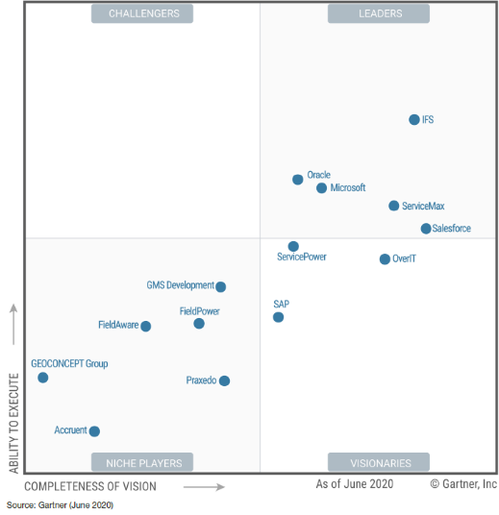

**Gartner Review:**

FieldPower enters this Magic Quadrant as a Niche Player. This status reflects its good market understanding and its product’s affordability, which are offset by a lack of both strong marketing execution and a strong ecosystem of independent software vendors (ISVs) to extend its capabilities. FieldPower’s FSM product focuses on connected field service (with an IoT gateway and over 450 plug-and-play sensor integrations), automation for proactive maintenance, and schedule optimization. It has improved its customer portals, parts management and subcontractor enablement.

Most of FieldPower’s approximately 70,000 users are in midsize and large telcos, service providers, and manufacturers in EMEA and North America. It also targets real estate owned (REO) service providers.

**Strengths as per Gartner**

* **Product breadth:** FieldPower’s IoT gateway and customer and vendor engagement portals help support current strategic initiatives, such as equipment as a service and customer and vendor engagement.
* **Industry strategy:** FieldPower ties its sales compensation to industry performance and depth, and provides configuration and training templates specific to its focus industries. This helps it achieve among the shortest implementation durations, while still having robust functionality. Also, the functionality needs of REO services and property preservation providers are not supported sufficiently by most other vendors.
* **Market understanding:** FieldPower’s product offers capabilities, particularly in the back-office area, that are often overlooked by other vendors. Examples are returns management, robotic process automation (RPA) — used for interfacing with shipping software and ERP systems — and a new equipment approval workflow connected to FieldPower’s customer portal.

## FieldPower Overview

FieldPower’s Field Force Management solution has the capability to plan and dispatch field force and their properly stocked vehicles to a customer's location or Network location in a timely manner in order to deliver on its service commitments. The solution will automate the processes for the Field Force and be able to track all the Field force’s activities easily by the dispatchers/Managers. The system has the facility to send automated alert messages such as SMS/emails to the corresponding field staff/Dispatchers based on the critical/jeopardy situations. Dispatchers have the facility to dynamically schedule/reschedule the jobs in jeopardy situations. Field Force will have real-time connectivity with central dispatch, regional warehouse hubs, and able to coordinate with the nearest available resources.

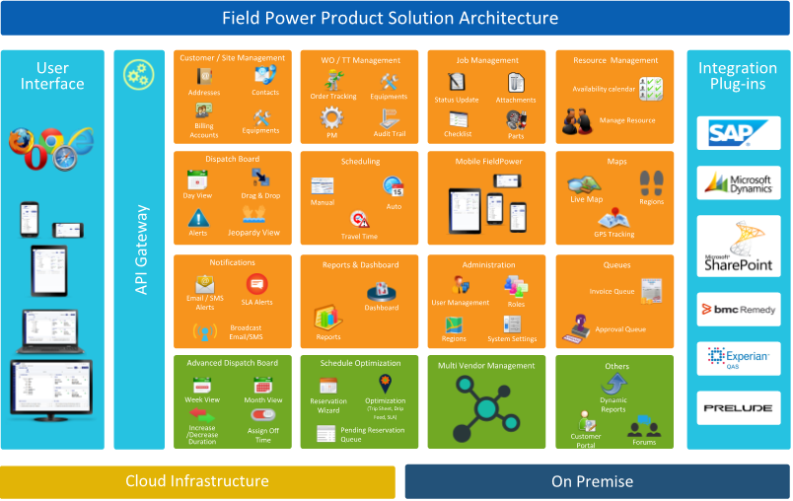

**Cloud Hosting**

FieldPower cloud model provides the customer not to worry about the infrastructure requirements as it is being handled by us.



**Web Based Online Solution**

FieldPower is a secure web-based solution. Deployment of the application is centralized, such that it simplifies the system maintenance and updates. Online hosting alleviates the necessity to download or update specialized software or hardware restrictions. The online hosted environment provides greater security and administrative controls, thus removing the risk from the hardware in the field.



**Audits**

FieldPower provides complete audit tracking functionality for all business transactions. An audit trail log for each activity is maintained to track the user, activity, and date/time.

* User login audit trail
* Application error logs
* Audit trail for master records ( who and when the records are created or updated)



**Master Data**

Master data includes records about technicians, vendors, service levels, parts, regions, routes etc. Master data is used to automate many of the decisions and transactions, and administrator configured business rules can be easily imported and maintained.



**User Rights**

User management and access privileges to the application are tightly controlled and configured with the role-based, access control module. System administrators create user roles and assign access privileges to application screens, activities to the created roles. Then, the administrators will assign roles to the applicable users.



**Security**

FieldPower provides secure connections for data transfer between the browser and the database, by implementing SSL and data encryption as required.

* Secure login for each user, including Dispatcher, Technician, Vendor, and Customers
* Top ten security vulnerabilities as specified in the OWASP (Open Web Application Security Project), including cross-site scripting and SQL injection, are addressed.
* Sensitive data such as passwords are stored in encrypted format



**Scalability**

You have the ability to handle any number of Field Engineers, Vendors, Dispatchers and administrative users. You can create multiple regions to manage geographic groups of personnel.



# FieldPower – Key functionalities



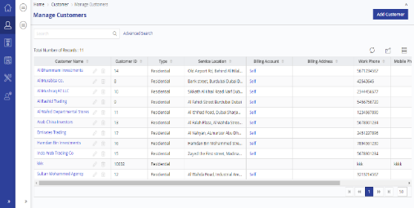**Customers/Sites Management**

* Supports multiple addresses & contact details
* Manage Customer On Premise Equipment / Asset details
* Manage Business, Company or Consumer Residential Site
* Manage PM Schedules of the Customer
* Track Recent Order History by Customer
* Customer / site Based Holidays
* Customer / site based working hours
* Ability to set Preferred Vendor
* Maintain Customer Contracts

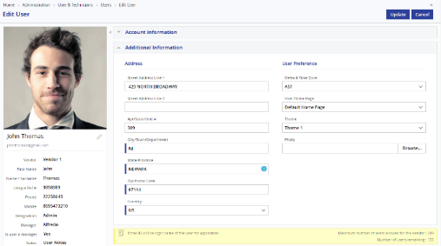

**User Management**

* Create and manage user profiles
* Manage organizational user hierarchy
* Assign multiple roles to each user
* Manage vendors and their technicians
* Manage account preferences such as theme, photos



**Technician Management**

* 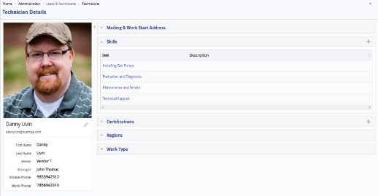Manage Technician Availability (Duty Roster)
* Manage working time and off times in calendar view
* Manage Technician Skills
* Manage Technician Certifications
* Allot Technicians’ working Regions
* Associate Work Types with technician
* Manage vendor technicians in the same interface
* Manage Tech Pricing/Cost
* Manager can track their team's jobs

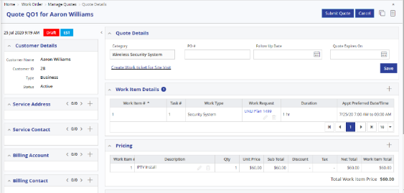**Quote Management**



* Create Quote
* Manage Quote
* Quote Revision
* Print / Email Quote
* Close Quote as Won or Lost
* Convert Quote to Order
* Quote Reopen
* Link to Work ticket



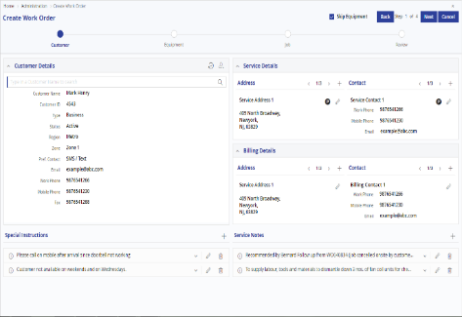**Work Order Management**

* Create Work Orders through an easy wizard flow
* Import work orders from any integrated system
* Add multiple jobs with different technicians and timing
* Automatically reserve or schedule a job
* Manually schedule jobs when necessary
* Capture the equipment and part details
* In-House jobs picked by In-House technicians
* Maintain work order pricing
* Capture the SLA for the work order
* View Audit Log, SMS & Email Log
* Ability to Clone Work Order

**Job Management**

* 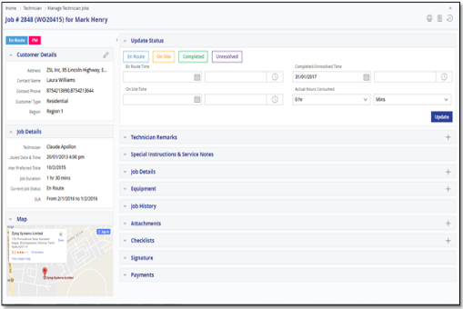Update status as En-Route, On-Site, Completed or Unresolved.
* Equipment details can be added or modified on site
* Manage Spare Parts details
* Add additional work requests and charges
* Add Attachments of before and after Job
* Capture the Payment information
* Capture the Customer signature
* View and update the dynamic forms
* Job Print & Email
* Job Report with Photo Attachment
* View the Job History
* Punch Points & Self Schedule
* Hourly & Fixed Price/Cost

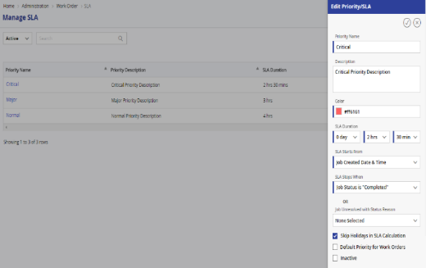**SLA Management**

* Define SLA based on Job priority
* Track SLA adherence against jobs
* SLA based on Customer Type, Equipment or Work Type
* Response & Resolution SLA
* Advanced SLA configuration parameters
* SLA alerts in Dispatch Board
* SLA based Reports



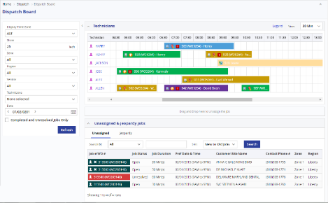**Scheduling & Dispatch Board**

* Automatic Scheduling or Manual Scheduling
* Bulk scheduling of jobs
* Drag and drop job to schedule or reschedule job in Dispatch Board
* Auto calculate travel time
* Schedule optimization
* Scheduling determines the estimated time needed to complete the job
* Configure the Scheduling Parameters
* View SLA Alerts and Attention required jobs
* View jobs in Jeopardy and take action
* Instant notifications to technician and customer
* 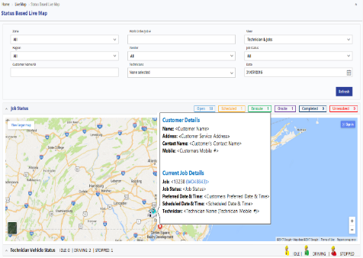Week / Month Views in addition to default Day View



**Location Management (Maps)**

* Identify exact location of the Work Order
* Current location & status of the technician along with the job details
* Support Google maps and Bing maps
* Interactive Map View
* Track Technicians’ Travel History with GPS tracking

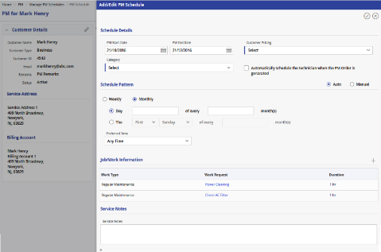

**Preventive Maintenance**

* Create preventive maintenance schedule for Customers / Site / Equipment
* Plan and view maintenance activities for a period
* Choose automatic recurrence or manual pattern
* Plan the task details to be performed for each PM
* Auto generation of Work Orders based on PM Schedule
* Ability to delete / modify selected PM frequencies
* Track the history of PM Work Orders



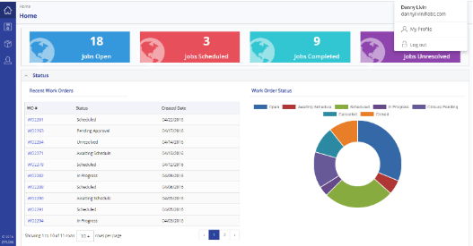**Customer Portal**

* Separate portal for customer
* Customers can create and track their ticket status
* View recent order history
* Manage the Equipment details
* View Work Order details
* Impressive analytical dashboard with quantified information on all the jobs for the customer
* Auto authorize/schedule client order based on customer

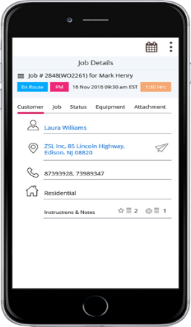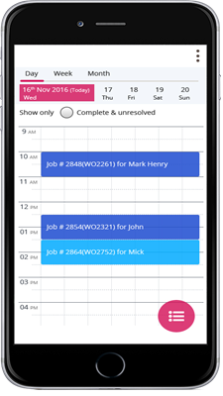  
**Mobility**

* IOS and Android
* Job Calendar, Week and Day View
* Jobs Location in Map View
* Displaying Flags for Job
* Job details view
* Update the current Job Status
* Check In / Check Out
* View & Add Attachments (images / documents)
* Signature capture
* Add & Modify Equipment
* Parts Request
* Dynamic Forms
* Add additional tasks and charges
* Payment Collection
* Customer’s recent order history
* GPS Tracking
* Add & Edit Instructions and Notes for a job
* Technician Profile update
* Online and Offline mode
* Auto-Syncing of Jobs & Activities
* Geo-Tagging of attachments for verification
* Image Annotation / editing
* Audio Recording
* Face ID/ Finger Print



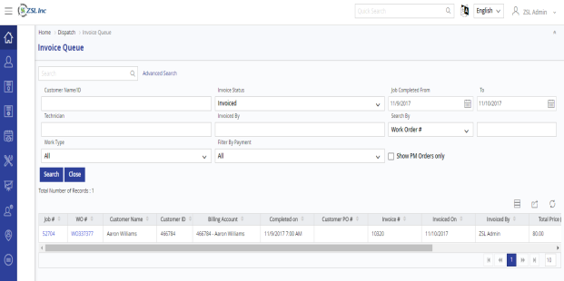**Billing & Invoice**

* Work Request & Spare part based pricing
* Ability to provide discounts
* Ability to add additional pricing to the base price of a job on need basis by the technician
* Automated Invoice generation at the job completion
* Flexible payment options against the invoice
* Integration Support
* Provision to revoke approval of Jobs for updating job information



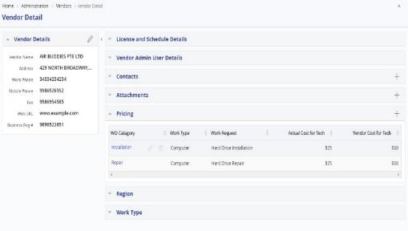**Multi-Vendor Management**

* Ability to maintain multiple vendors / sub-contractors
* Ability to schedule to vendor technicians
* Ability to maintain and monitor vendor technicians and their activities
* Complete encapsulation of data between vendors
* Vendor restrictions by Regions / Work Type
* Vendor based pricing for Work Requests
* Provision for attaching Vendor Certificates
* Manage Vendor Contacts

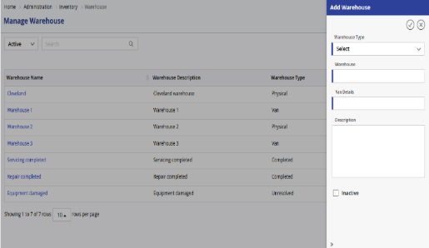

**Spare Parts Management**

* Part / Sample part master – Add & import
* Add attachments
* Multiple Warehouse Management
* Manage Truck Stock and Vehicle Inventory
* Stock Transfer between Warehouses
* Inventory Adjustment
* Track inventory by location and status
* Part Request and Part Receiving
* OEM Part Requests and Returns
* Inventory reports

|  |  |
| --- | --- |
| **Email & SMS Notifications**   * Configure templates for email / SMS notification * Define recipients of the email * Job notification to Vendor & Technician * Job status notification to the defined email recipients * Broadcast email & SMS to group of recipients * Online communication log |  |
|  |



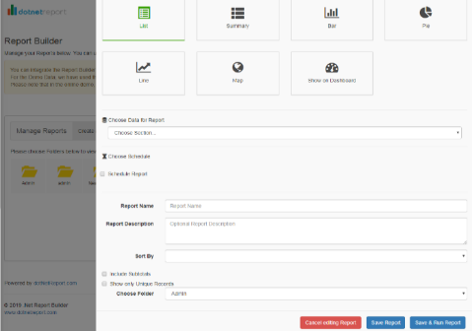**Ad Hoc Reports**

* Users able to create their own reports
* List Reports and Summary Reports
* Reports with Bar/Pie/Line Chart Report
* Choose Data for report and rename columns
* Choose Report filters
* Setup Formula for calculated fields
* Include subtotals
* Schedule and Email Reports
* Print or Export Report to Excel



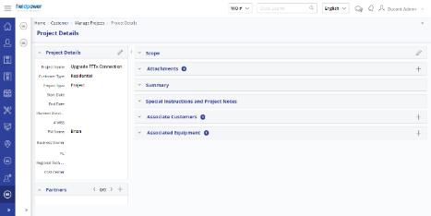**Project Management**

* Manage Project Details like Project duration, PM and Business owner
* Map Partners/Vendors to the Project
* Configure Project related settings
* Manage Project related documents
* View Sites/Assets associated with the Project
* Load the Project schedules and assign partners and Technician

|  |  |
| --- | --- |
| Image result for reports & dashboards icon  **Reports & Dashboard**   * 3 Types of Dashboards like Descriptive, Predictive and Risk Dashboard * Dashboards driven based on defined KPIs . * Multi-dimensional View of KPIs using various Graphs * Various Filters and customization options |  |



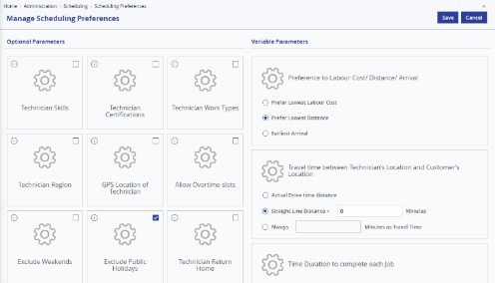**Administration**

* Manage Region & Zones & Territories
* Manage Skills & Certifications
* Manage Roles & Role Privileges
* Manage Work Order Master
* Manage Custom Fields/ Custom View
* Define Holidays
* Manage SLA
* Manage Tax
* Scheduling Preferences
* System Settings



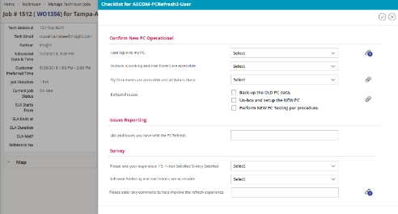**Dynamic Forms**

* Create customized Form template
* Manage Conditional Checklist Templates
* Add customized Questions
* Provide Headers
* Define various type of response controls
* Export and Print Checklist Templates
* Attach Checklists in WO Master or ad hoc
* Export and Print Checklist
* Photo / Document Uploading

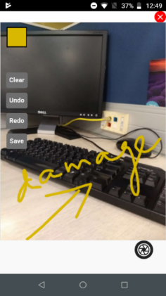**Photo Management**

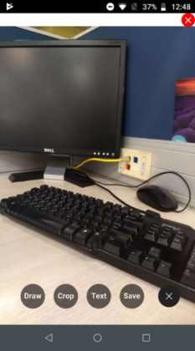

* Capture Real time Sign in info using uploaded Photo
* Timestamp, Geo location etc.,
* Robust Drag and Drop images/documents
* Photo Annotations
* Photo Cropping
* Drawing over image
* Audio recording
* Image attachment with Lat & Long
* Image Compression and Server Side validation
* Audio & video upload and attachments
* Before, During and after Photo
* Duplicate Photo detection
* Customized Naming
* Photo Image Sizing (restriction /unlimited)

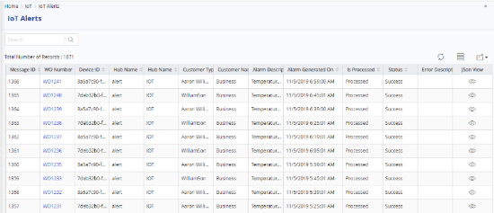

**Integrated IOT Platform**

* Range of Plug and Play IoT devices
* Monitor devices in real time
* Setup rules and alerts
* Integrate with external systems using Webhooks
* Direct integration with FieldPower for Ticket generation



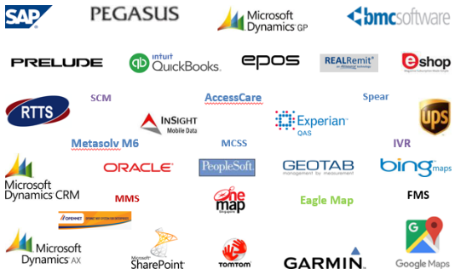**Integration**

* QuickBooks
* SAP
* Dynamics 365
* Service Now
* Remedy
* OSS / BSS Systems
* Bing/Google Map
* Weathers
* Others

## About ZSL

ZSL Inc., with headquarters in Edison, New Jersey. ZSL has earned a reputation as a respected leader in providing technology-based business solutions and services that leverage a globally positioned workforce of Software Engineers and Subject Matter Experts. From locations throughout US, Canada, India, Asia Pacific and Europe, ZSL develops and supports a broad range of industry specific and customer enterprise business applications with a proven delivery model that combines local consulting and delivery centres with highly scalable and cost-effective offshore development and testing facilities.

ZSL has a long standing history of approaching every client and every project as a partner, carefully configuring teams of business and technology professionals that complement and optimize client-side project groups, guaranteeing the highest quality deliverable in the shortest time-to-market achievable.

ZSL’s effectively managed intellectual capital is the foundation from which our clients draw upon specialized knowledge in an increasingly broad range of business applications and computing environments. The loyal following of clients seeking to leverage our proven delivery methodology includes many small and midsized companies, as well as many respected leaders in Pharmaceuticals, Finance & Banking, Insurance, Life Sciences, Telecommunications, Marketing, Retail, Transportation & Logistics and Consumer Electronics.

ZSL complements a vast array of human and technological resources with strategic partner relationships, including proven solution providers and market leaders in current and emerging technologies such as Web 2.0, SOA, Business Intelligence, CRM, Web-To-Print, Wireless Communications, Mobility, Field Force Automation and Managed Services.

At the core of ZSL’s value proposition is our ability to assemble and dedicate a solution delivery team to meet our clients’ unique requirements. Strict adherence to ISO and CMMI certified processes applies to every client and every project regardless of the approach that best meets the clients’ needs: Onsite, Offsite, Offshore, or our award winning Hybrid Onshore/Offshore project engagement model.

### Quality Standards and Services

Competitive solutions, customer satisfaction, and conforming to quality standards are the basis of ZSL’s strategies and practices. ZSL’s Quality Assurance Group (QAG) ensures that the Quality Management System is implemented in all of our projects.

ZSL have been awarded:



**SEI-CMMI Level 3** and are working towards **CMM level 5**.



**ISO 9001 standard in 1999** and currently certified for **ISO 9001:2008**

ZSL has an independent validation and verification centre with ZSL Testing Centre of Excellence (ZTCoE) to ensure that rigorous testing procedures and standards are implemented and complying with CMMI. This practice within ZSL forms the life line for quality product development.

### Global Clientele Partial List

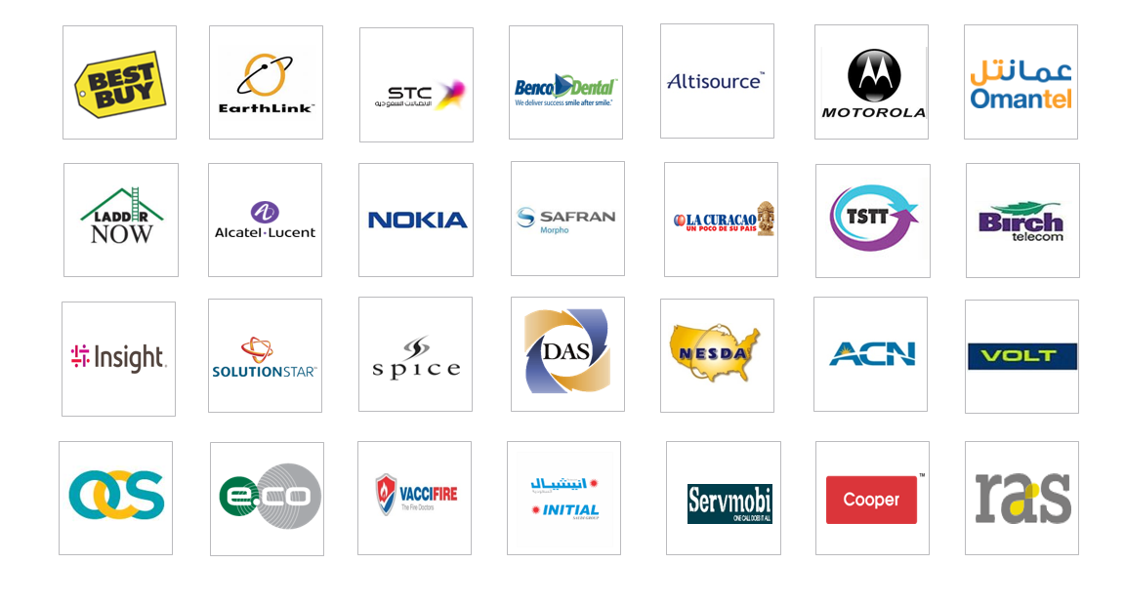

# Field Service Management Solution Requirements

The following table provides ZSL response to Nationwide’s requirement for Field Service Management Solution.

Please refer Section 3 - FieldPower Features for detailed explanation of FieldPower features.

|  |  |  |
| --- | --- | --- |
| **Area** | **Question** * Desired but Not Required | **ZSL Explanation** |
| **Solution Capabilities** | | |
| **Customer** | Does your solution enable the customer to be notified via email, text alert and on a digital platform the name and contact information of the service professional assigned? | Fully Supported. FieldPower provides system wide, job level alerts and notifications through email and also through an SMS to Customer.  Please refer the section  Auto SMS and Email |
| Does your solution include the picture of the service professional assigned? Explain. | Fully Supported. FieldPower has the option for capturing the profile picture of the technician / service executives in user master.  Please refer the image  Profile Picture in User Master  This profile picture will be displayed in Dispatch Board and Technician Job Details.  Please refer the image  Technician Picture |
| Does your solution allow customers to schedule and/or cancel appointments via self-service based on the service professional's pre-defined schedule on a digital platform (e.g., website, mobile app)? | Fully Supported. Customer portal in FieldPower has an option to check the availability of technician / service professionals at the time of Order (service request) creation. It displays the availability of technician for a specified date and slot. Also shows the technician’s current location in map.  Please refer Customer Portal |
| Does your solution automatically send reminders to the customer and the service professional about upcoming appointments and alert in case of any delay / update in schedule? | Fully Supported. FieldPower provides job level alerts and notifications through email and SMS to Customer / Service Professionals based on the defined conditions like scheduled appointments.  Please refer section Alerts & Email Notification setup |
| Does your platform allow a customer to indicate if they would like to be at the appointment location (home, property, repair shop, etc.) at the time of appointment? | Fully Supported. FieldPower provides flag thereby indicating customer appointment location.  Refer the section Map Functionality |
| How does your solution maximize the customer's experience in establishing or changing an appointment? Appointment information, uber-like maps, uploading photos, web promotions, etc. | Fully Supported. FieldPower Custom portal has the option of flexible map to show to the current location of technician post, starting the job by technician. The en-route option where the movement of technician is also visible in customer portal.  Schedule Optimization (Uber) Component provides an efficient solution to manage the Organizations Workforce to meet the Customer satisfaction and reduce the Organization’s Operational cost by optimizing the Workforce schedules.  Please refer Customer Portal |
| Can the customer provide overall experience feedback via your service; used to measure NPS and/or customer satisfaction? | Yes. The technician can update the customer rating/ feedback and his remarks about the service using the ‘Technician Job Details’ screen of the FP application and mobile device.  Please refer section Customer Feedback  Please refer section Customer Feedback in Mobile. |
| Does your solution require the customer to login so that they can interact with the scheduling platform? | Fully Supported. FieldPower has this option where Customer can check the orders / claims via Customer Portal.  Please refer Customer Portal |
| Does your solution require the customer to download an app so that they can interact with the scheduling platform? | Yes. FieldPower provided customer self-scheduling portal to create, manage and track the status for each job.  Please refer Customer Portal |
| **Operation** | How does your solution account for service professionals being assigned to multiple jurisdictions / territories?  Specifically, what controls are available to manage cross-jurisdiction / territory assignments? | Yes, this can be achieved by using region/route management feature where you can define route and assignment right job to the technician.  Please refer Region Master |
| Can your solution automatically assign service professionals to field jobs based on all the following characteristics: Job Type Job Complexity Service professionals capacity limits by day, week, month Service professionals skill sets Service professionals licensing and accreditations | Yes, the solution automatically assigns service professionals to field jobs Based on the various scheduling parameters (skill, certification, region) the jobs scheduled for specific technician or service professional.  Please refer section Scheduling Preferences |
| Can your solution be predictive in how long a service professional may need to spend on field inspection (based on job type and associated complexity historically) and create schedule? | System predicts job duration by calculating the average actual hours taken by tech to complete the job for the past 1 month. System will provide predictive job duration as report based on service request. You could configure the same in work order master also.  Please refer section Work Order Master |
| Does your solution recognize changes in weather and/or traffic conditions and automatically make recommendations to the service professional to reschedule? | Yes. The system shows weather overlay in LIVE Maps and lists all the jobs as report affected by storm or hurricane. The system also can show both current and forecast conditions to manage catastrophic events efficiently.  Please refer section Weather Overlay |
| Does your solution have the ability to automatically optimize route for service professionals based on real-time traffic and the location of the remaining appointments? | Fully Supported. FieldPower has Optimizer engine runs and re-optimizes for every 15 minutes based on scheduling variables including traffic and weather events. All the service professionals work time will be considered based on duty roaster and schedule/rescheduled based on customer requested appointment date and time.  Please refer section Route Optimization |
| Does your solution automatically notify the service professional if a newly assigned task is in / near the area they are currently working in and optimize route accordingly? | Fully Supported. Optimization engine continuously runs and find the nearest tech/lowest distance to the customer service location. Optimization engine allocates preference to the technician who are on job in a particular location based on route and region assignment. The whole optimization engine runs based on scheduling variables i.e., one-time configuration settings in FieldPower.  Please refer Scheduling Management |
| Does your solution auto-fill newly available appointment slots when a customer cancels appointment without advance notice? | Yes. Auto fill option is available where System considers as available appointments when customer cancels their appointments. Optimization engine automatically considers these cancelled appointments as available appointments on each automatic run.  Please refer Scheduling Management |
| Does your solution integrate with any core claims platforms (e.g. Guidewire, Duck Creek, CCC)? Please indicate any other licensing platforms, HR software, employee time management software and/or sales platforms with which your solution integrates. | Yes. FieldPower has the capability of integrating with various platforms in the market. For instance ERP, SAP, CRM, ticketing system. We are also ready to provide API for integrations based on customer needs.  Please refer section Integration |
| Does your solution allow change in business rules for assignment and scheduling without requiring IT reprogramming (e.g., by a business user)? | Fully Supported. FieldPower provides number of configuration and scheduling variable parameter to change the business rules for scheduling and dispatching. There are many configurations throughout the system to handle various business cases and configurations.  Please refer the section Scheduling Preferences |
| Does your platform allow a business user to configure Guidewire or FNOL claim attributes for inclusion / exclusion in resource qualification? By territory, state, zip? | Yes, FP will allow to configure the claims with different attributes to defined resource qualification / skillset by territory, state and zip. Based on the detail requirement study this can be configured as per Nationwide business requirement |
| Is your platform currently in market for scheduling property claim adjusters? If yes, how many insurance carriers do you have as a customer? | Yes, FP is deployed to different markets around the globe where Insurance claim management is part of US implementation, successfully Implemented next generation FP dispatch/scheduling software systems for Claims management space to deliver transparent,  next generation service and technology to insurance carriers.   * Insurance adjusters. Real-time access to the National calendar for customer, factoring the GPS location with special tools requested (40 ft ladder) this gives flexibility to their customer to book an appointment in few click to  have the inspector to inspect the property in a given date and time. Home Insurance Roof Inspection– USA   Single integrated Holistic solution to manage and dispatch claims and Live weather updates and Flexible deployment of inspector to different region / location based on the catastrophe events. |
| Does you solution allow the resource to set calendar availability parameters? | Yes. FieldPower has the option to set calendar availability parameters, where we have a duty roaster feature to set the availability parameters that includes:   1. Work Time 2. Off Time 3. Over Time with approval conditions   Please refer section  Duty Roaster |
| How does your solution handle job/inspection resource reassignments? Routing determination Customer notification Reporting for throughput analysis | Assignments and Re-assignments will be taken care based on Zone, Region, Route, Skill, Certifications and Lowest distance parameters. Customers gets notified by Auto Email, Auto SMS, Customer portal and Customer App.  Please refer Scheduling Management  Please refer section Alerts & Email Notification setup |
| How often does the solution re-optimize the schedules (daily, weekly, multiple times a day)? | Optimization engine consider the list of jobs based on priority, current day and future day jobs.  For the Current day jobs, Optimization automatically run for every 15 minutes for the defined business hours (say 6 PM to 10 PM, Its configurable).  For the future day jobs, Everyday night, system will optimize next X day’s job by reshuffling all the tentative reserved jobs. The next X days are configurable. As a first step, we will configure it to next 3 days.  Please refer Scheduling Management |
| Is the re-optimize scheduling routine automatic or have to trigger by manual input? | Yes. Re-optimization is taken care by automatically; no manual intervention is required here.  Kindly Refer the ZSL response of previous question.  Refer the ZSL response of previous question.  Please refer Scheduling Management |
| Does the solution re-optimize the schedule immediately after an appointment is changed (duration of appt, day, and time slot)? | Yes. Optimization Engine instantaneously considers the cancelled / changed appointment availability as available work time and assigns a right technician based on scheduling variables.  Please refer Scheduling Management |
| Does the solution communicate appointment changes to third party contacts (not registered users) as well as primary customer contact? | Fully Supported. As per the defined SMS & Email Template, System will trigger a message to appropriate Customer, Technician, Vendor and any other personal as required  Please refer the section  Auto SMS and Email |
| Can the solution accommodate sudden high demand for claims in an area and allow additional field personnel to be assigned jobs in overlapping areas? | Yes. Accommodation based on Region and route configuration settings that can be easily achievable in FieldPower solution. Technician Master  Please refer Region Master |
| Does the master schedule display and manage both employed and contracted assignments and scheduled appointments? | Yes. System has the ability to set route assignment for internal/W2 employees and contract employees. Based on region and route assignments, system automatically assigns the job to the internal as well as contract resources. Optimization engine provides first preference to internal/W2 employees for scheduling jobs rather than contract employees.  Please refer Region Master  Please refer Scheduling Management |
| Does the solution provide scheduling for desk (virtual) inspections where there is no travel required? | This can be achieved through Inhouse jobs. In the master template we shall assign job / task to in-house technician. Once the task is assigned it will form a separate Q where the technician can self-assign and complete the tasks. |
| Does the solution allow for field resource to access their individual schedules, make changes, add appointments, etc.? | Yes. FieldPower has got this feature where technician has the option to access his schedules using Job Details and he can make changes and also add tasks / appointments.  Refer Adjust Job Duration  Refer New Task Creation |
| Please describe how your solution manages catastrophe events such as major storms, tornadoes, earthquakes, etc. | FieldPower allows dispatcher or scheduler to bulk assignment or bulk scheduling the job to technician or third-party contractors. In the case of catastrophe events, the system will auto schedule based the jobs to internal adjusters and also look for third party 1099 contractors for additional job. Example. One of the clients in REO Industry, the system handle more than 5000 sub-contractors. We are planning to integrate the system with EarthvisionZ for catastrophe events and alerts. Currently the system is integrated with AccuWeather for weather maps and forecasting. |
| Can you solution be configured for ad hoc inspection locations. Example: Set up a field inspection location at a local Lowe's so that claimants can drive up vehicles for hail damage inspection. | Yes. FieldPower supports ad-hoc section locations/site where customer can drive up to the location for inspection. |
| Does your platform integrate with roof imaging platforms (e.g. EagleView) to determine height/slope in consideration of determining vendor need? | Yes. FieldPower supports to view the Eagle-view report and also capable of integrating with roof imaging platform.  Please refer section Roof Imaging Eagle View |
| Can your solution consider near term (example: next 2 days) availability and capacity before assigning field job to a service professional? | Yes. We have a duty roaster feature to set the availability parameters includes:   1. Work Time 2. Off Time 3. Over Time with approval conditions   Please refer section Duty Roaster |
| Can the solution manage supplements and schedule supplement appointments? | Fully Supported FieldPower application has got multiple options to achieve the scenario namely:  Option 1: Technician inform customer to coordinate with Call center to create a new job  Please refer section Create Work Order  Option 2: Technician can also add additional tasks along with existing tasks in the same job  Please refer section New Task Creation |
| How does the software predict resource capacity? What are the demand inputs? | Using previous month’s data, system displays count of best performer for High priority Tickets. Additionally, user can drill down to various dimensions by clicking View More Option tab and fetch the inputs. |
| Is there a software development kit that would allow us to add your scheduling software to our existing digital capabilities? Please describe this access. | Yes. FieldPower has out of the box REST API for any integration / customization that is required.  Please refer section Integration |
| Does the solution have an automatic geofencing ""check in"" and ""check out"" time stamping capabilities? | Yes. Geo fencing based validations is available for each job assigned to a technician where the check-in and check-out time can be identified at each level.  Please refer section System Settings |
| Does the solution have a manual task completion logging capability? | Fully Supported. FieldPower does have the capability where we have timestamp and audit log that is reflected with remarks in a repository of all the work orders.  Please refer Work Order History (Audit Log) |
| Does your solution account for jurisdictional SLA inspection requirements (i.e. supplemental or reinspection must be completed within X hours of request in Y jurisdiction)? | Yes. SLA (Service Level Agreement) / priority of the jobs can be configured in detail by FieldPower Administrators. FieldPower offers flexible ways of defining SLAs with varied time measurements. The user can define priority first and consecutively the SLA duration time for the priority in the same screen. Jobs should be performed / completed adhering to the applicable SLA thereby adhering to jurisdiction SLA inspection requirements  Please refer SLA/Priority management |
| How does your platform manage a hybrid work force where most jobs are handled by employed resources, however overflow or non-supported geographies are given to independent providers? | System has an ability to define hybrid work force like W2/1099 resources. Based on region and route assignments, system automatically assign the job to the internal as well as contract resources. Optimization engine give first preference to internal/W2 employees for scheduling jobs rather than contract employees and independent providers. |
| Does your platform allow for incorporating SLAs into alerting for notifications to dispatcher or assignee? | Yes. The application has an auto email template, where if an SLA is breached or if a technician is nearing an SLA an auto email is sent to the dispatcher/ assignee thereby alerting them. |
| How does the solution visually inform the customer of the resource location? | Live Map gives us a map-based view of all the field activities, where the customers can get to know about the resource and the current location where they are. |
| Can the solution assign a priority to the job/inspection so that high priority work is scheduled first? Or is this a FIFO scheduling design? | Optimization Shuffler Runs every few hours to rearrange the sequence of the jobs based on the Scheduling Preferences (Region / Territory, Priority, distance etc.).  Please refer Scheduling Management |
| What is the ability for the software to recognize when an unscheduled job is slightly longer than the time available and relax constraints to allow this job to be scheduled.  (Ability to balance the time constraints to a complex job vs. time available, so a complex job does not go out of the scheduling SLAs). | FieldPower has option to manually adjust the job duration to accommodate the availability while scheduling the job to the technician. |
| Is the assigned resource able to reject a scheduled assignment and have the system reschedule for them? Does it capture a reason code for the rejection? | System provides the option for the technician to either accept or reject a job once it is scheduled to them. If the technician rejects the job, the job will be reverted to Awaiting Schedule status and the job can be scheduled to a different technician based on the scheduling parameters. |
| Can your solution easily scale up and down based on situational changes such as catastrophe events which would drive increased claims for a period of time? | Accommodation based on Region and route configuration settings that can be easily achievable in FieldPower solution. Technician Master has this capability to scale up and down. |
| How does the system determine which resource to use for claims with overlapping territories? | System determines the resources based on hybrid configuration either W2 or 1099 employees. We could say either Internal or Independent contract employees. In manual scheduling, system gives suggestion to choose internal employees with preferred skills, certifications, lowest distance and tech preference always to use internal employees heavily. In auto-scheduling, optimization engine considers the internal employees first as tech assignment for job rather than external employees. Territories configuration can be easily done by zone, region and route configuration in FieldPower. |
| Can your scheduling solution handle intra-day rescheduling, cancellations, extended appointments, real-time traffic adjustments, etc. | Optimizer calculate the travel time using tech GPS location and Map points (Bing/Google) including Traffic.  IF a job is reserved with the travel time of 30 minutes and at the time of allocation, the optimizer may increase or decrease then travel time based on real traffic data (Bing/google) and the subsequent job also shuffled.  If a new job is created near to tech location, then the optimizer automatically considers the job and allocated to nearest technician.  If a job is cancelled, then the optimizer automatically allocates a next nearest job to that technician for the next run.  Please refer Scheduling Management |
| How does your system deal with scheduling exceptions such as unresourced appointments or appointments in a jeopardy condition? | A job may be in jeopardy when it is unable to be started by the technician due to the overlapping with the actual timings of a different job scheduled to the same technician. When a job is in jeopardy condition, email notifications are sent across to the dispatchers and the job is also displayed in a separate area in the Dispatch Board. The dispatcher can take immediate action based on this to reschedule the job to a different technician.  Please refer Scheduling Management |
| Does your system contain intelligence that learns and adjusts over time based field resource pattern, evolving traffic conditions, etc.? | Yes. It does based on duty roaster settings. In duty roaster, we have a feature to set the availability parameters includes:   1. Work Time 2. Off Time 3. Over Time with approval conditions |
| Does your solution automatically set appointment windows by job type and complexity? | Job Type and Complexity are some of the scheduling parameters based on which job is scheduled to the technician by FieldPower. The system will consider these parameters while scheduling the job to the technician |
| Can the solution manage supplements and schedule supplement appointments? Can the system ensure that the supplement be assigned to the original field resource that created the estimate? | FieldPower application provides preference to W2/Internal employees rather than independent contract employees unless otherwise you specifically define the configuration in manual/Auto-optimization workflow. The supplement appointment like customer cancelled appointments and new resources deployed due to catastrophic events will be considered first for internal employees. |
| Mobile Application | Is there a mobile application for the resource assignee? | Yes, Mobile application is available for all Field adjusters and third-party adjusters/tech.  # Calendar View |
| Do users have the ability to work offline and then update once back in coverage area? | Yes, FieldPower Mobile application works in offline mode also. Technician can sync the data with server application once technician back to online.  # Offline mode |
| Do you have a mobile application which will interface with your web application? | Yes, Mobile application is interfaced with web application.  # Interface with web application |
| Does your mobile application include features for geolocation to show when the assignee will be near the assigned location? | Yes, there are two features Geolocation and Geo-Fencing.  Mobile application provide geolocation to web application based on setting in web application. Based on geo location  - Geo fencing setting - Application would validate with assigned location when update the status of job.  - Technician, job / technician can be tracked in real time.  - Geo location would be captured at the time of photo capturing / attachment.  #  Geo Fencing |
| Does the mobile application allow for manual check-in and completion of an assigned task? | Yes, Manual Check in & Check out and Job status are available.  # Check in & Check out |
| Does your mobile application provide alerts to the assignee of incoming task assignments? | Yes, we support both SMS & Push notification (alert).  # Push Notification |
| Does you mobile application account for drive-times and provide map assistance to the assignees to direct them to the quickest way to the job/task? | Yes, Mobile application is integrated with google map for Job location and driving direction and also our scheduling engine will consider the drive time for any appointment scheduling.  # Driving Direction |
| Does the solution offer a mobile capability that allows the field personnel to communicate and receive information on jobs and schedules? | Yes,  - Chat feature is available where technician can interact with Administrator and fellow technician as well.  - There is feature called nearby technician where all technical who are all nearby job location would be displayed with contact number. So, technician can be contacted for any support.  - Technician would be notified through push notification If job is schedule.  # Mobile Chat  # Nearby Technicians |
| Does the solution allow field personnel to share appointment details with one or more third party contacts via email or text? | Yes, Technician can share appointment details with fellow techs or third-party contacts based via email or SMS text or other media (Based on Policy)  # Sharing Appointment |
| Does the solution allow field personnel to reschedule an appointment that was previously scheduled? | Partially Supported, Technician can create the same job from feature named “Punch Point” and can do self –schedule based on availability. This will be part of upcoming roadmap  # Punch Point |
| Does the solution allow field personnel to reject an appointment that was previously scheduled? | Yes, Technician can reject an appointment that was previously scheduled  #Status Update |
| Does the solution allow field personnel to adjust the duration of an appointment previously scheduled? | Yes, Technician can adjust the duration. |
| Is the field resource information tagged for both a time stamp and GPS location when performing actions? | Yes, Geo location would be captured at the time of status update, photo capturing / attachment, Checklist.  # File Attachment  # Driving Direction |
| Reporting | Does your solution have the ability to export reports on forecasts in MS Excel, .csv and directly print graphs and data (to assist in reporting)? | Yes. We do have an ability to do export the reports in excel, pdf and email that report data. The following out of box reports available in our solution to track, manage and forecast the unprecedented occurrences.  Dashboards: Management, Dispatcher and Operational  WO Report: Customer Job Summary Report, Customer SLA report  Technician Report: Technician SLA report, Tech Utilization Report  Inventory Report: Van Inventory Report, Stock Status report |
| Does your solution have the ability to format reports for email? | Yes. FieldPower solution provide ad-hoc report feature to create your own set of reports based on your business needs as well as configure the fields and the display of reports. These reports can be downloadable in excel, pdf and send to customer in email format as your expected. |
| What are the out of box reporting capabilities and data outputs? | The following out of box reports available in our solution:  Dashboards: Management, Dispatcher and Operational  WO Report: Customer Job Summary Report, Customer SLA report  Technician Report: Technician SLA report, Tech Utilization Report  Inventory Report: Van Inventory Report, Stock Status report |
| What data is available and can we see the changes over time? | Fully Supported |
| What analytics capabilities are included with your platform? | FieldPower analytics is cloud-based solution that extracts, transforms, and integrates data from sources for visualization through simple web application. Under Analytics Suite there are three type of Dashboards.   1. Descriptive Dashboard 2. Predictive Dashboard 3. Risk Dashboard |
| Does your reporting encompass all modules and include both employed and contractor activities? | We do have reporting facilities to take tech capabilities of W2 and 1099 employees. |
| Does your reporting offer dashboards and graphing options? | FieldPower analytics Dashboard & Reporting has various Graph and List Report. |
| Does you solution encourage collaboration and data sharing among team members within the platform? | Fully Supported |
| Does your solution allow users to easily create individually preferred views of data without requiring an IT or technical resource? | We have custom object to create custom fields and custom report using ad-hoc reporting feature to achieve the extended requirements. |
| Does your solution allow for import of data for reporting and analytics that comes from other 3rd party platforms? | Yes |
| **Technology** | | |
| Availability | Will you agree to the following (and if not, please describe why you need to deviate from this standard)?:   The solution service shall be available 99.9% of the time, measured weekly during all hours of the day excluding Standard Maintenance Hours. Can you commit that your support teams will also have 99.9% availability? | Yes, our solution does support 99.9% availability and support team also available 99.9%. |
| Maintenance | Customer has defined the time period for maintenance of the solution / systems as follows: Scheduled maintenance between 7:00 pm - 11:00 pm EST Saturday each week. Will you agree to the following?:  1. Maintenance will be performed during the Standard Maintenance Hours. When additional time for maintenance is required outside of the Standard Maintenance Hours, Company shall notify Customer, within normal business hours, at least 48 hours prior to the start of such scheduled additional time.  2. Company shall notify Customer of any specific Scheduled Maintenance Downtime at least one week prior to such scheduled downtime. | Yes, we will follow the mentioned maintenance window.   1. Yes, this is acceptable. 2. Yes, this is acceptable. |
| Hosting Environment | Who do you use to host your application (hosting provider)? | AWS [Amazon Web Services] |
| Are all components of the application hosted with this hosting provider? | The whole solutions runs on AWS. |
| How many data centers are used to host the application? | Two data centers [In HA]. |
| Is your hosting model multi-tenant (meaning multiple customers are hosted on the same physical hardware) or does each client get their own dedicated hardware (physical or virtual)? | Each client has their own environment and dedicated virtual instance(s). |
| If the application is hosted on a multi-tenant platform, what is being shared between customers / clients? Examples:  a. Dedicated Operating System / Virtualized Hardware: Physical hardware is shared but the operating systems are partitioned using virtualization technology so each client has their own operating system.  b. Separate Application Instances, Shared Operating System: Each client’s application/instance is shared within a single operating system but each client gets their own instance of the application (separate memory processes, middleware, etc.)  c. Separate Application Installations, Shared Middleware / Application Server: Each client’s application/instance is shared within the same set of middleware / web and application servers but deployed as separate applications with the middleware/application server technology.  d. Single Application Instance Shared By All Customers / Clients: Each client is shared within a single instance of the application. | Yes.  a. Dedicated Operating System / Virtualized Hardware: Physical hardware is shared but the operating systems are partitioned using virtualization technology, so each client has their own operating system. |
| If the database is multi-tenant, are tenants separated by database, schema, or share a single schema? How is the data kept separate? Typical models include:  a. Standalone Database Server (client doesn’t share hardware).  b. Shared Database Server, Separate Database Instances (operating system shared, but each client has separate database instance).  c. Shared Database Instance, Separate Database (each client’s data is separated by a database, but are sharing the same database instance).  d. Shared Database, Separate Schema (each client’s data is kept in the same database, but tables and objects separated into separate schemas).  e. Shared Database and Schema (All client data is stored in a shared database and schema and data is separated by SQL query filters). | Yes.  a. Standalone Database Server (client doesn’t share hardware).  Each client has separate database in separate instance under High Availability. It’s not shared with other clients. |
| Can you provide an architecture diagram depicting what your deployment environment looks like (web servers, app servers, database servers, virtualization, data replication between data centers, etc.)? | Find attached the Architecture details in the appendix section  Refer diagram ***Cloud architecture*** |
| Server Architecture | Can you describe your server architecture and hosting environment (# of servers, types of servers, etc.)? | The required details are shared in the architecture diagram  Refer diagram ***Cloud architecture*** |
| Can you describe the operating system, middleware, and database technologies used by the application / solution? | OS - Windows Server 2012 R2 or later.  Middleware - .NET Core, REST based APIs. Redis Cache is used as a middleware.  Database - SQL Server 2017.  Please refer ***FP-Technical Architecture***  Please refer ***FP-Security Architecture*** |
| Do you leverage virtual servers in your architecture, if so, where? | Yes. We use EC2 [Elastic Compute Cloud] instances on AWS. |
| Application Architecture - General | What customization options does the application support? Some configuration (using out of the box functionality? Heavy configuration and flexibility? Custom code? | Yes, Application drives with set of configuration settings in system level. Also have Custom fields, custom forms, Configurable report management (dynamic). |
| What constraints are in place for customization or custom code to extend the application functionality (is there a certain framework that these changes need to be made within? Can you expand upon these details? | The system allows administrator to add custom field and dynamic forms and also allows ability to customize the various views for the users, also allows users to create ad-hoc reports. In addition to that system is having REST API calls for various integration |
| How much customization do you allow to the user interface? Simple logo / color / branding changes? Or do you allow complete access to the HTML/CSS/Javascript frontend/UI code? | Themes, list views, export fields, custom reports, custom forms. Not allowing the access to HTML, CSS or UI code. |
| Does the application depend on services provided by third parties? If so, can you expand on the functions of these services and the technology used for these interfaces (description of interface, its functionality, and what the protocol used is)? | Based on configuration Google / Bing services will be used for maps.  Based on settings, configured SMS service will be used to send SMS. All services are used https protocol. |
| Application Architecture - Interfaces | What interfaces does the application expose? (browser-based user interface? protocols to receive data files? web services? citrix? others? are all interfaces web browser-based interfaces?) | Fully Supported. This is a browser-based app. All the data transit happening through https.  Data files can be shared either FTP/SFTP or one drive. We will support if any other mode of data file sharing. |
| What protocols are used within each of those interfaces (HTTP, HTTPS, SFTP, SCP, SSH, RMI, JMS, MQ, JDBC, etc.)? | Fully Supported. We support HTTP, HTTPS, SFTP, MSMQ protocols. |
| For each interface, can you define if they are synchronous or asynchronous? | Fully Supported. Service interfaces are defined as synchronous as well as asynchronous based on your requirement. |
| Application Architecture - APIs | Do you expose APIs from your product to allow customers to integrate with? If so, can you provide more information on these APIs (develop guide / documentation, developer portal, etc.)? | Yes. We will share developer API portal. This portal contains all the REST API information along with developer guide and documentation. All REST APIs are presented in the developer portal using swagger and/or postman specification. |
| Do you have a public facing ‘developer portal’ that describes your APIs? | Yes, the developer portal described above using Swagger and/or Postman is public facing. |
| How are your APIs licensed? Do all customers have access to them included in their use of the product or are the APIs licensed separately? | API licenses are a part of the product. There is No separate license required. |
| What type / methodology of authentication is used with the APIs? API keys? | All APIs exposed via an API Gateway. We use AWS API Gateway.  Some features of the AWS API Gateway are   1. API Keys [each user get an API Key]. 2. Custom Authorizer. 3. Custom Domains 4. Request throttling. |
| If web services are exposed to the customer, can you describe the type of web service and message format used (SOAP, REST with XML/HTTP, REST with JSON/HTTP, etc.)? | Web services are exposed in REST with JSON/HTTP, REST with XML/HTTP. |
| Security Architecture – Identity & Access Management | What types of authentication and authorization technologies does the application support? | OpenID Connect with OAuth 2.0 protocol is used for authentication and authorization. |
| If the application supports SAML, what version of SAML is supported? | Yes. SAML 2.0. |
| What technology is used for SAML (CA Federation Manager, Microsoft Active Directory Federation Services / ADFS, Oracle Federation Identity, homegrown, etc.)? | ADFS, OKTA |
| Does your solution document controls and procedures that help to safeguard personal information and managing information security? | Yes, we do have controls in place to handle Data Privacy and Security. We are in the process of getting ISO 27001 Certified or GDPR compliant. |
| Can your system remember at least the last 6 passwords, so passwords are not reused? | Yes |
| Client Architecture | Can you describe specific browser or client software requirements and versions? | Support all standard browsers like Chrome, Edge, FireFox, Safari. |
| Can you describe any special requirements for client libraries or browser plugins? (.NET, Java, ODBC, etc.) | No plug-in required. |
| Can you describe the types of connections that the client will need to make in support of the application (either within the client’s internal network or to the application and internet)? | VPN tunnels / Site to Site VPN are used to achieve this. It is important we need good internet bandwidth from the client’s network. |
| Are there any specific network requirements for the client (bandwidth requirements, VPN tunnels, etc.)? | No. |
| Scalability | If the application experiences unexpected load and performance is degraded, how do you scale your environment? | We do HA and horizontally / vertically scale on demand. |
| Can you describe the process to scale the environment to allow for increased unexpected traffic and load? | We use well known monitoring tools including AWS CloudWatch and some custom homegrown scripts/solution to monitor traffic and load. We also have alerts setup. Based on this we scale server(s) horizontally/vertically on demand. |
| Does your scaling model support rapid elasticity, meaning can the application be rapidly and elastically provisioned, in some cases automatically, to quickly scale out and rapidly released to quickly scale in. | We use well known monitoring tools including AWS CloudWatch and some custom homegrown scripts/solution to monitor traffic and load. We also have alerts setup. Based on this we scale out/scale in server(s) or scale up/scale down on demand. |
| If the process to scale the environment is not automated, how long does it take to scale the application to address unexpected increased load? | Scaling can be achieved within 1-2 hours. |
| Is your server provisioning process automated? Can you describe the process? | No, if new server(s) need to be added, a request would need to be made through a formal process. |
| Has the process of scaling the environment been tested? | Yes. We have tested the entire setup multiple times using industry standard tools like NeoLoad. |
| Data Architecture | Is replication, streaming, mirroring or similar technology used within the database platform? | We used SQL Server Always-on clustering. |
| Does the application support records retention policies and scheduled purges of data? If so, how does it support this? | Please refer the below the appended document which consists of retention policy and data purging technics. |
| Is data encrypted at rest and in transit? | All sensitive and PII data are encrypted during transit (using HTTPS/SSL). |
| Performance | What performance KPIs are defined and monitored? | KPI are   * Simple operations – 2 -3 secs * Medium operations – 5 – 6 secs * Complex operations - < 10 secs |
| Can you provide the results of performance tests that have been run on the version of the application that is currently running in your production environment? | Yes tested. We used NeoLoad. Report will be shared later stage. Include the report in one drive. |
| What are your quality assurance practices for testing performance?  Manual, scripted test, application performance monitoring software? | Automation done through NeoLoad. |
| Non-Production / Testing Environments | Do you have a non-production environment that can be used for performance testing using automated testing scripts run by Customer | Yes, we have UAT, Pre-Prod environment(s) that can be used to test a) patches b) performance etc before moving to live/production. |
| Do you have a non-production environment that can be used by Customer for User Acceptance Testing (UAT)? | Yes, we have UAT, Pre-Prod environment(s) that can be used for UAT before moving to live/production. |
| Capacity Management | What capacity management KPIs are defined (CPU utilization, memory utilization, storage analysis, etc.) | Monitor and ensure that CPU usage percentages are within the expected range for the system between 0 to less than 35% on normal usage. During bulk or heavy usage of the system within the expected range of between >36% to <62%.  Continuously proactively monitor memory counters along with disk counters to avoid performance counters.  Continuously monitor the amount of free storage space or disk usage on your system and monitor the trend of disk usage to avoid server downtime, server failures, and data loss. |
| How are the capacity management KPIs used to drive decisions made on when capacity expansions are needed within the environment? | Based on our monitoring tools and KPIs defined, alerts are triggered when utilization  goes above the KPI or is underutilized. |
| Local Recovery | For a local data center failure that does not require failover to a separate data center, what is the Recovery Time Objective (RTO) to restore service? | Not Applicable, since we are using the Cloud. |
| For a local data center failure that does not require failover to a separate data center, what is the Recovery Point Objective (RPO)? | Not Applicable, since we are using the Cloud. |
| How often are backups of the application and data made? | Full backup: Once a day.  Differential backup: every 6 hours Log backup: every 15 minutes. However, backups can be customized based on client’s requirement. |
| Where are backups of the application data kept? | All backups are stored in AWS S3 -> object storage. |
| How long are backups kept? | Our organization policy is to retain backups for 7 days. However, this can be customized based on client’s requirement. |
| Has the process of fail over been tested for servers in an active-passive configuration? How often is this tested? | Yes, we have tested the entire environment. We do this test, once in 6 months. |
| Disaster Recovery | If there was a data center failover, what is the Recovery Time Objective (RTO) to restore service at a separate data center? | Cloud with HA: The application is designed to scale across two different data centers (AZ) using load balancers. If one Availability zone (Data Center) goes down, the application load switches to the next data center in real time without the application going down thus maintaining High Availability. If for some reason, both data centers go down, backups are retrieved [based on the backup policy] and the system is brought back online with an RTO of 2 to 4 hours within the same environment. |
| If there was a data center failover, what is the Recovery Point Objective (RPO)? | Cloud with HA: The application is designed to scale across two different data centers (AZ) using load balancers. If one Availability zone (Data Center) goes down, the application load switches to the next data center in real time without the application going down thus maintaining High Availability. Based on the backup policy, the RPO will be 30 minutes within the same environment. |
| Have you fully tested your Disaster Recovery process (completed a full migration to DR environment)? | Yes, tested, once in a year. |
| If you do test your DR process, how often do you test it? | Tested. We do this exercise once a year. |
| Has the process of fail over to a separate data center been tested? | Yes. We test the failover to a different data center multiple times before we go live. We also test the fail over process once a year in the live environment, based on approvals from the client. |
| How often is your disaster recovery process tested (where you actually restore your application to a separate data center)? | Yes, we do this exercise once a year where we actually restore the application from backups and restore it to a fully working application. |
| High Availability | Does the application support high-availability and if so can you describe what this means? | Please refer to the Architecture diagram for HA. The application is designed to scale across two different data centers (AZ) using load balancer setup. If one Availability zone (Data Center) goes down, the application load switches to the next data center in real time without the application going down. |
| Is the HA mode for the application active-active across multiple instances of the application or active-passive (meaning a single instance of the application is running and if it fails, it fails over to a separate instance that previously was not running or was not being used)? | It is active-active for application [Web and App Tiers]. But Active-Passive for SQL Server Standard Edition. |
| Are redundant NICs (network cards) used on all servers? | NICs are managed by AWS. But we do have additional NICs [EIPs] added to each instance. |
| Are redundant routers, switches, and firewalls used? | Redundancy of routers, switches and firewalls are managed by AWS. |
| Can the application run simultaneously in more than one data center? Is this the default mode? | Yes, the application runs in two data centers. |
| Monitoring | What is being monitored within the environment? | Application Performance, APIs usage, CPU usage, Memory usage, Disk usage, services, backup jobs, etc. |
| Can you describe your environment monitoring and alerting process? | We use AWS cloud watch and Zabbix |
| Is the client notified of an outage? | In the unlikely event of an outage, we a notification is sent through email and SMS. A company representative will also call and inform you about this outage and discuss plans to bring the system back up. Please note that some outage can directly occur at the cloud service provider level. |
| Other | Are there any minimum hardware/software requirements for the customer to run your application? | Laptop / Desktop with a compatible browser e.g. Chrome / Edge / FireFox with a minimum of 4 GB RAM. |
| Do all inbound connections flow through stable firewalls, DDOS protection, network intrusion detection/prevention systems? | Yes, all inbound connections are secured, monitored with different controls in the AWS Cloud. |
| If you have integrated with Guidewire, can you provide how many carriers and the name of the customer/carrier? | Based on client’s expectations we have expertise to integrate with the said technology. |
| **Deployment** | | |
| **Implementation** | Describe the implementation process of your Company's proposal for the proposed solution including a description of any resources (along with their qualifications), methods, and tools to achieve on-going success. | Please refer the section FieldPower Project Implementation |
| Will you be utilizing an implementation partner? If so, what is their experience with the solution? | No |
| What is your typical time frame to implement your solution for a client with similar business? | Typically 3 to 4 Months |
| Attach a project plan detailing the end to end tasks and dependencies involved in your implementation process. | Please refer the section FieldPower Project Management |
| Describe in detail an implementation completed for similar solutions. | FieldPower is deployed to different markets around the globe, We have successfully Implemented next generation FP dispatch/scheduling software systems for Ladder Now LLC founded in 2012 to be the first company in Ladder Assists / Claims management space to deliver transparent,  next generation service and technology to insurance carriers. FieldPower is also having larger number users group from REO Property Inspection for real estimate market |
| Describe the role and level of commitment of personnel that is required to successfully deliver your proposed solution/services. | The typical project team consist of  Project Manager Lead BA/Solution Architect Developers, Testers |
| How will your Company determine the success of this project as it is being completed as well as after its completion? | Post project reviews are conducted at the conclusion of all projects, and Principals and Project Managers are responsible for ensuring that they are completed before the release of the Project Manager to a new assignment. The post project review collects information concerning the project, the way it was organised and conducted, quality metrics and measurement criteria applied, and the data upon which the conclusions and recommendations are based. |

# FieldPower Features

## FieldPower Overview

FieldPower is a leading commercial web based Field Service Management application that is currently utilized in many regions around the globe, and supports multiple languages. FieldPower is available either as a hosted application or as an on- application, according to client requirements and preference.

One of the primary attributes of FieldPower is the ability to optimize internal operation efficiencies, by selecting the suitable technician, with the required skill set on time at lowest cost per job. Allocating the required manpower and equipment’s with optimized routes is accomplished with a complex algorithm that adjusts with the client configuration in the application. Improving the ratio of repair time to drive time as well as service levels and simplifying the user interface improves the internal efficiencies and provides customer satisfaction to the Nationwide.

The optimization of field service operations is a complex task that demands command of logistical, technical, and commercial aspects of the business. Effective management of field service to achieve SLAs with minimal costs requires precise knowledge of customer obligations and service provider capabilities. The real-time adjustments made in the face of unexpected events require a very dynamic response. FieldPower offers a Comprehensive Field Force Automation system designed to provide a complete management of the task assignments that are allotted to skilled and available technicians. FieldPower includes the following features - Service Order assignment, Scheduling, Dispatching, Maintaining task status, Reporting, and Spare Parts Inventory with service allocation. FieldPower has rich functionality required to enable you to achieve optimum technical and commercial performance.

FieldPower’s Workforce Management solution has the capability to plan and dispatch field service personnel and properly stocked vehicles to customer locations as per schedule. This solution automates the end-to-end processes for the work force, and enables dispatchers and managers to easily track the activities of all Field Engineers. FieldPower has the ability to send SMS messages and email alerts to the field technicians for real-time schedule changes, important updates, or incoming customer comments. Dispatchers have the ability to dynamically schedule and reschedule jobs that are in jeopardy of missing service level commitments or established service levels. Field delivery personnel and service technicians have real-time connectivity and communication with central dispatch, regional warehouse hubs, and coordination with the necessary, nearest available resources.

## FieldPower Architecture

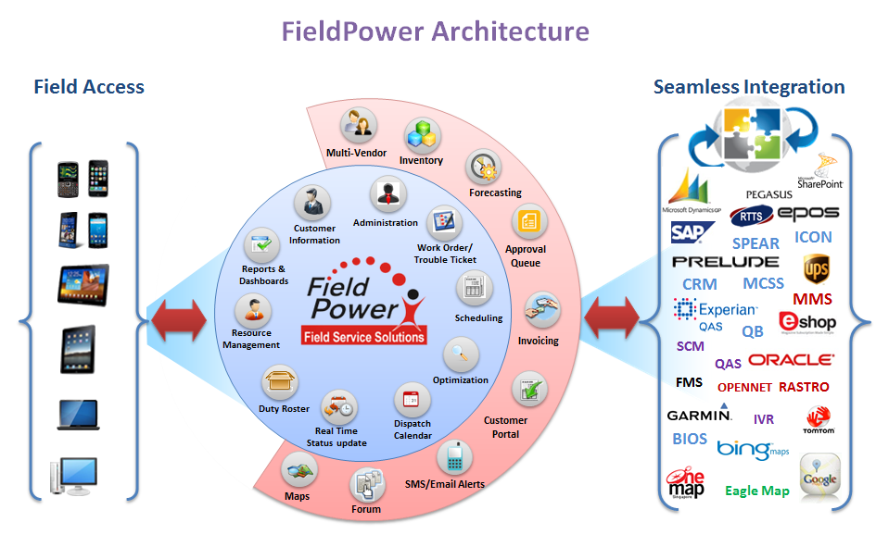

*FieldPower Architecture*

**Web Based Online Solution:** FieldPower is a secure web based solution. Deployment of the application is centralized, such that it simplifies the system maintenance and updates. Online hosting alleviates the necessity to download or update specialized software or hardware restrictions. The online hosted environment provides greater security and administrative controls, thus removing the risk from the hardware in the field.

**Master Data Management**: Master data includes records about technicians, vendors, service levels, parts, regions, routes etc. Master data is used to automate many of the decisions and transactions, and administrator configured business rules can be easily imported and maintained.

**Reports**: A variety of reports can be queried, generated, exported, printed, or emailed. A detailed history of transactions and results related to the Service Orders is available for reporting. Reports and graphical dashboards have drill down options to review high-level performance or low-level details with a single click of a button. Also, you have the controls to dynamically build a query, based on your preferences.

**Security**: FieldPower provides secure connections for data transfer between the browser and the database, by implementing SSL and data encryption as required.

* Secure login for each user, including Dispatcher, Technician, Vendor, and Customers
* Top ten security vulnerabilities as specified in the OWASP (Open Web Application Security Project), including cross-site scripting and SQL injection, are addressed.
* Sensitive data such as passwords, are stored in encrypted format

**Audits**: FieldPower provides complete audit tracking functionality for all business transactions. An audit trail log for each activity is maintained to track user, activity, and date / time.

* User login audit trail
* Application error logs
* Audit trail for master records (who and when the records are created or updated)

**User Rights Management**: User management and access privileges to the application are tightly controlled and configured with the role-based, access control module. System administrators create user roles, and assign access privileges over application screens, activities and print or export capabilities, to the created roles. Then, the administrators will assign roles to the applicable users.

**Scalability**: You have the ability to handle any number of Field Engineers, Vendors, Dispatchers and administrative users. You can create multiple regions to manage geographic groups of personnel.

**Inventory Management**: State-of-the-art inventory management enables you to manage parts by status and valuation. View the real-time inventory availability, allocated inventory, items pending return for credit, and items on order. Automatically assign the replenishment stock levels, manage vehicle inventory, and make better use of available internal stock reallocation, so as to minimize procurement costs. Tangible savings are realized when inventory and assets are properly managed.

**Forum:** FieldPower Forum is a place where Technicians and Dispatchers have the ability to start communication (in the form of posts) and reply to other Technician’s or Manager’s posts.  A member of the community in the forum posts a message, which is visible to everyone in that community.  Once read, there is the option to post a reply, which can also be visible to the community.  Thus, a discussion can build up without all users having to be online at the same time.

**Quote Management:** FieldPower supports comprehensive Quote Management processes. Quote Management enables to establish the special price quotations for existing products. FieldPower Supports Quote for Customers based on the Customer Enquiry. From Quote, the price of the Equipment/Parts will be checked, and if the cost is accepted by customer, then the quote can be converted into a respective Order. Quote Management is an optional module in FieldPower application.

**Sales Order Management:** FieldPower offers Sales Order Management processes. Based on the request from the Customer Products/Equipments/Parts will be sold to the Customers. Sales Order Management efficiently manages the complexity of different types of orders from multiple channels in a way that minimizes order entry costs, exceeds customer expectations, and ensures order profitability.

**Rental Order Management:** FieldPower supports Rental order functionality, by providing automation for all the order processes. Rental Management Solution enables equipment providers to maximize return on investment by maximizing equipment utilization. Based on the request from the Customer, Equipments will be provided on Rental basis.

## Features

### Customer / Site Management

Customer / Site management is one of the key capabilities of the FieldPower product. The following are some of the features of the Customer & Site management in FieldPower:

* Supports multiple addresses & contact details
* Manage Customer On Premise Equipment / Asset details
* Manage Business, Company or Consumer Residential Site
* Manage PM Schedules of the Customer
* Track Recent Order History by Customer
* Customer / Site Based Holidays
* Customer / Site based working hours
* Ability to set Preferred Vendor
* Maintain Customer Contracts

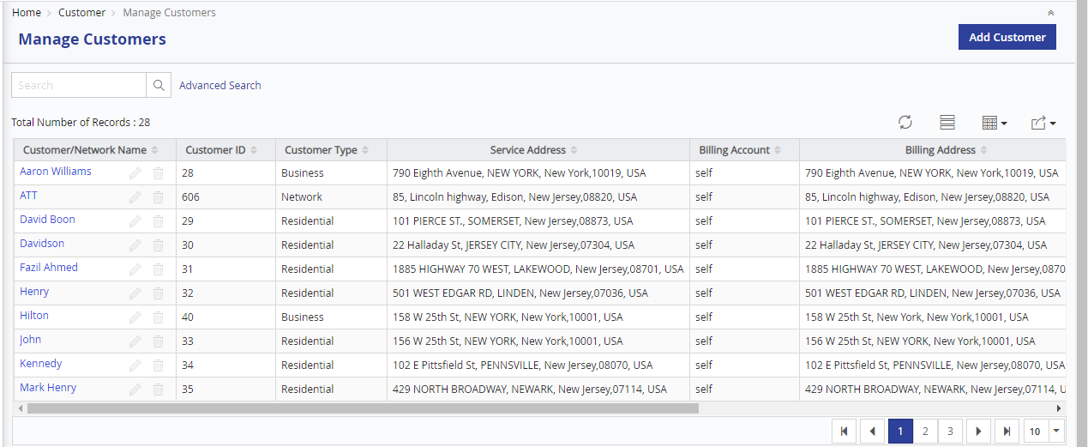

*Manage Customers - List view*

**Customer Details**

Customer / Site details screen enables the user to create a new Customer / Site or modify the existing Customer / Sites. Basic information like main address and other details are captured here. FieldPower generates unique id for each Customer / Site, which can be used for integrating the Customer / Site information with any other system.

**Multiple Address / Nodes & contacts**

Several Service / Node Addresses can be maintained for a single Customer / Site, from which one of the Service Address / Node can be made as primary. When a wok order is created for the Customer / Site, the primary service address / Node will be chosen by default. But the user will have the option to change the required service address / Node, which can be chosen from a lookup.

A Customer / Site can have multiple Contacts for each of the Service Address. One of the Contact would act as the primary Contact for the service address. The primary Service contact would be auto populated while creating the work order for the customer / Site.

**Equipment / Node Info**

This section allows the user to maintain Customer / Site equipment / Nodes. This equipment / Nodes can be mapped to one of the service addresses. The user can also define the SLA (Service Level Agreement) for the equipment / nodes. This SLA will be applied by default whenever a Work Order is created against the equipment / node. But this can be overridden and changed for individual ticket also.

**Recent Orders Tab**

The complete history of the work orders created for the Customer / Site will be listed in this section in the reverse chronological order, with recent order on the top. Also, the status of the work order when and by whom it was created will also be displayed. The Work order will be a hyperlink, clicking which the system will redirect to the work order details page, to enable the user to see the full work order.

**Attachments Tab**

The Customer / Site related documents and photos can be uploaded in the attachment section and maintained in the system.

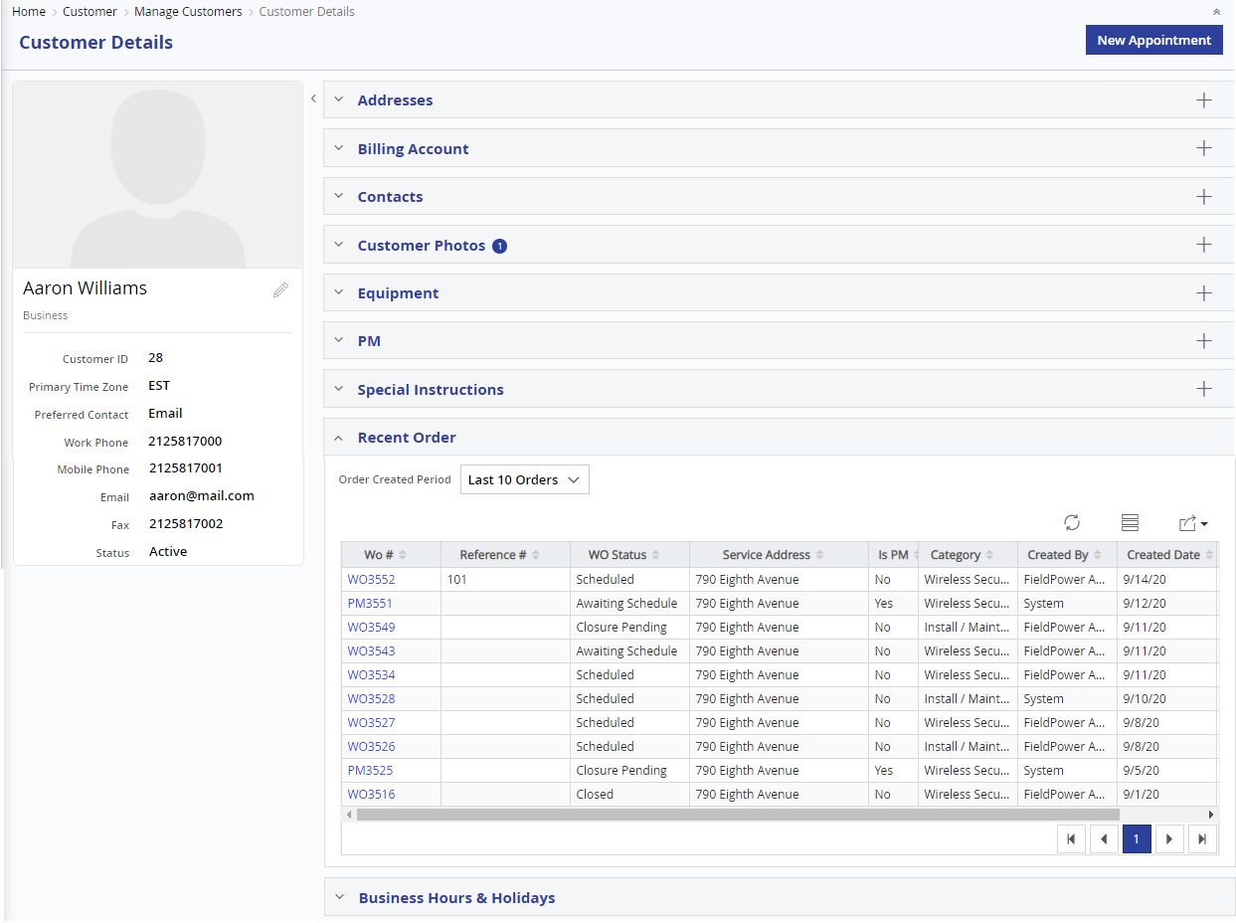

*Customer – Recent Order Details*

### Multi - Vendor Management

FieldPower has the capability to maintain multiple Vendors / Sub-Contractors. The Vendor Management System allows creation of multiple vendors and sub vendors. It also allows you to define multiple technicians against each vendor.

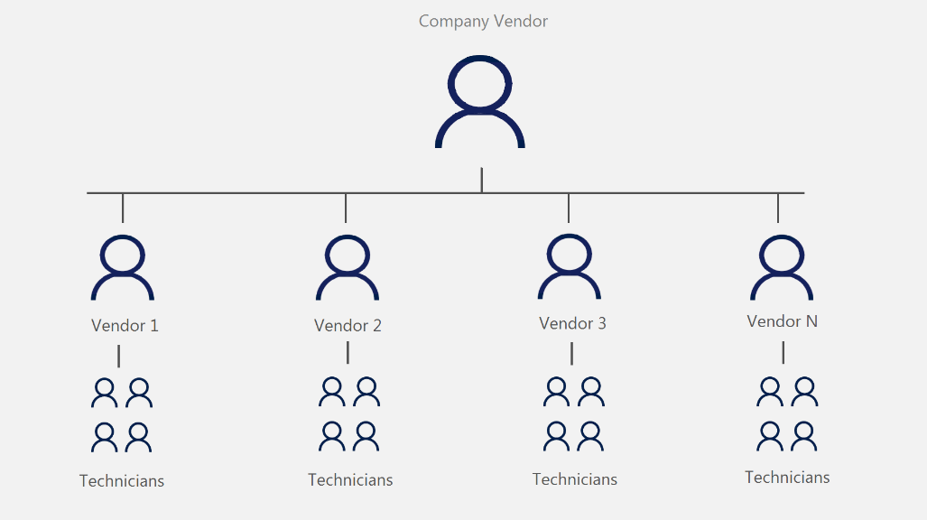

FieldPower Administrators can create different types of Technicians under each Vendor.

* + Field Technicians
  + In house Technicians

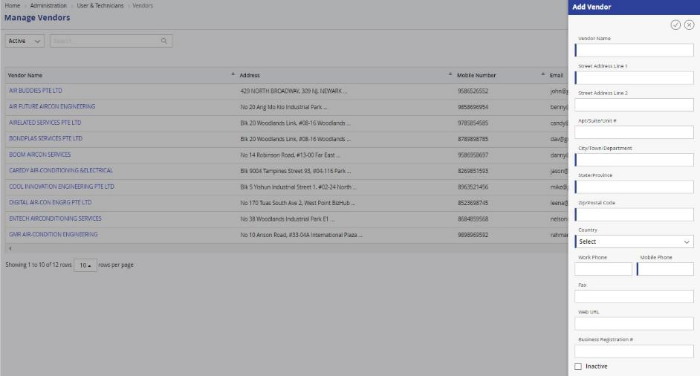

The Vendor Administrator has autonomous access privileges and can control it among his users. But your administrators can set boundaries for the vendor administrator to work within. For example, if your administrators provide access to the vendor administrator to have a set of screens, the vendor administrator can set access privileges only among these screens to his / her users. Also, the vendors can be set to work only in specific regions and also with specific types of work alone.

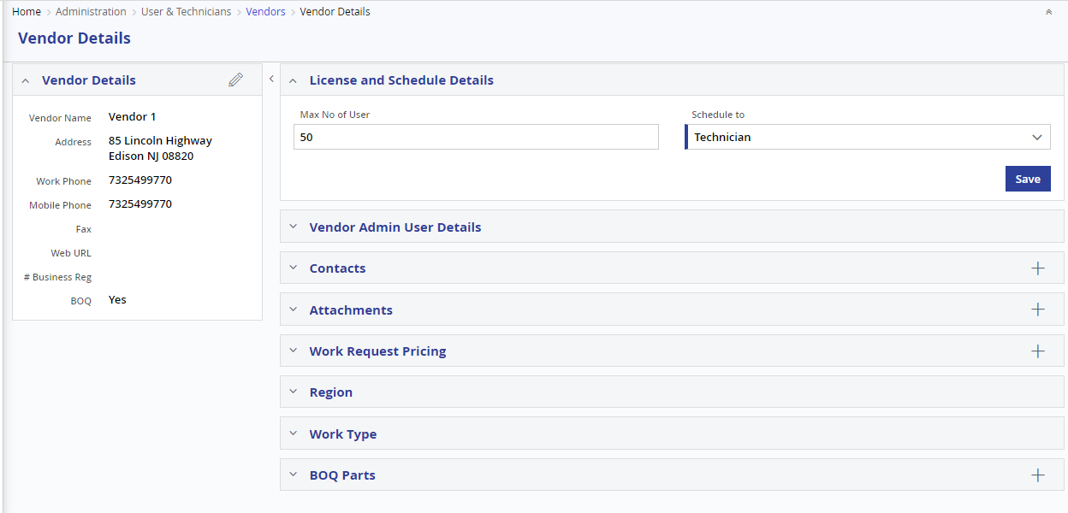

FieldPower will maintain the complete data encapsulation or hiding between the vendors. In this way, the vendors will feel safe about the data of their technician being visible to other vendors. The master entries like users, technicians and their related mapping with skills and certifications, created by one vendor will completely be hidden from another vendor. The vendor users like admins and technicians can only see their list of jobs and will be hidden all other details in all screens.

#### Dispatching to Vendor Technicians

The jobs can be scheduled directly to vendor technicians by FieldPower dispatchers or the Vendor dispatchers can schedule the jobs from the queue themselves, to their technicians. When the Vendor dispatcher sees the Work Orders list or the Dispatcher Board, he / she can see only the jobs related to them. They can then assign it to their technicians and monitor them accordingly.



### Preventive Maintenance Management

The Preventive Maintenance Schedules or the PM Schedules can be maintained and managed in FieldPower extensively. All the plans and inspection schedules can be created as PM schedules, and set to different frequencies like weekly, monthly, daily etc., The PM Work Orders will be created automatically by the system on regular intervals and assigned to technicians based on the various scheduling parameters configured like skill, certificate etc.

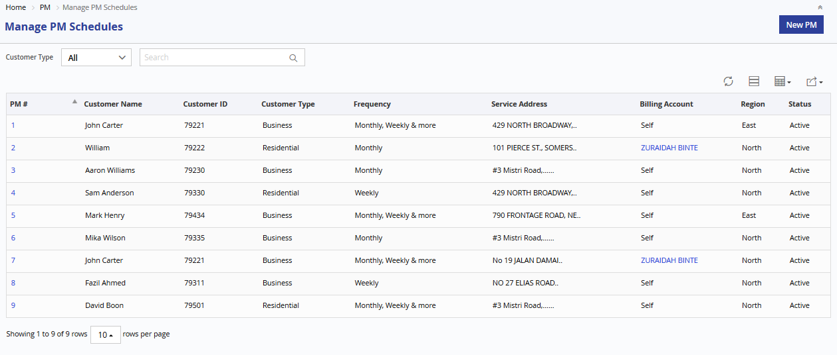

*Manage PM List View*

**Add/Edit PM Schedule**

Once the user selects the customer, the user can select the PM Start, End date and Recurrence Pattern for the PM Schedule. The user can then specify the job that need to be done in the PM schedule.

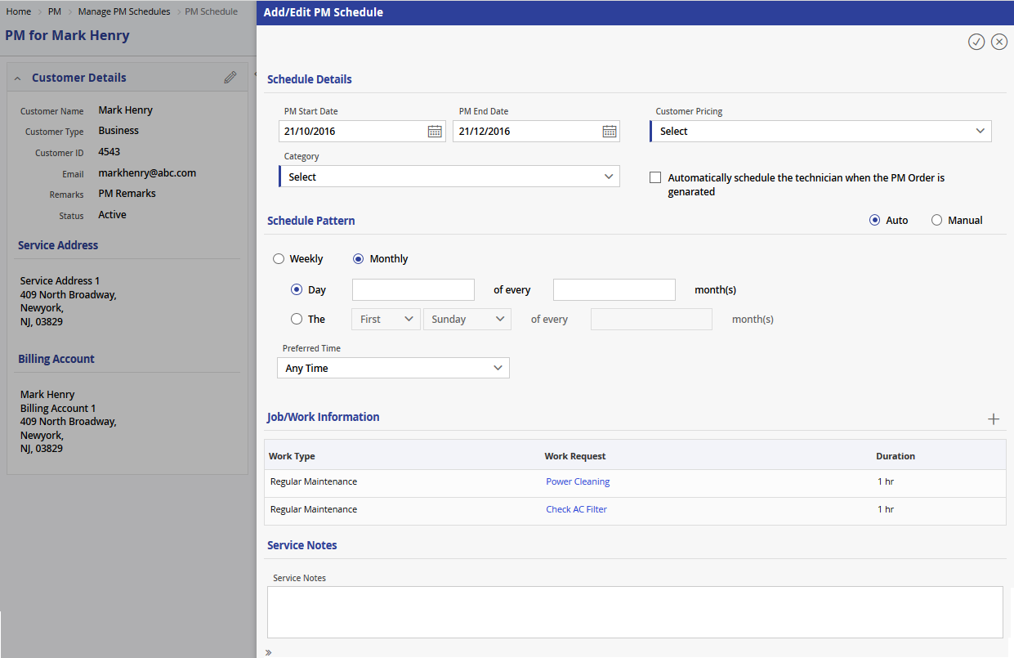

*Add/Edit PM Details*

**Add/Edit Equipment**

The Preventive Maintenance Work Order can also be set up for a specific Customer’s Equipment / Asset. This is an optional step and if specified, the schedule will be specific for the equipment / asset selected.

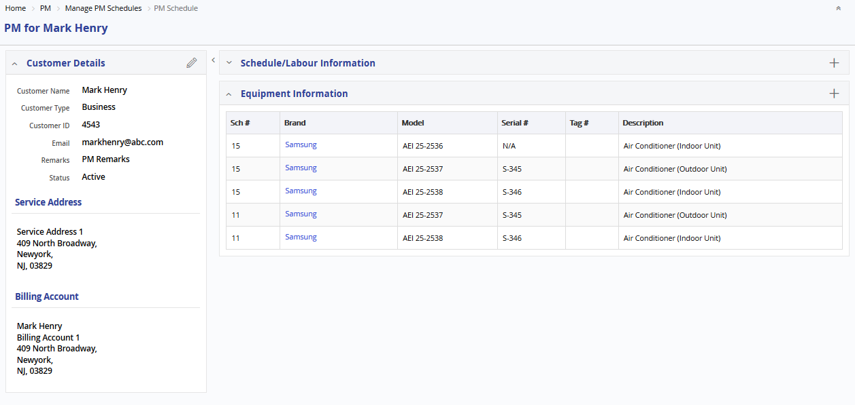

*Add/Edit Equipment Details*

**PM Work Order Full View**

Based on the PM Schedule Recurrence patter, System will automatically create a Work Order. The Work Order will have a legend “PM”, indicating that it is created using a PM schedule.

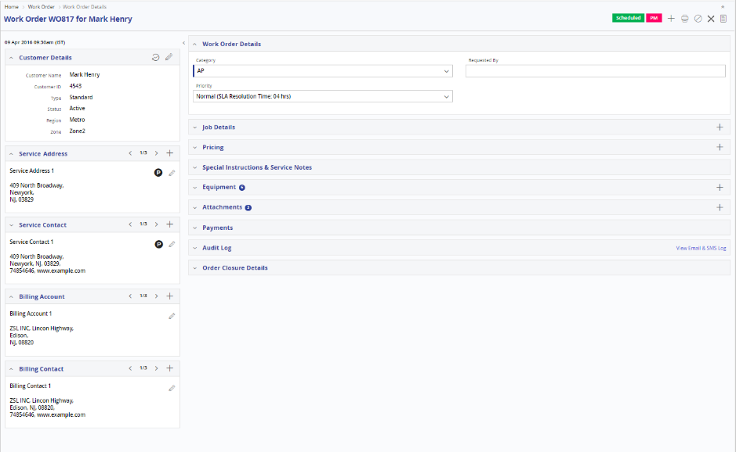

*PM Work order*

### Work Order Management

Work Orders decide the core business flow of FieldPower. The TTs can either be created in FieldPower or can be coming into FieldPower by integration with existing systems. In anyways, FieldPower gives the complete flexibility to manage even the complex Work Order. Work Order Management comprises the following features:

* Ability to Capture Customer & Contact Details
* Maintain Service Request Details along with their priorities and categories
* Maintain & Monitor Technicians Activities
* Maintain different statuses at job level, part request level and work order level
* Maintain & Monitor Spare Parts Requests
* Ability to add & Maintain Multiple jobs in a single Work Order
* Maintain Complete Audit history of the Work Order
* Visibility of the complete history of the earlier Work Orders for the customer and the equipment

#### Create Work Order

Creating a Work Order in FieldPower, with wizard like intuitive screen design, makes this task very simple. The ticket can be created by Admin or back office people or by the customer themselves (through the customer portal).

**Select Customer / Site**

Work Order creation starts with Customer / Site information. The Admin or back office users can search and select the Customer /site, with variety of filters provided like name, Type, Service Address, Billing Address, Contact name, Contact address etc. For the customer portal, this information is already pre-fetched with the primary address information filled in. The user can change the address if needed, by selecting a different service address / node. The users can check, whether there are any Pending jobs for this customer / site. If required, the user can add the new requested job to any of the Pending jobs for the customer / site.

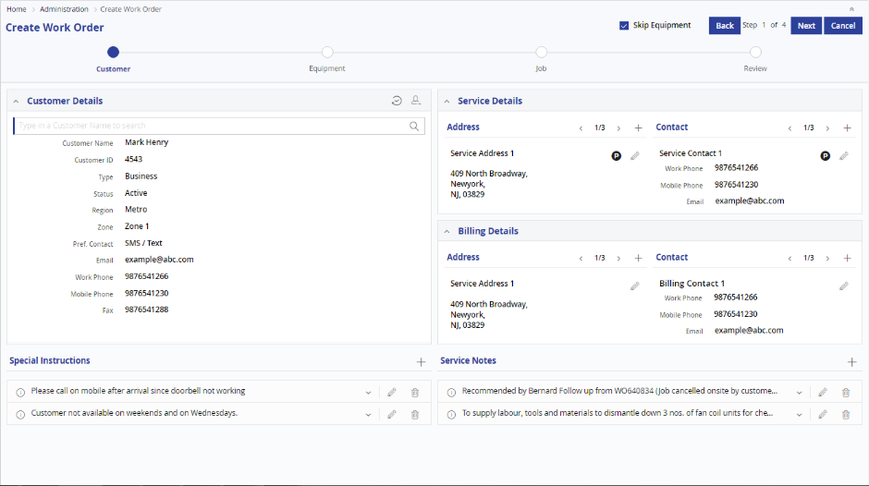

*Select Customer / Site*

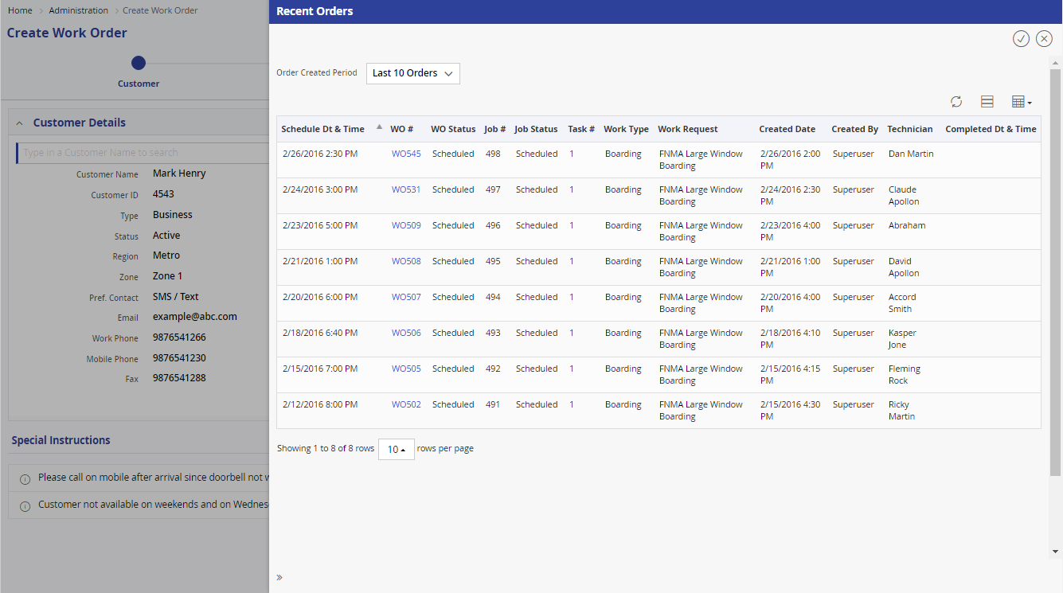

*Recent orders for the customer / Site*

**Select Equipment**

Upon selecting the customer /site information and the service location / Node, the users can search and select the existing customer/ Site equipment’s for the requested TT. The user can also add new Equipment to the Customer / Site, if the specified equipment is not available in the list. But this equipment step is optional and can be skipped. In this case the jobs will not be associated with any equipment.

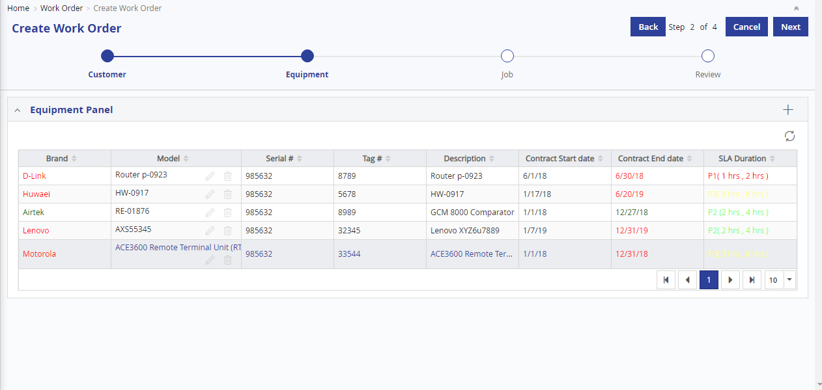

*Select Equipment*

**Select job Type**

As a final step, the user needs to provide the actual service / job type requested by / to be done on the customer / Site. FieldPower has the ability to add multiple Jobs to a job. These jobs can be assigned to same Technician or different technicians based on scheduling preferences.

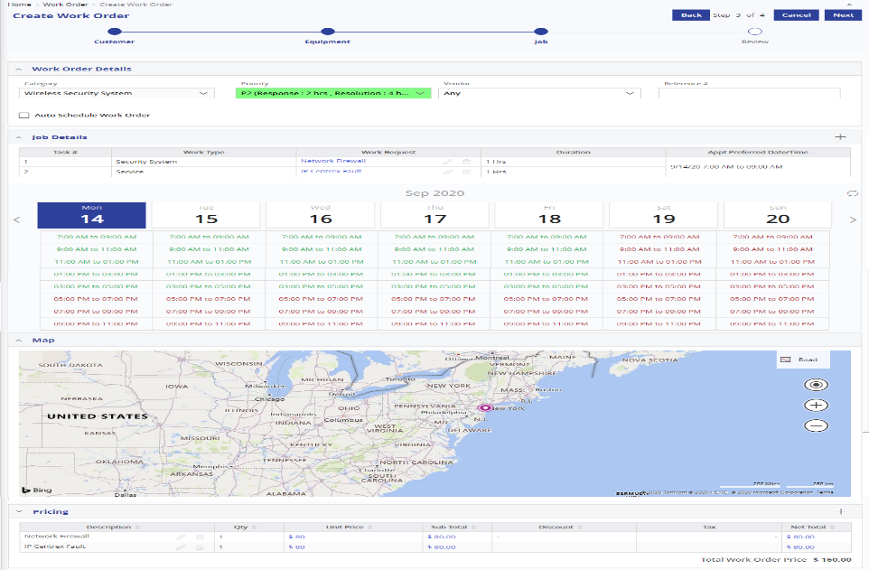

**Confirmation**

Before actually creating the TT, FieldPower summarizes all the information provided in the earlier steps in a single page. If required user can go to previous screens and make necessary changes. Once the user reviews and confirms, the jobs will be created and the system will display the job #, as a reference #, to keep track.

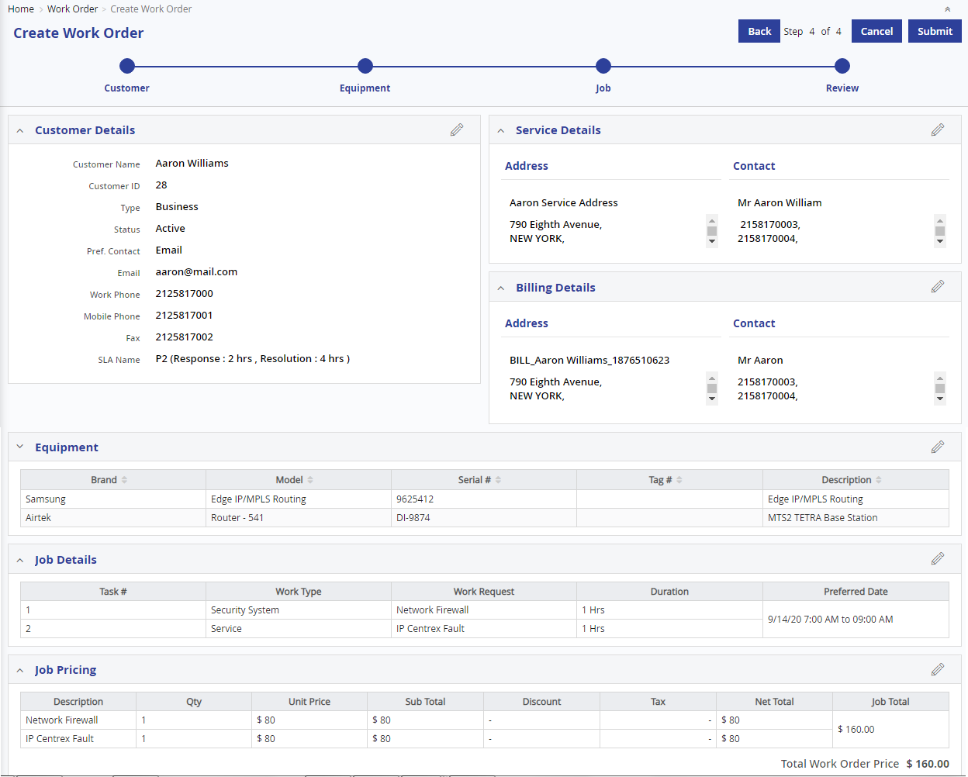

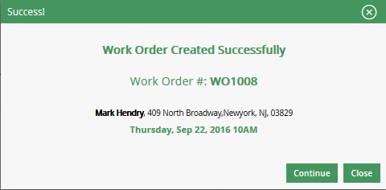

*Confirmation Popup*

#### Import Work Order

FieldPower provides the option of both upload and download option. Once we have downloaded the template and keyed in data and uploaded. The system is capable enough to create a work order automatically and assign it to the right technician. If the keyed in data are faulty then the system will identify the type of error using a hyperlink.

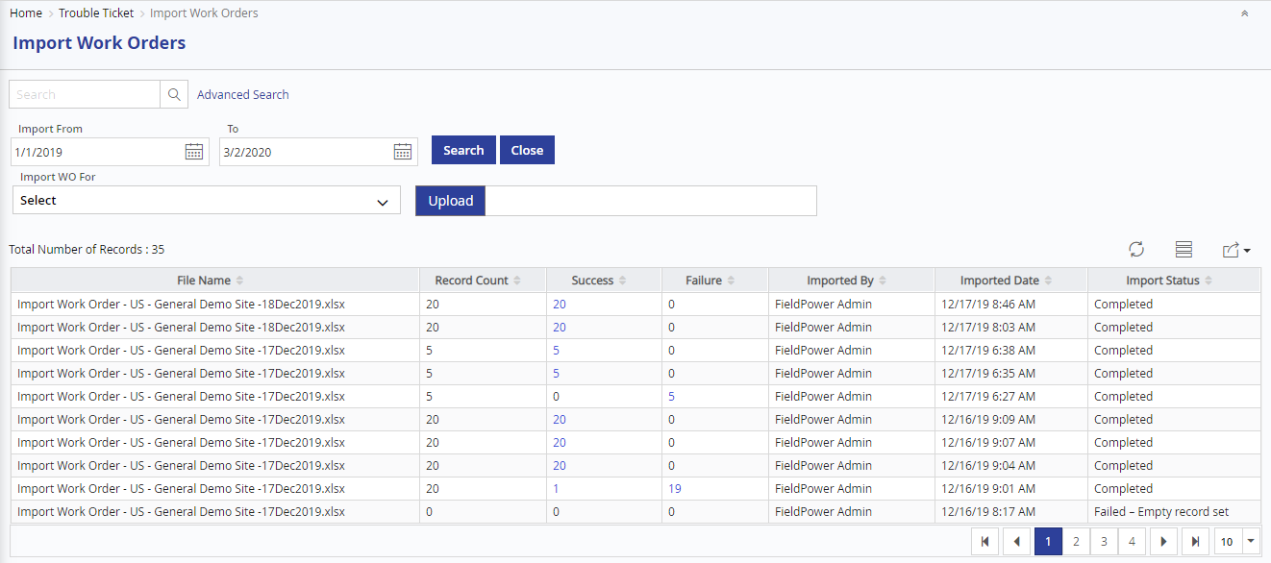

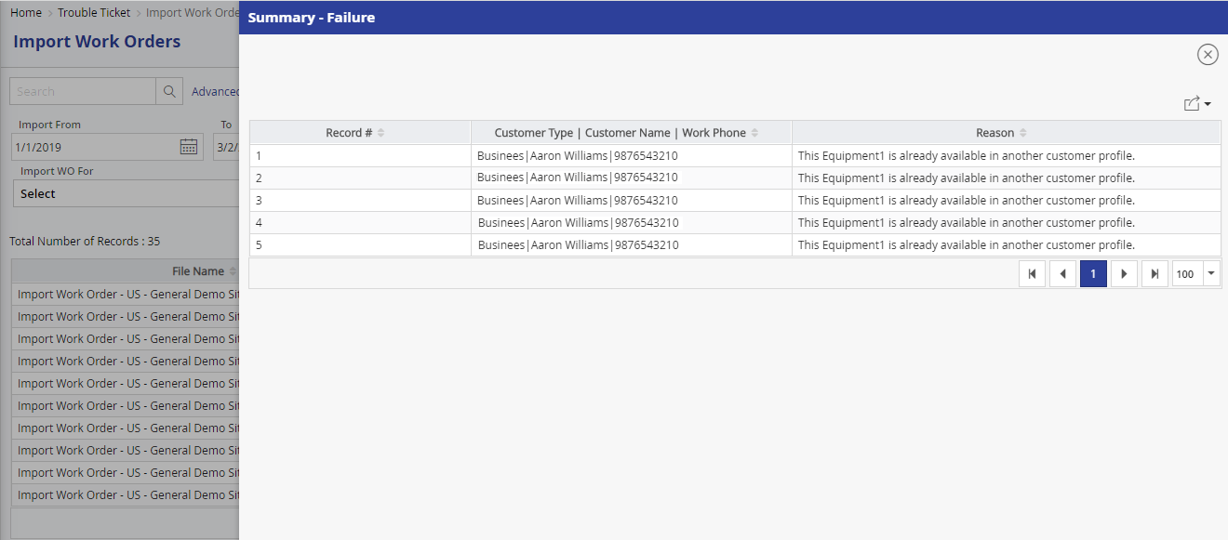

#### Attachment Section

This section of the work order will display all the attachments that are attached to the jobs in the work order. The attachments that have been specified in the WO master against the job type will also get automatically attached and displayed here. The system also displays a column displaying the geocode variations. Whenever a photo is taken and attached to a job in the mobile application, it will be stored along with the geocode / GPS information as to where it was taken. After uploading, FieldPower system will decipher the GPS information and compare them with the GPS location of the service location. If there is a discrepancy, the system will flag an alert. The system also has an intelligent way of discounting certain radius, which is usually 50 square meters.

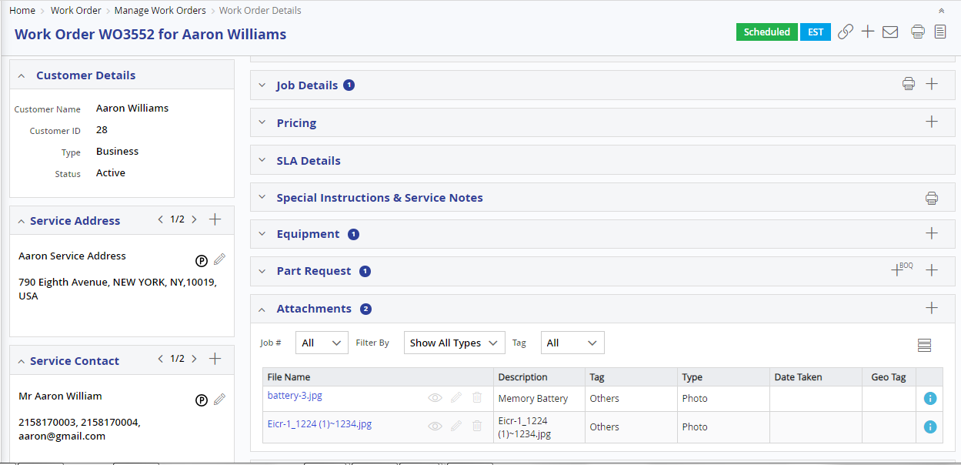

#### Work Order History (Audit Log)

All the actions done on the Work Order will be maintained by the system. The details are tracked right from the creation of the Work Order and each status as to, when it was scheduled, completed / unresolved and by whom. When each status is changed, and the history displays, who was responsible for the status change and when it was done. For example, scheduling a job to a technician, will change the job to “Scheduled” status. If this was done by manually, the dispatcher name will be displayed along with the timestamp of when it was done.

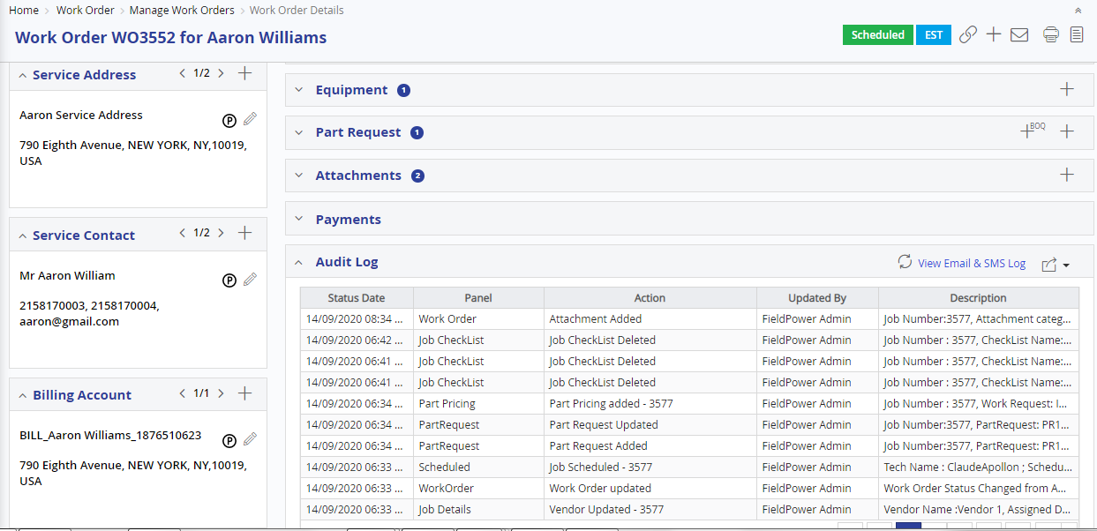

*Work Order Audit Log details*

The user will also have the option to view the previous Work Orders for the customer or the equipment, along with their status and links to navigate the user, to that Work Order.

#### Part Request

Whenever there is a requirement for a spare part, the part request can be raised by the technician / dispatcher. The detailed explanation of the Spare Parts inventory is explained in a later section.

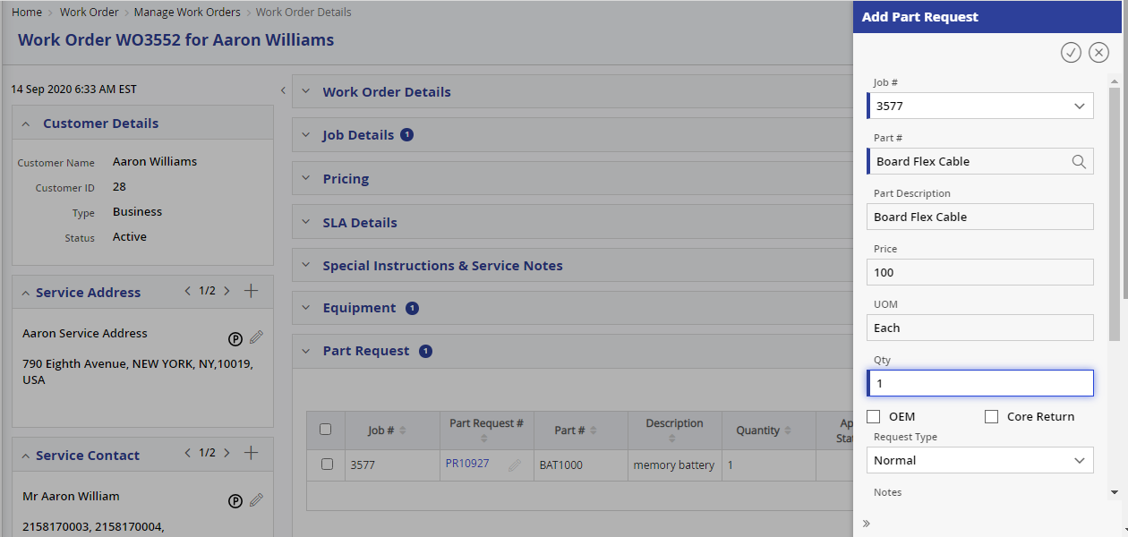

#### Work Order Closure / Approval

When all the jobs in a work order are completed, it goes to “Pending Approval” state. This is a manual approval mechanism, wherein the administrator or any user who is designated and has access privileges to approve will cross check all the job completions. If needed the customer satisfaction call / survey can be done by him before approving the work order. Once approved, the work order is closed and all the details are frozen and become not editable. The users can only view the information in the work order for reference purposes.

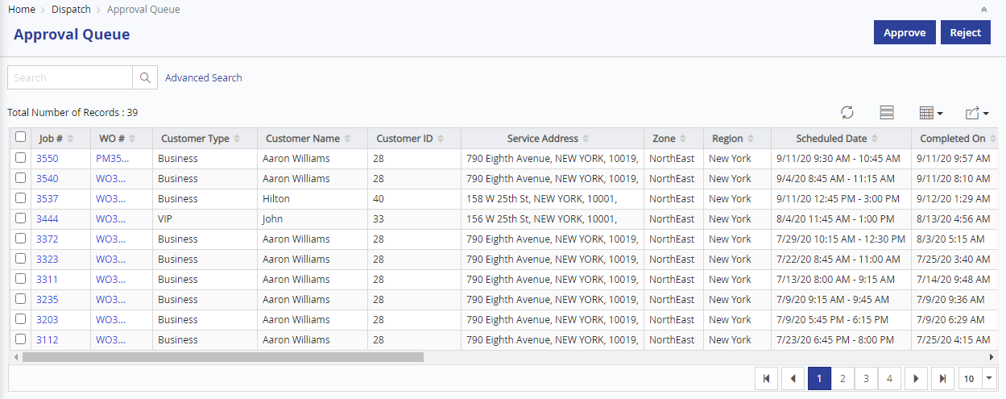

### Project Management

FieldPower solution on Project will have basic information like WBS and milestone management to ensure proactive tracking and management of works. Every project will be mapped to a single site where we can dynamically configure processes, SOW. The site will have all equipment information where the system shall have the capability to manage each site as an individual project, under which we shall have WBS info.

Manage projects List View will display all projects that has been created in FieldPower. Based on access rights, Admin user will have an access to Edit and Delete created projects. System will not allow user to edit if project is linked with other entities.

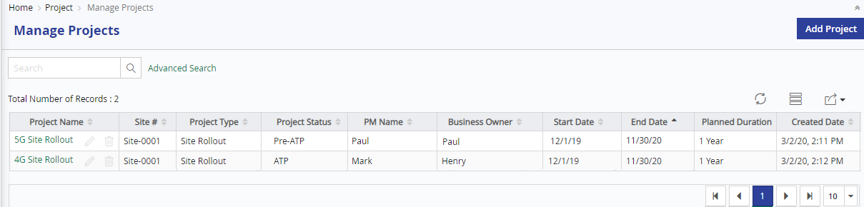

Manage project details view will display relevant details of specific project and admin can create project Tittle, attach relevant attachments, configure Special Instruction and Notes of this Project, Associate equipment based on Site.

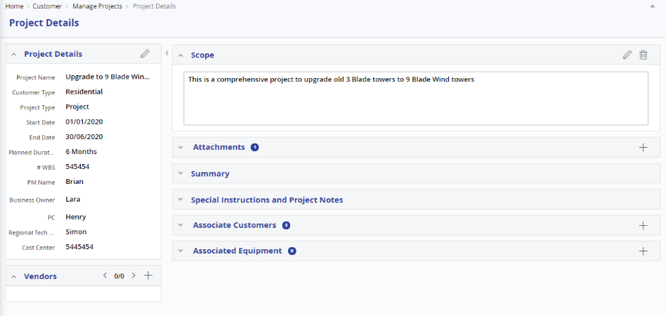

### SLA / Priority Management

SLA (Service Level Agreement) / priority of the jobs can be configured in detail by FieldPower Administrators. FieldPower offers flexible ways of defining SLAs with varied time measurements. The user can define priority first and consecutively the SLA Duration time for the priority in the same screen. Jobs should be performed / completed adhering to the applicable SLA.

SLA count down time will start based on the value defined in the “SLA Starts From” dropdown. The “SLA Duration” determines the response time within which the jobs should be Onsite or Completed or Unresolved with any specific reasons by the technician as configured in this master.

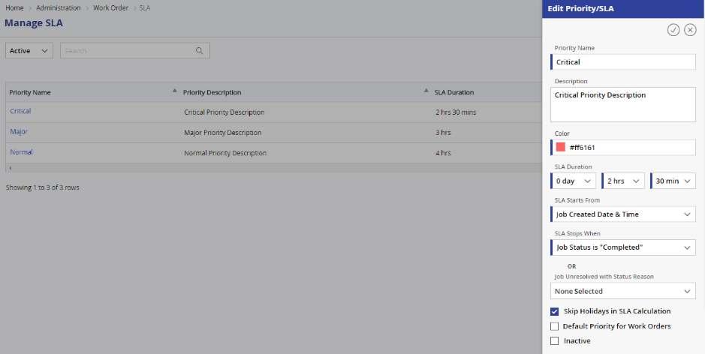

#### SLA Alerts

If the time taken to complete the job exceeds the defined SLA, then appropriate alerts will be displayed to dispatcher in Dispatch Board to take necessary actions in order to overcome jeopardy situation. The jobs which have not adhered to the defined SLA terms will be listed in the reports, so that admin user can take appropriate action to meet SLA terms for forthcoming jobs. This is also displayed in the dashboards also to enable the management to arrive at some statistics. In the work order page, the system has a section for SLA details. It displays the SLA details along with time remaining. It also displays whether the FO has met the SLA or not based on the SAL duration.

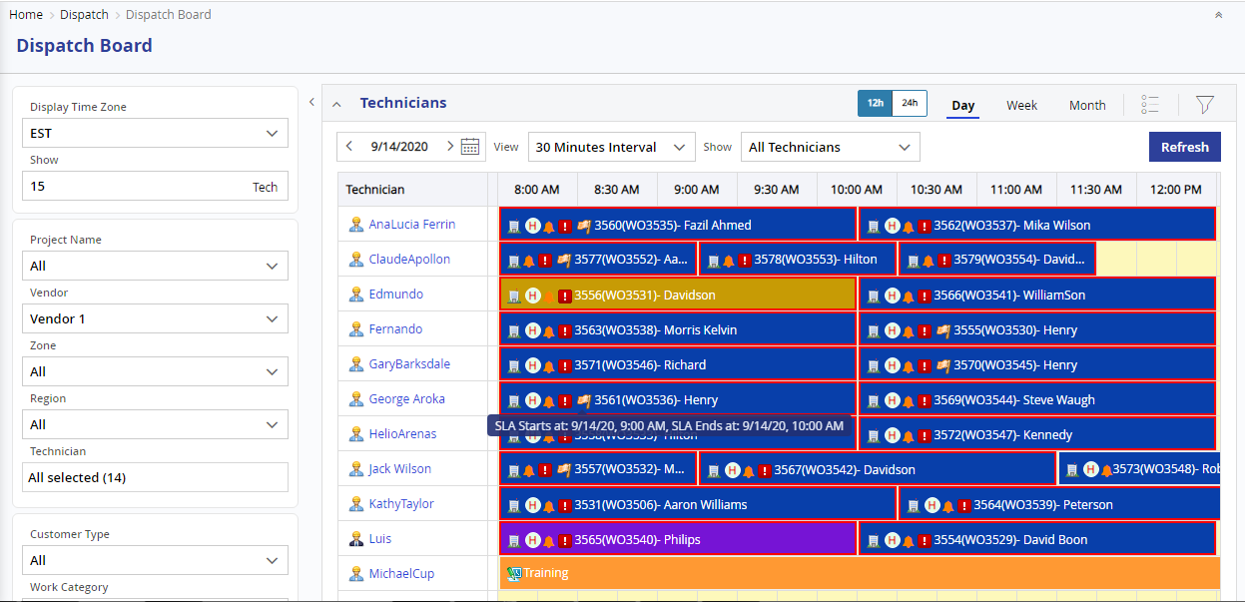

*SLA Alerts in Dispatch Board*

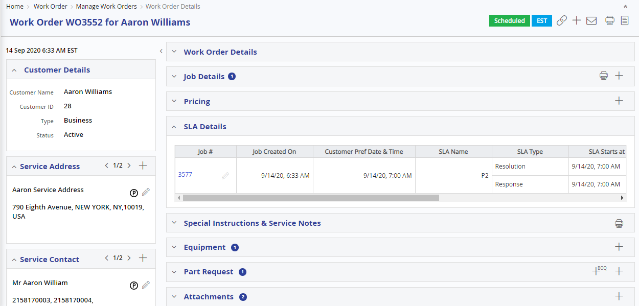

*SLA Details in Work Order*

### Scheduling Management

Scheduling is the core of the FieldPower application. Our unique, flexible, configurable, intelligent scheduling engine can handle complex scheduling requirements, based on street level routing, technician skills, certifications and driving time to the customer location, availability, cost factors, SLA response time, preferred technicians and spare parts availability. The Intelligent scheduling & Optimizing Engine can optimize the Field service performance with proactive and predictive business Nationwide.

FieldPower’s scheduling and optimizing engine can help you provide efficient service management and execution in these and other ways:

* Increase your first-time fix rates and customer satisfaction
* Decrease the MTTR
* Reduce costly breakdowns and bring service management efficiency to a new level

A Job in a Work Order can be scheduled automatically or manually based on the master/system configuration settings. Automatic Scheduling will assign the available best technician for a job based on the various configurable, scheduling criteria’s. As circumstances change, it continuously re-optimizes and redistributes the workload among the technicians. Automatic scheduling sets appointments without human intervention, balancing lowest cost, best customer service and SLA’s to schedule your priorities.

While scheduling multi-technician / crew jobs, the system will check that the required technicians are all available. If they are all available at the right time, only then will the system schedule the job.

Typically, 40% of service events are rescheduled, modified service, or otherwise adjusted before completion/execution of Field Technicians. This requires flexible systems to adapt intelligent algorithms in a) continually monitoring and b) applying logically best decisions/assignments based on (I) changes in resources – availability etc., thus accommodating unexpected delays/jeopardy either by Field Technician, or in direct response to changes in customer requests. When such impacts are dynamically rendered in real time, FieldPower re-optimizes through its algorithm the next or the best available choice/option based on customer preferred time to make an informed decision to a customer service.

#### Scheduling Preferences

The Scheduling Preferences screen is used for configuring the parameters applicable for Scheduling. Based on these settings, all the scheduling activities will happen in the system. In Automatic Scheduling and Optimization, the scheduling variables will be automatically applied and the user cannot override the values. But in the manual scheduling screens, the system will only warn the dispatcher, if any pilferage happens to the scheduling preferences set. The system will then allow the user to override these settings, but will keep a record of the override that has happened.

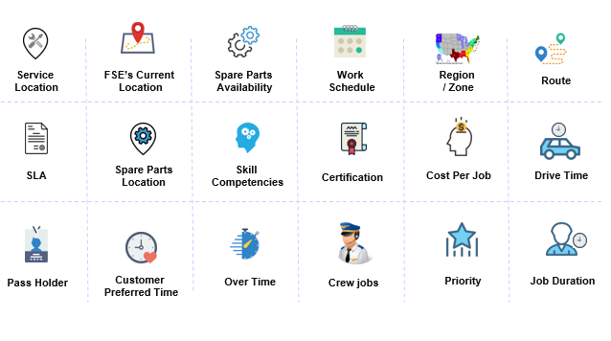

*Automatic Scheduling - Configuration*

**Street level routing capabilities**

FieldPower has integrated with Google maps and provides the functionality to optimize the street level routing. It allows the dispatcher to optimize the travel time for all the jobs scheduled to the technician. Route optimization reduces the travel time for the technician in an efficient way to increase available productive time.

**Drive Time Calculations**

FieldPower has the capability to arrive at drive time based on one of the following configurations:

1. Actual drive time
2. Straight line distance.
3. Fixed travel time.

**Actual drive time:**

If the type is “Actual Drive time distance”, then the distance between customer address (Destination) and technicians address (Current location) will be calculated with the help of Google or other GIS data. The drive time arrived in this option would be exact and will match the technician’s route taken for the job.

**Straight line distance:**

If the type is “Straight Line Distance”, then the system will calculate the distance between the address using a formula, which will just give the distance between two lat, long coordinates. This won’t take the spatial data or roads into consideration.

**Fixed travel time.**

If this type is chosen, for each task / Job, a fixed travel time will be considered. It does not vary for both the customer as well as Technician location.

#### Key Benefits of Scheduling

* + Skill based Scheduling
  + Skill Level based Scheduling
  + Technician Certification based scheduling
  + Region / Zone based scheduling
  + Job Type based scheduling
  + Customer Preferred Technician
  + Restricted Area Restriction
  + Site Accessible Hours
  + Overtime based scheduling
  + Assign technician based on Nearest Location
  + Assign technician based on technician costing
  + Schedule based on customer preferred date and time
  + Actual travel time based scheduling
  + Straight line distance/time based scheduling
  + Fixed travel time based scheduling
  + Option to Ignore Sundays and Public Holidays
  + Option to choose various Job duration options – Job type based duration / flat time
  + Allot multiple technician to a job based on job type setup
  + Priority / SLA Based scheduling
  + Parts Availability based scheduling
  + Technician GPS Location based scheduling

#### Methods of Scheduling & optimization

**Trip sheet Method – Nightly Run / One Time Run**

* + - Optimization Scheduler Runs Midnight before the day starts
    - Takes all the Scheduled / open jobs and Optimizes it for least distance between the jobs, starting either from Technician Home or Office location

**Drip feed Method – Continuous Optimization**

* + - Optimization Shuffler Runs every few hours to rearrange the sequence of the jobs based on the Scheduling Preferences (Market, Priority, distance etc.)
    - Optimizer takes all the scheduled / open jobs and Optimizes it for least distance between the jobs, starting either from Technician Home or Office location

#### Manual Scheduling – Work Order Page

There are two ways of doing manual scheduling, one using the dispatcher board and the other using the Manual Scheduling popup in the Work Order page. In both cases, the user will have the list of eligible technicians matching the scheduling criteria, along with their distance and available time. The user can use the various filters to override them and assign the job to the desired technician.

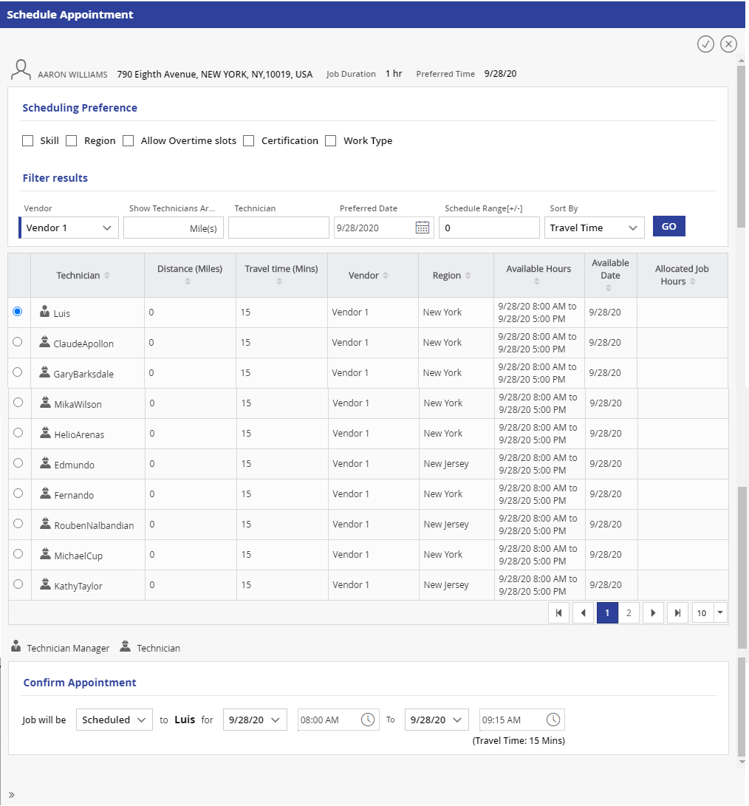

#### Automatic Scheduling

Whenever a job is created, either manually or by a PM schedule or by integration with other systems, the FieldPower tries to schedule automatically, based on the settings in the job master. Automatic Scheduling assigns the available best technician for a job based on the job and the scheduling preferences set by the administrators. As circumstances change, like technician falling sick or unavailable or rejecting the jobs, it continuously re-optimizes and redistributes the workload among the available workforce. Automatic scheduling sets appointments without human intervention, balancing lowest cost and best customer service. Automatic scheduling fits the changing needs of your business, winning the trust of your dispatchers and schedulers by enabling them to work flexibly in automatic or manual scheduling modes to suit customer needs and experience.

#### Route Optimization

FieldPower has its own in-built intelligent algorithm to match the best fit of Technician to job using continuous route optimization. “Route Optimizer and scheduler” is used to provide the lowest operational cost to the customer by ordering the jobs that are scheduled to a technician in proper sequence. In other words, the Route optimizer shuffles the jobs in a day by changing the order of the jobs, so that that total distance travelled by the technician is lowest. But the optimizer intelligently keeps in mind the SLA and the customer preferred time and shuffling happens accordingly.

### Dispatch Board

FieldPower’s Dispatch Board is designed to provide the look and feel of a Gantt View. The real-time dispatch view allows you to reassign work (System will suggest the alternate Technicians), text the technician, receive confirmation of time of arrival at the customer location, and display driving directions – all in one place, at one time, and while keeping a complete history of events.

Dispatch Board comprises of the following features:

* Drag and Drop functionality
* Manually override the auto-assignments
* Reschedule/Cancel/Complete the jobs
* View State wide, Region wide, Technician wise and Appointment date wise scheduled jobs
* Track Assigned works
* Track Planned work time
* Track Actual Travel/Work time
* Off Time/On Duty details
* Task details allotted to a technician
* Alerts to the Dispatcher
* View the completed jobs

**Unassigned Tab**

Jobs which are in Open and Unresolved status will be listed in the Unassigned tab. These jobs can be scheduled to the technicians by dragging them and dropping them against the relevant technician at a suitable time slot. Alternatively, the system suggests the list of technicians who match the scheduling criteria for the job and who are available. The dispatcher can assign it to the suggested technician by just selecting the technician.

**Jeopardy Tab**

Jobs which are in danger of deviating the scheduled date and time will be automatically moved to the Jeopardy tab. The dispatcher / admin user can reschedule Jeopardy jobs to other suitable technicians at a different date / time.

**Real Time Status Updates**

Whenever a status of a job is updated by technician, the same is reflected in the dispatcher board instantly. The jobs are colour coded, so that the dispatcher / supervisor can see the status of jobs by different colours. The dispatcher board can also be set to refresh automatically every specified minutes, as configured in the system settings.

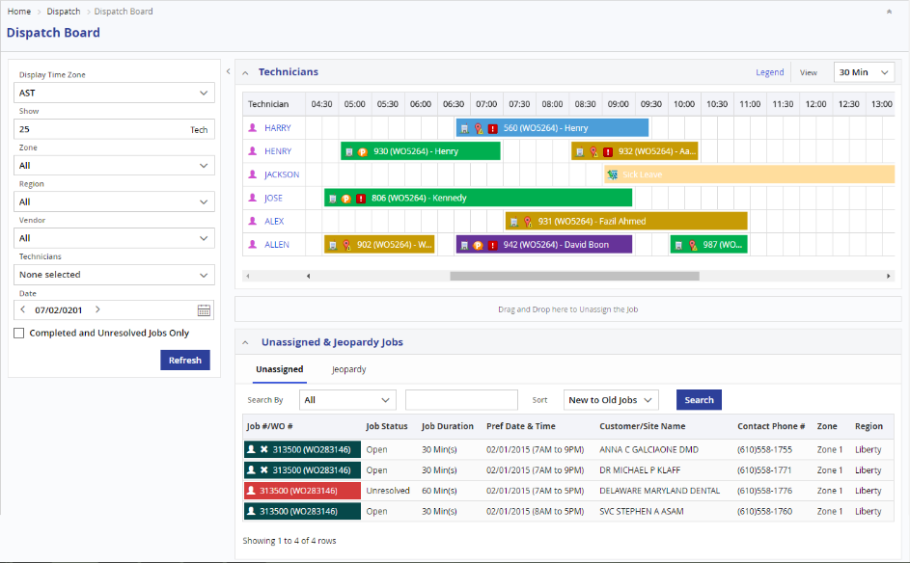

*Dynamic Dispatch Board – with provision to Schedule using Drag & Drop and monitor the progress of Jobs*

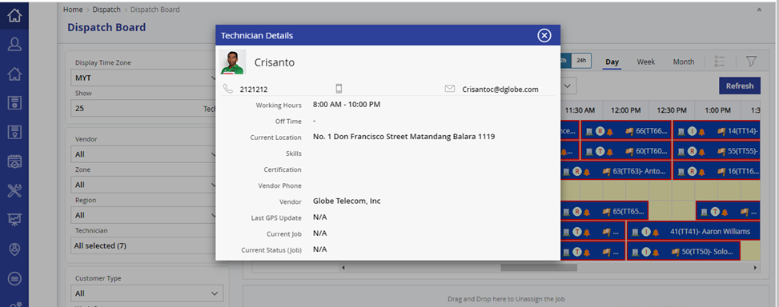

*Dispatch Board - Technician Popup with profile photo (when clicked on a technician name)*

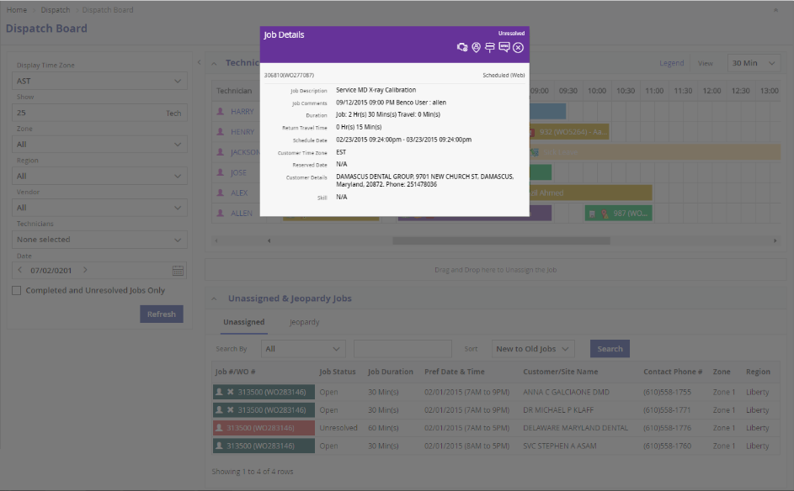

*Dispatch Board - Job Details Popup (when clicked on a job)*

**Drag & Drop and Parameter Mismatch Message**

Rescheduling a job in the dispatcher board can be done by just dragging the job and dropping it in the timeslot of the required technician. When a job is dragged and dropped against a technician FieldPower verifies the scheduling parameters and will warn the user if any of the scheduling parameter is mismatched. The dispatcher can then choose to override or not, by providing valid justifications in the comments.

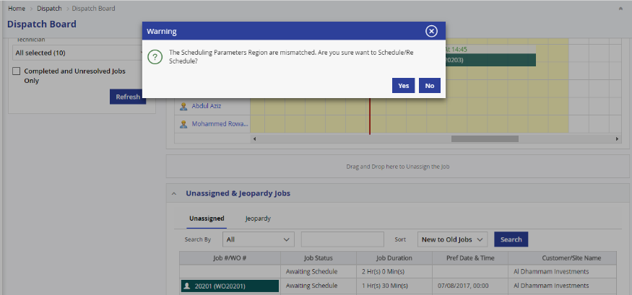

**Attention Required**

The Dispatch Board will prompt an “Attention required” flag for those jobs which require the immediate attention of the dispatcher/supervisor. These “Attention required” flags, can be set in the system settings screen by the user. Upon seeing the alert, the Dispatcher can take appropriate action.

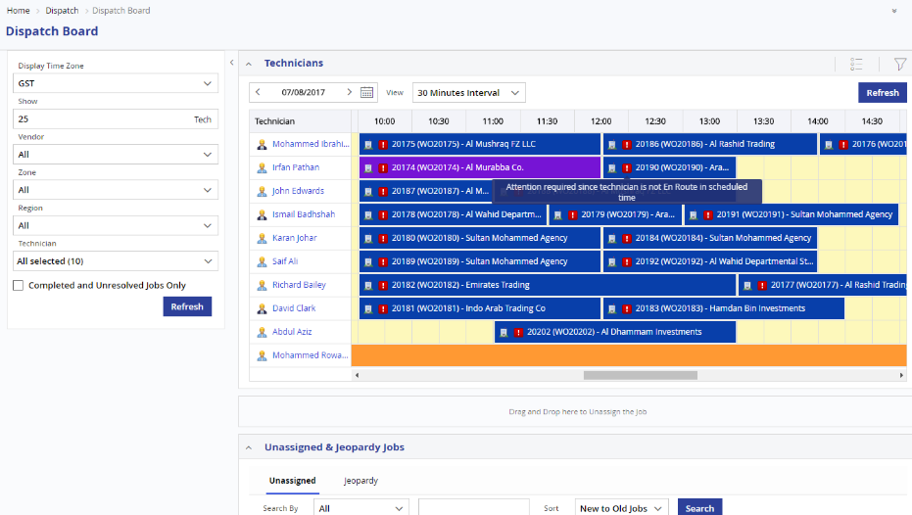

**Suggested Technician**

For each job, the system will display the list of technicians who match the scheduling parameters and can be assigned alternatively. The dispatcher can use this option to take a guided decision.

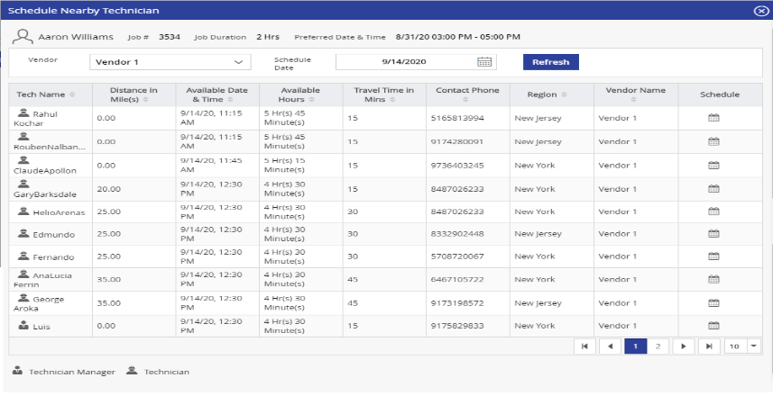

*Dispatch Board - Suggested Technician Details*

**SMS to Technicians & Customer**

For each job assigned against a technician, the Dispatcher can send SMS to the Field Technician and Customer, to get the immediate attention from Technician and Customer. Technician’s name, mobile number and the job details will be auto populated in the Confirm SMS popup. The dispatcher can add / edit the text as per the needs, before sending the SMS.

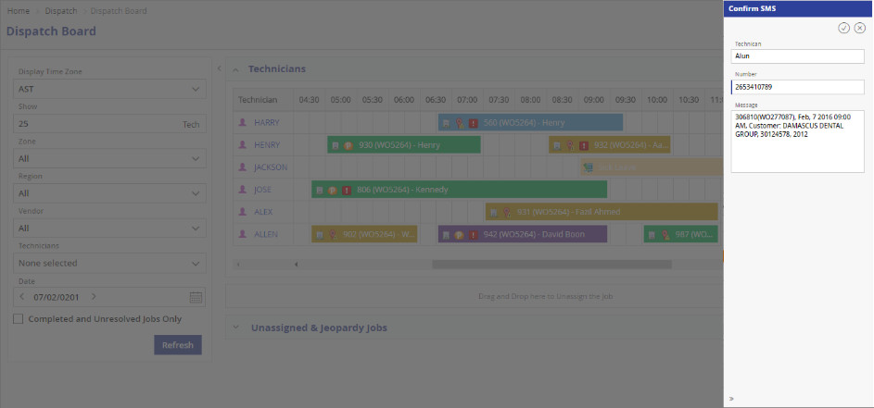

**Driving Directions**

The dispatcher can see the route / driving direction for each of the jobs. He can view this and give turn by turn direction to guide the technician.

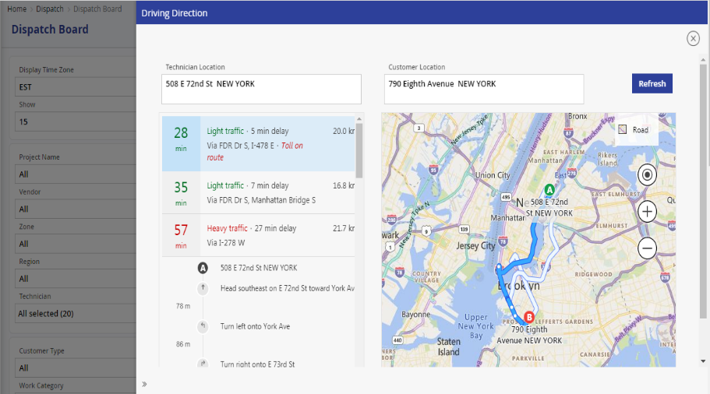

### Notification Alerts

FieldPower has various ways of notifying the users / administrators on the happenings of the application. These can be auto-generated SMS, Email or on-screen notifications.

#### Auto SMS and Email

The Email & SMS that are sent from the system, can be configured through the template screen provided in the administration section. Using this screen, the admin user can create Email & SMS templates based on each of the Job Status, like scheduled, unresolved, completed etc., He / she can also decide on the target audience for the Email & SMS. Admin user can select the fields to be displayed in the content, set Font name and Font size (Email template) etc. These templates can be used for escalation notification of Jeopardy jobs, rejected jobs, unresolved jobs etc.

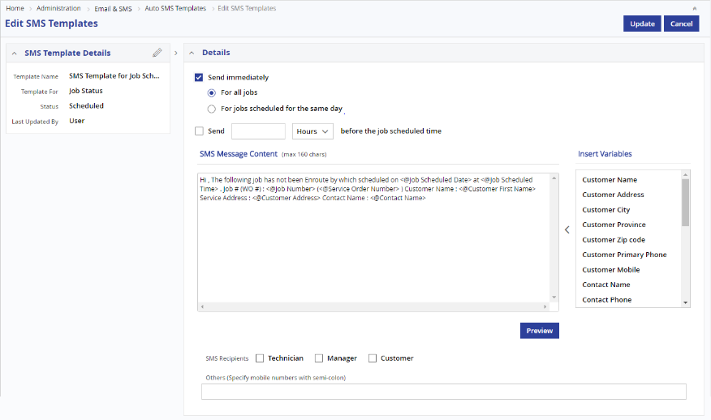

*SMS Templates*

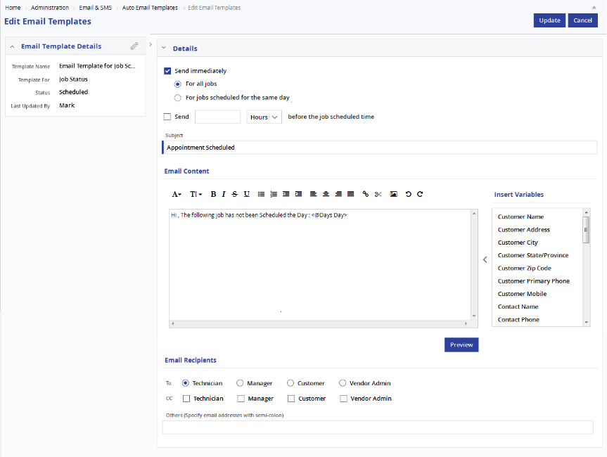

*Email Templates*

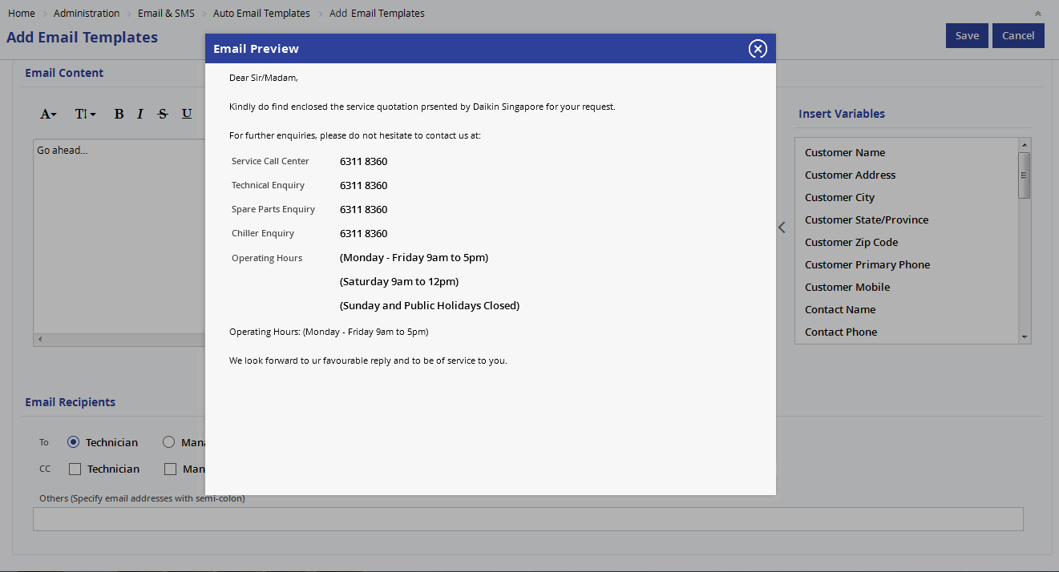*Email Templates - Preview*

#### Broadcast Message

There are certain situations, wherein the SMS or Email need to be sent to all users or set of users, irrespective of jobs. To enable this, FieldPower has the option of Broadcast Messages / Bulk Messages.

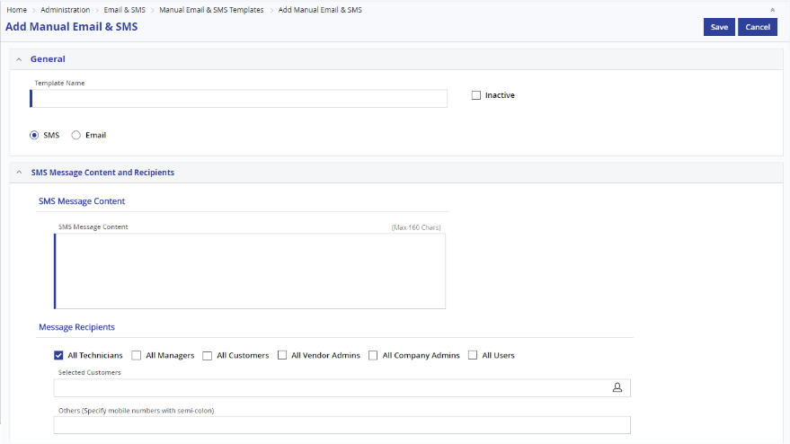

#### Attention Required

If a work order is assigned to a technician, he has update the status as planned. If he is not responding, system will display an alert in the dispatcher board. The dispatcher can act upon it and resolve the same. The settings for this alert like the duration can be set in the system settings by the admin user.

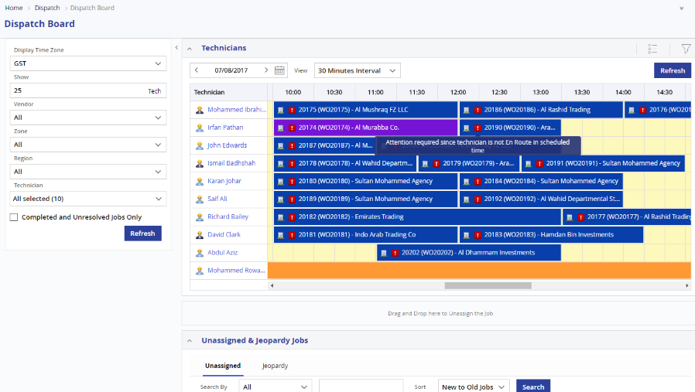

#### Delay in completing the Job – Jeopardy Queue

FieldPower’s Dispatch Board has a dedicated tab to display all the jobs in Jeopardy situation. Jobs which are in danger of deviating the scheduled date and time will be automatically moved to the Jeopardy tab. The dispatcher / admin user can reschedule Jeopardy jobs to other suitable technicians at a different date / time.

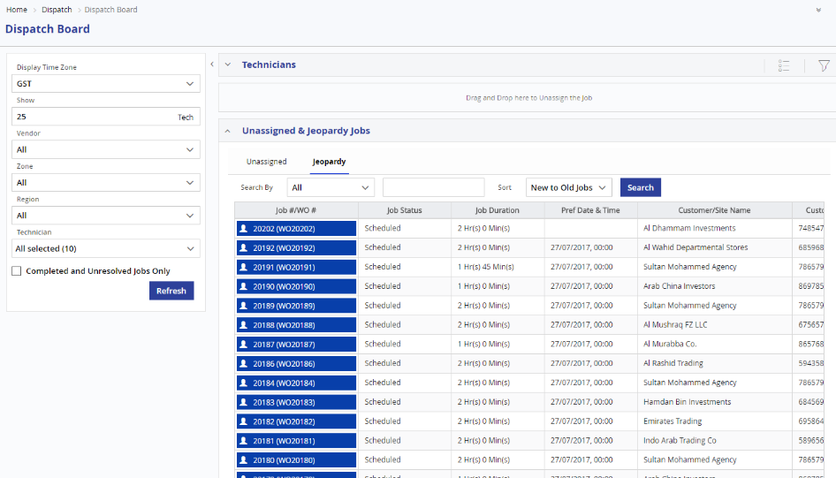

*Jeopardy Jobs - Tab*

### Tech Availability Management

FieldPower allows the admins to provide technician availability using the Duty Roster / Tech Availability screen. The technician availability / duty roster can be viewed as day view or week view. Admins can provide information about the technicians’ availability / unavailability / off times here either for all or for selected technician. The scheduling engine will use this availability for assigning jobs to the technicians.

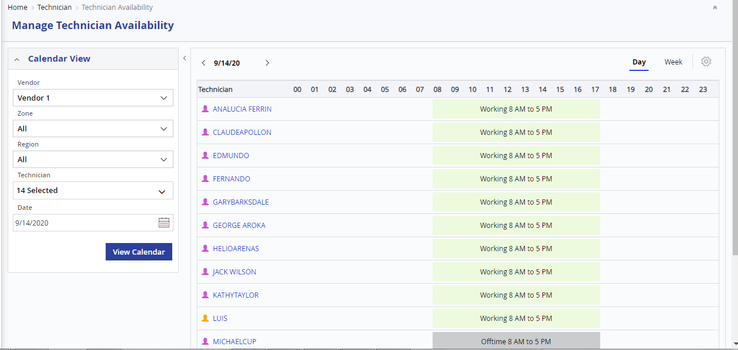

*Duty Roster – Day View*

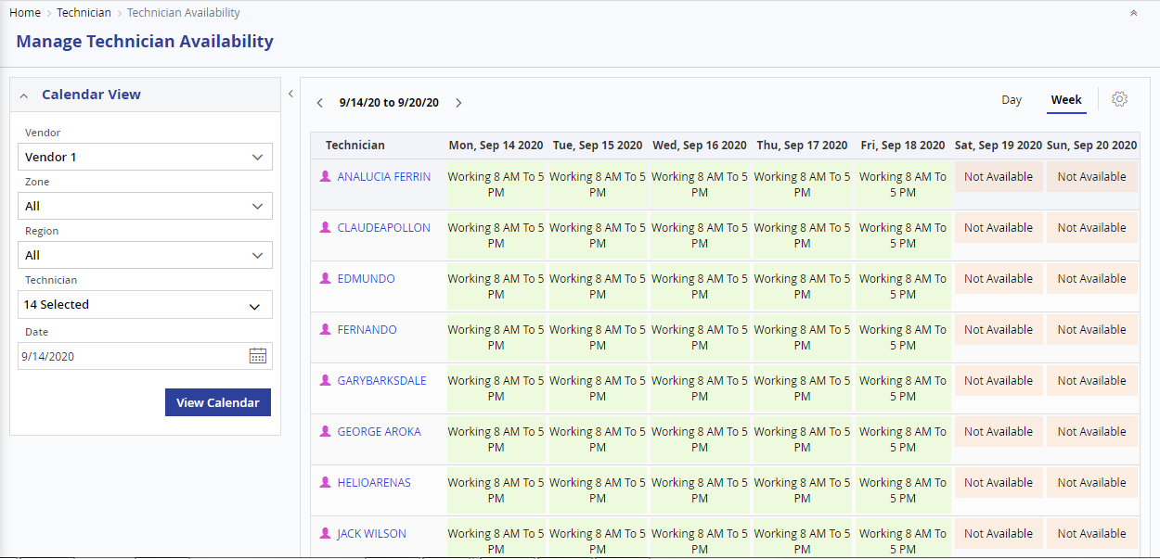

*Duty Roster – Week View*

### MAP Functionalities

Live Map gives us a map based view of all the field activities. There are 3 different Views provided for the map

* Technician Only
* Jobs Only
* Technician & Jobs

The default feature in FieldPower live map is Jobs Only view. This will display the location of all the jobs, country-wide for the specific vendor based on their status and Geo location.

In addition, the user has Category dropdown, status dropdown, regions and district as filters, to narrow down the required technician or job. Based on the District the technician dropdown will display all the technicians currently registered in FieldPower with mobile device will be displayed. The user can select one or multiple technicians from the drop down to track them very specifically. However, to view the History of the technician's movement for the day the supervisor has to select one technician from the list. Using the Date picker, the user can view the technicians and Jobs status for previous/future dates.

#### Technicians Only View

In Technicians only view, System will display the Current location of the technicians. **Stopped Technicians** will be displayed in **red colour,** idle techniciansin **Golden colour** and Driving **Technicians** in **green colour.** Icons display is based on Zoom level in the map.

When the user hovers the mouse over a technician icon, the technician details and the jobs assigned to him will be displayed.

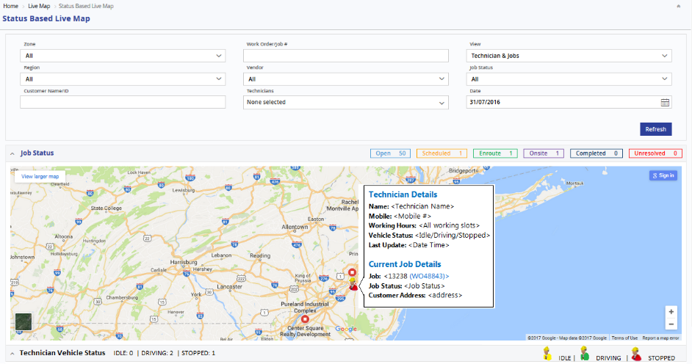

#### Jobs Only View

Jobs Only View displays the Jobs for current date as icons.

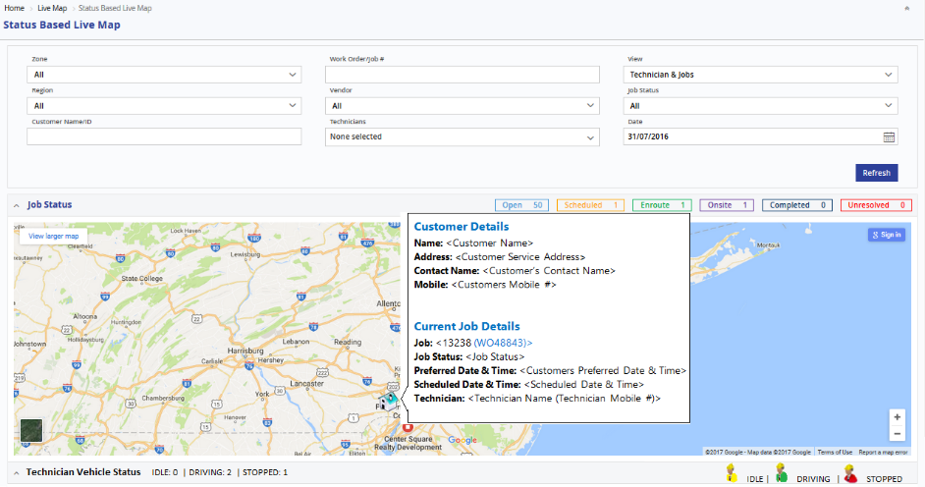

If the user places the mouse over the Home icon, system will display the Job details.

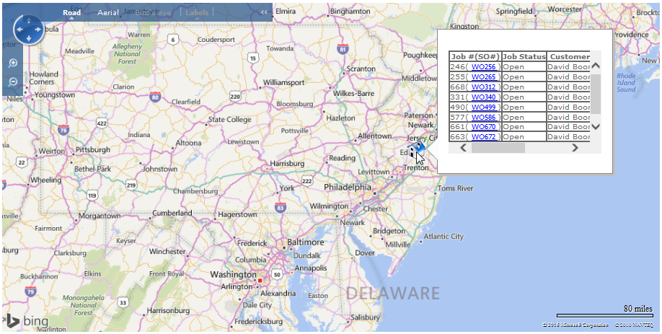

#### Technician & Jobs View

Technician and Jobs view is a combination of Technician only & Jobs only views.

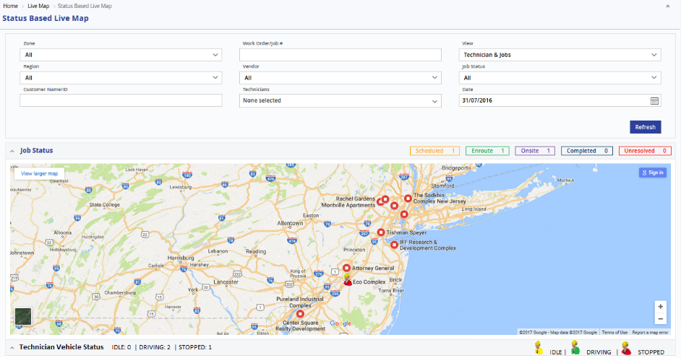

#### GPS Tracking

The mobile application of FieldPower has in build GPS updating mechanism. It constantly pings the server with the current GPS location of the device. This helps the system to keep track of the technicians. The GPS based Map has two options, By Last Position or By History.

In Last Position option, system will display the technician’s icon in the map, based on the last GPS position of the technician. The system also displays the last time when the GPS coordinates were received by the FieldPower system. The system will display technician icons based on their active or idle status (if the system doesn’t receive the GPS update from technician for 15 mins, it shows them as idle.

In History option, the user can view the entire travel history of a single technician in the map. System will display the complete movement history of the technician with a start and end point. All the points, based on the GPS location received from the Technician’s mobile will be listed as red dots, showing the complete route travelled by the technician on that particular day.

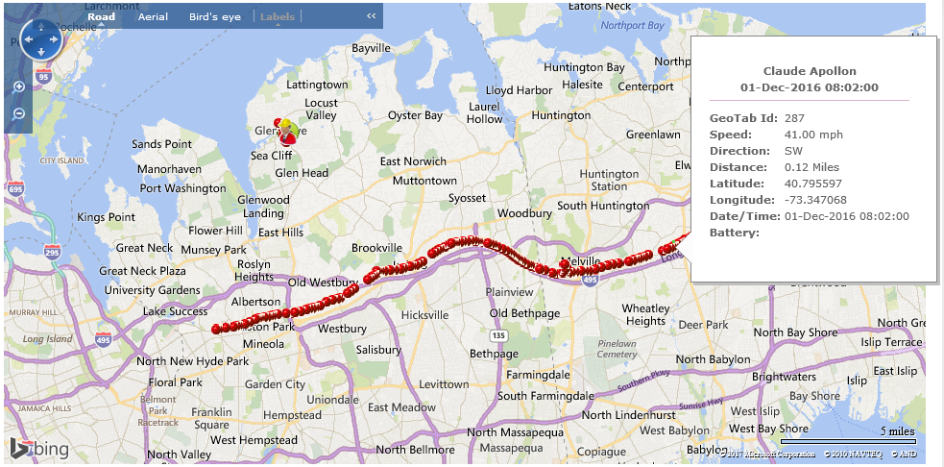

That is GPS tracking can be used for verification of a service in various ways.

* The GPS coordinate at the time of the status update can be checked with the Site coordinates and verified if both are the same or nearby.
* The GPS coordinate of the technician can be compared with the Site coordinate and the time which is mentioned as completed by the technician.

### Weather Overlay

A discrepancy report can be extracted from the system, indicating that the technician was not present during the status update / job completion.

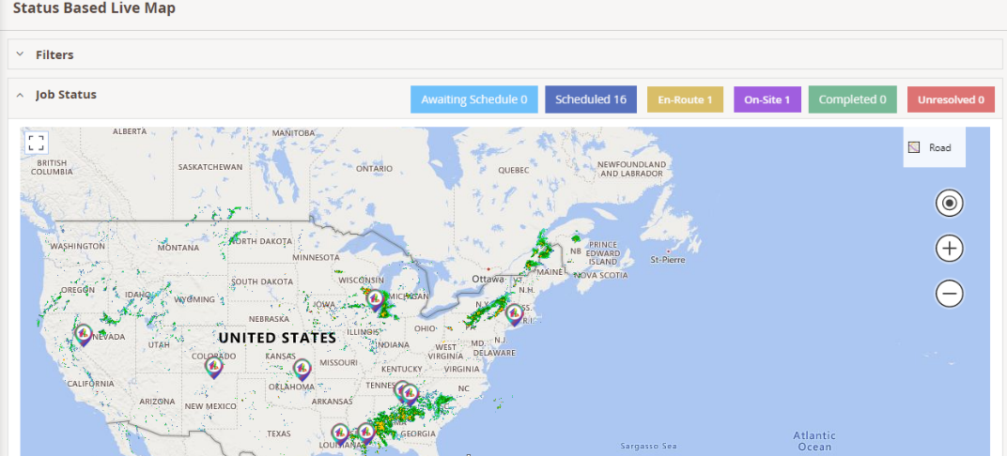

### Roof Imaging eagle view

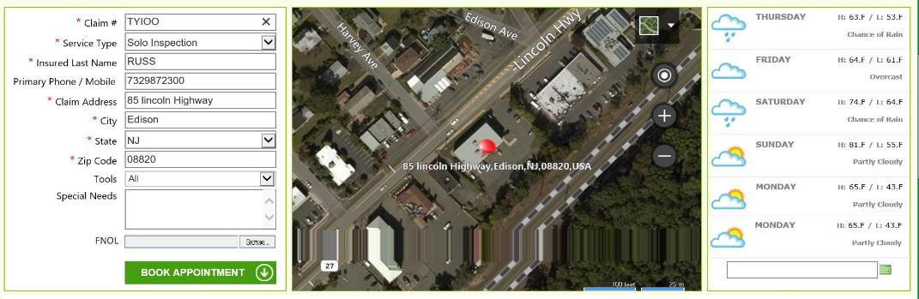

### Weather Forecast

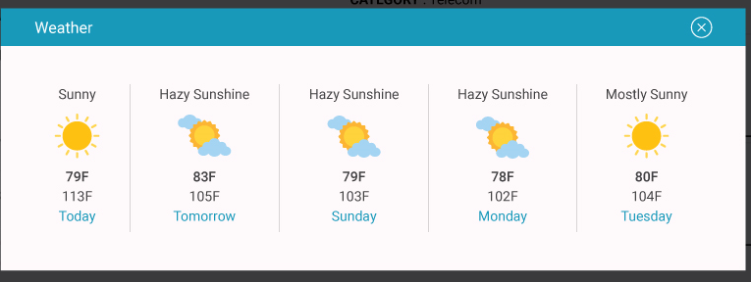

### Technician Portal

Being a web-based application, technicians can access the FieldPower anywhere with a secure Internet connection or from their mobile device. The role permission allows the technician to only view his own task assignments, pick the assigned job, and update the job status. The technician can update the customer feedback and his remarks about the service using the ‘Technician Job Details’ screen of the FP application and mobile device.

#### List View

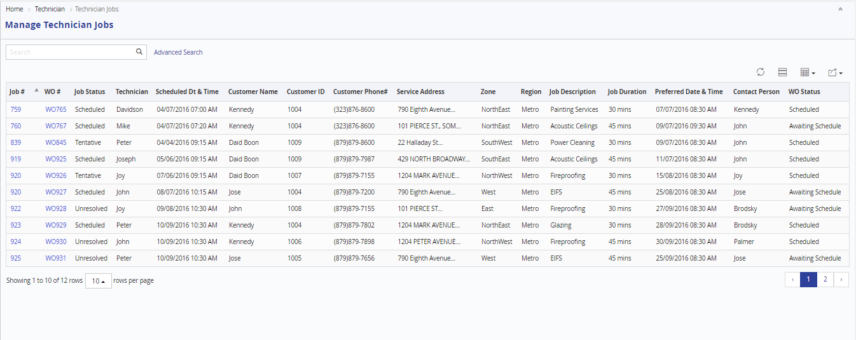

*Job Details List View*

#### Technician Job Details Screen

Field Power allows the technician to view his task assignments, pick the assigned job and update the job status. The following details are captured by the technician

* + Travel time
  + Arrival Time
  + Service Start & End Time
  + Departure Time
  + Actual Working time
  + Job status
  + Remarks
  + Signoff details and more

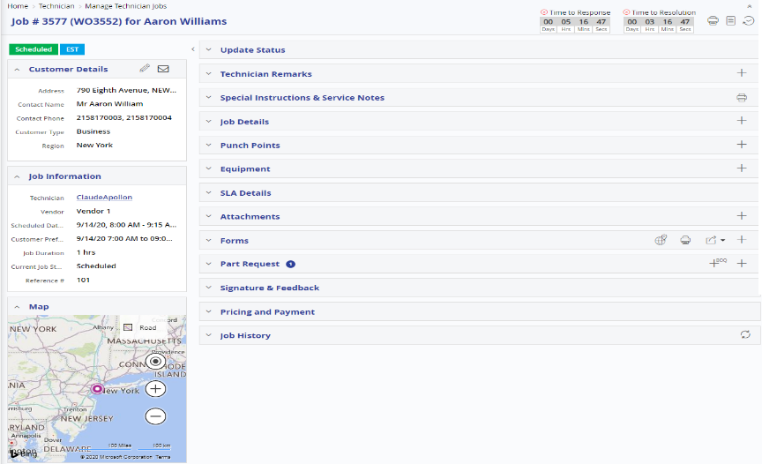

*Job Details*

The technician can update the real time job status using the technician job details screen. Once the technician updates the job status, the previous status gets disabled. The technician can go forward for the next status only. Also the screen captures real date/time for each status updates. The same status update can be viewed by the dispatcher through dynamic dispatcher board. In case any delay in completing the job or technician is unable to complete the job (Unresolved) alert will be shown to dispatcher for immediate attention.

#### Customer / Site Info Update

The Technician can view / update the contact information of the Customer / Site. This will be updated in the Site master for future references.

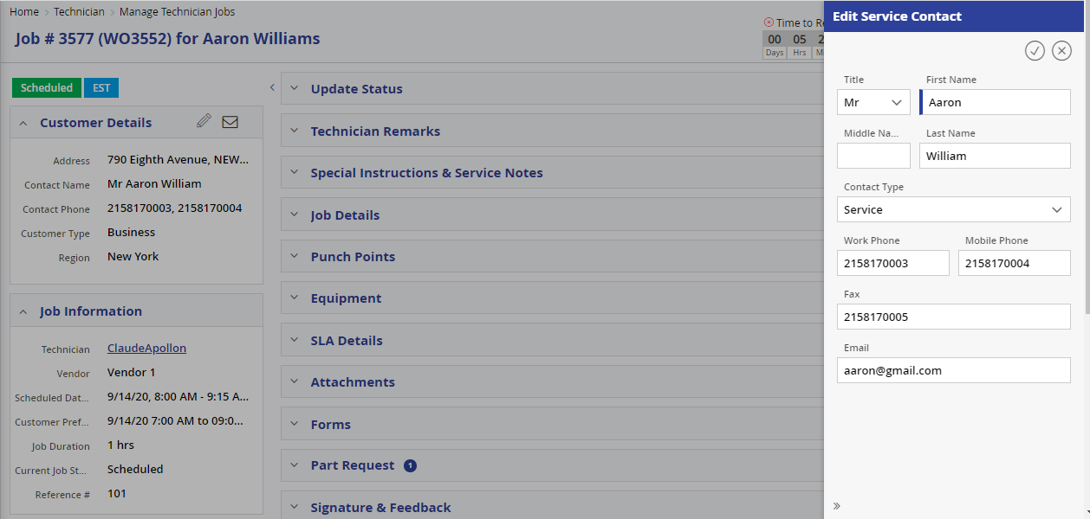

#### Job History Tab

The technician can view the complete history of the job assigned to him in this right from creation till the job is assigned to him / her.

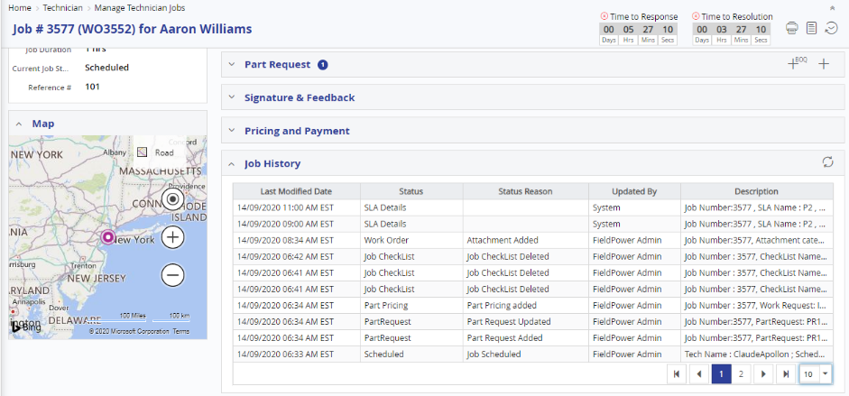

*Technician Job Details – Job History Tab*

#### Parts Tab

The technician can also request for spare parts using the part request option of the technician job details page. If the part is available with the technician in his / her car kit, the part will be auto-allocated. If the part is not available with the technician, the request will be redirected to the respective warehouse for replenishment to technician’s car kit.



*Technician Job Details – Parts Tab*

#### Equipment / Asset Tab

The equipment / asset against which the Work Order is created will be listed in this section of the page.

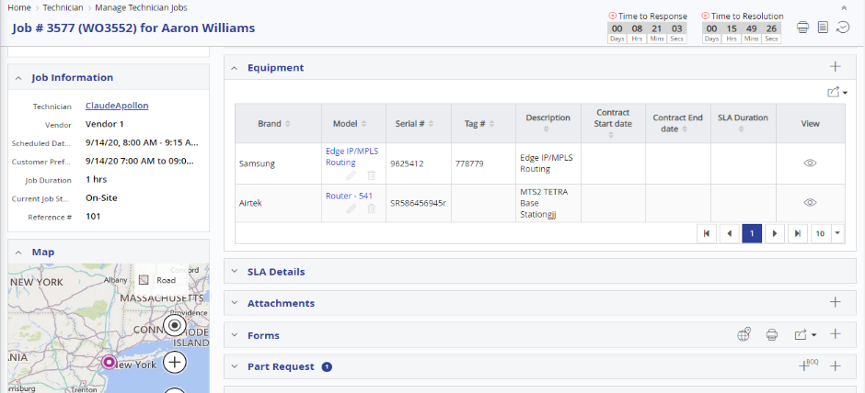

*Technician Job Details – Equipment Tab*

#### Attachment Tab

This section is used to view or upload attachments to the job. The user manuals when attached to the job will be downloaded / viewed by the technician helping him in resolving the issue faster. The technician can also upload images regarding the service details.

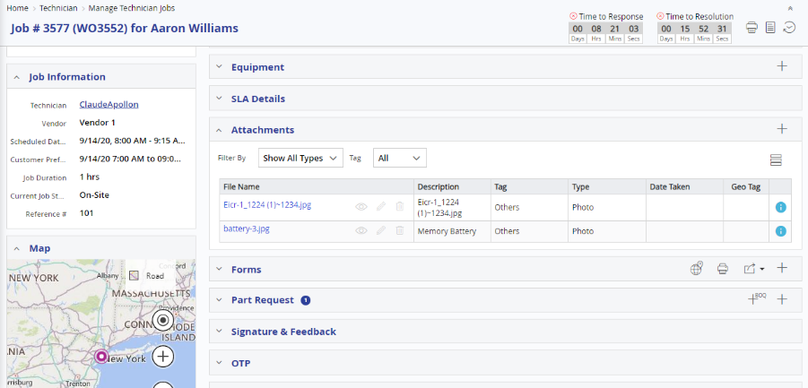

#### Signature Tab

This section allows the technician job details page allows the technician to capture signature from the customer as a proof of his / her visit and completion of the job.

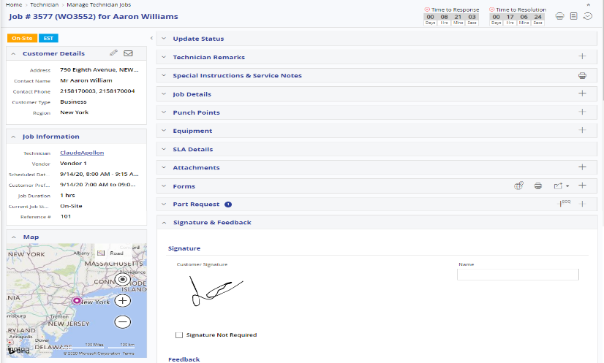

#### Dynamic Checklist / ETL (Equipment Test List)

While completing the Job, Technician can update the Dynamic Checklist. He / she has to put values against each of the checklist option, which enables the administrators in evaluating the completion / perfection of the job. This can be used for maintaining the ETL / Equipment test list provided by the manufacturer. Each manufacture will give a guideline / test(s) to be done on their equipment on a periodic basis. These are referred to as ETL or Equipment Test List. These can be configured into the FieldPower system as various checklists.

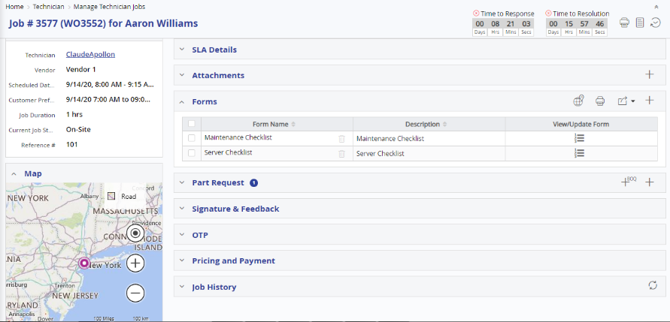

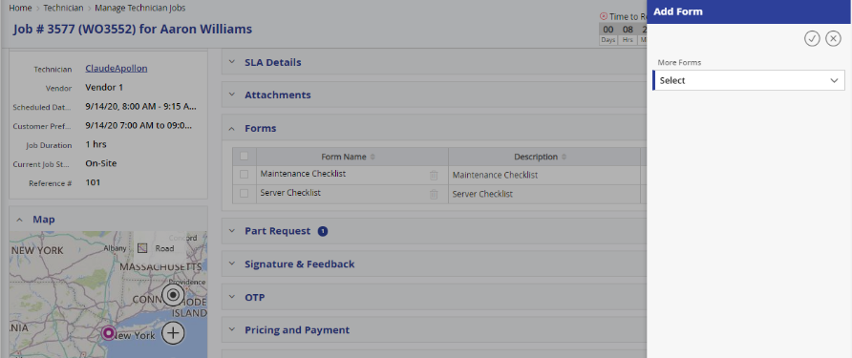

#### Adjust Job Duration

The technician job details screen also enables the Technician to Adjust the Job duration. In case of any unforeseen circumstance and if additional time is required, technician can increase / decrease the job. Based on the adjusted time, the dispatcher will be intimated and he / she can take proactive decision on rescheduling the other jobs which will be affected by this change.

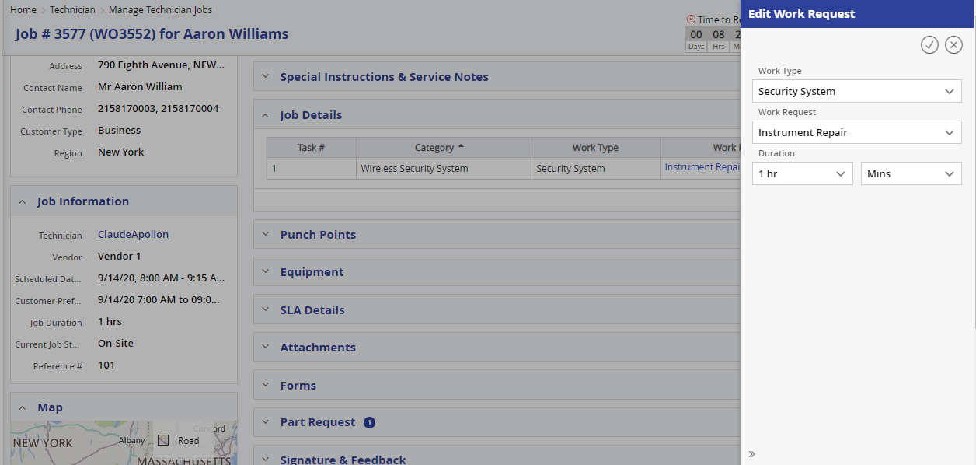

#### New Task Creation

If the customer asks for any additional service, the technician can add new job (based on access privileges. 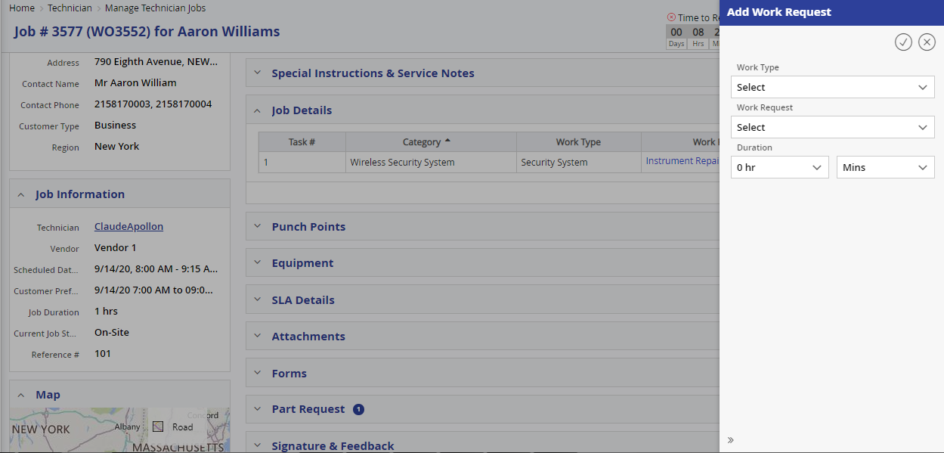

#### Resolution Code

When the technician completes the job, he / she has to give the proper resolution code from the available values. This helps the administrator in finding out the root cause of the issue.

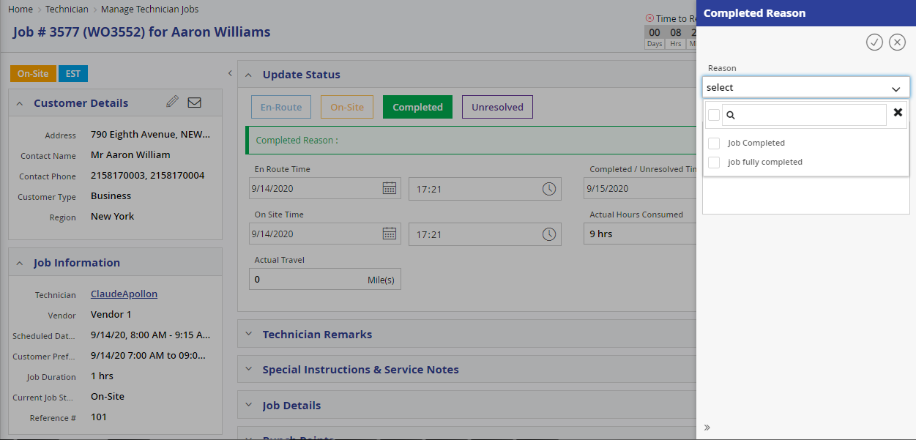

#### SLA

Technician level SLA

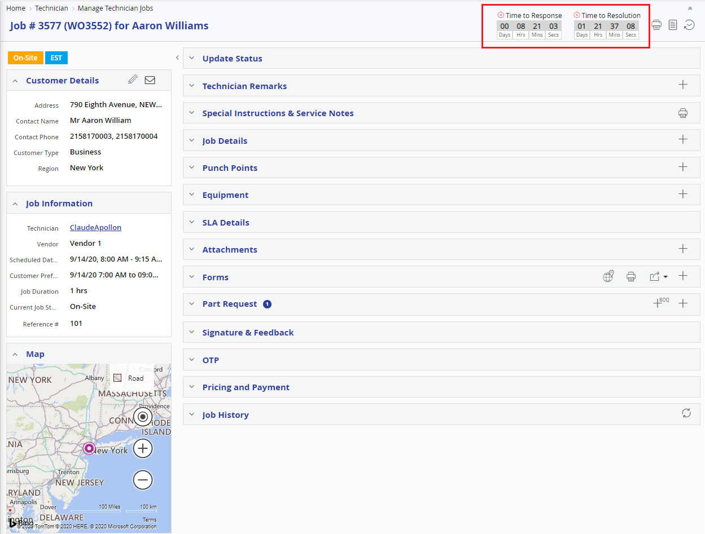

### Spare Parts Inventory Management

FieldPower has the extensive integrated spare parts inventory management system, comprising of the following modules.

* Equipment/Part management master
* Warehouse/Car Kit Management
* Inventory Adjustment
* Part Request Approval
* Location & Bin
* Stock Request
* Stock Transfer
* Stock Replenishment

#### Equipment / Parts Master

The Equipment / Parts Master Screen is used to capture the information of the Equipment / Part number and description and the type as New/Used and different type prices of the equipment / part. System has the option to differentiate the part as Serialized and Non Serialized. If the part is serialized each part is assigned a unique serial number for easy tracking. Each of the parts can be mapped with more than one brand. User can set the threshold limits like, min and max level settings for each of the warehouses individually. These are used for triggering auto emails to relevant users & admins when the threshold limits are reached. System also, keeps the track of the Parts History in Part Inventory Information, along with supplier and manufacturer information. Following are the key information of part master screen which can be maintained in the field power.

* Part number
* Substitute & OEM Part number
* Category
* Serialized and Non Serialized
* Cost, List Price and selling price
* Product family
* Manufacturer
* Extended description

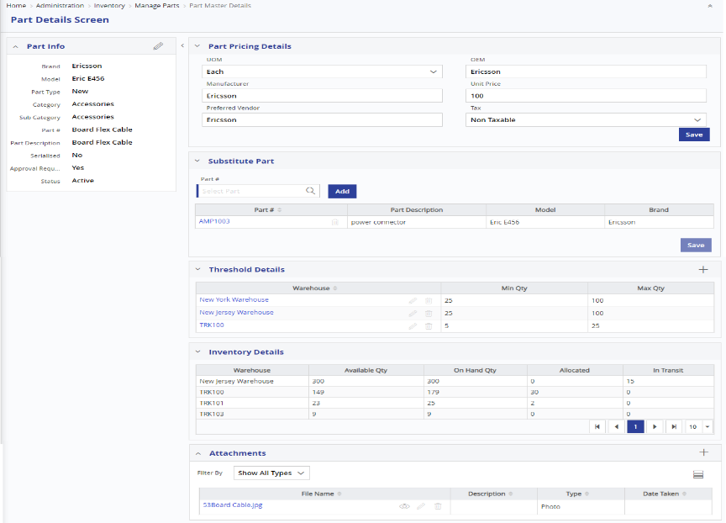

*Parts Master*

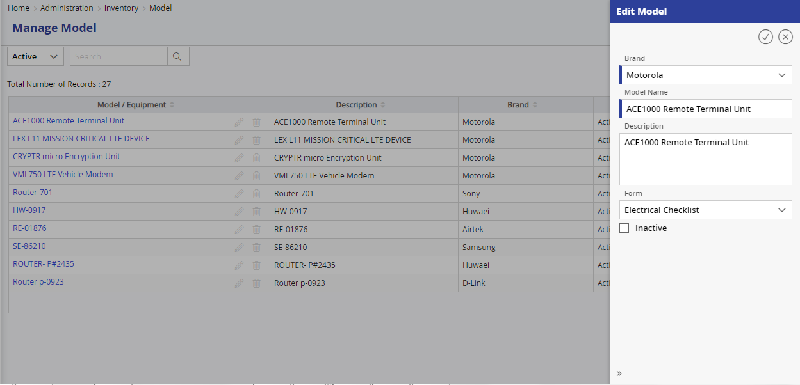

*Equipment Master*

#### Manage Warehouse

Warehouse Master enables the user to Create and manage Warehouse details including Physical/Car Kit warehouse information.

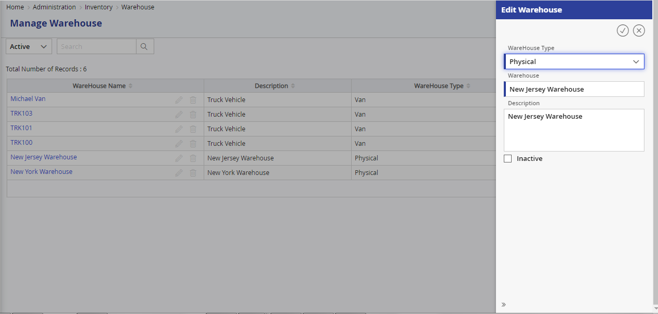

#### Technician Warehouse Mapping

In the user master screen each technician can be mapped with one or more warehouses. The technician can pick the inventory from any of the allocated warehouses.

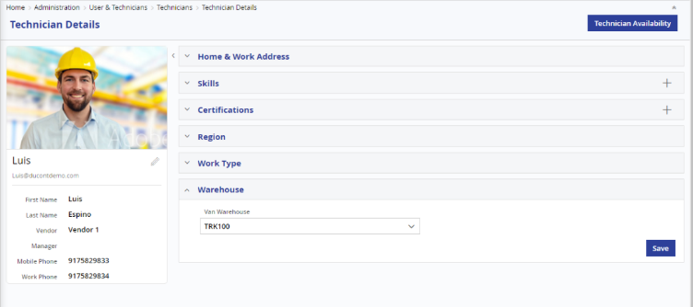

#### Part Request

The spare parts can be requested by dispatcher or technician in the Work Order page or from the Technician Job Details page. If there is sufficient stock available in the technician’s car kit, the part will be auto-allocated. If the requested part is not available, the part request will be updated as, ‘Awaiting Parts’ and the request will be sent to Receipt / Issue queue of the respective warehouse, for further processing by the Store manager.

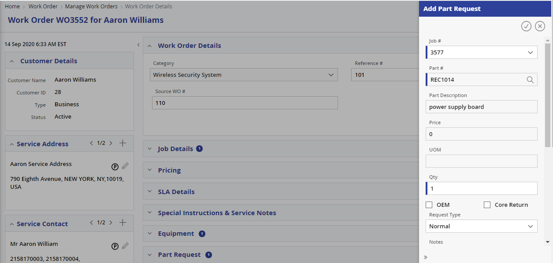

#### Warehouse Receipt / Issue Queue

FieldPower has the queue based inventory cart for tracking the inventory transaction easily. The inventory manager / store user, can choose the line item and process further. Based on the operation, the part can be received or issued by the warehouse in-charge. This can also be used for checking the requested & received quantity and allows partial issue / receipt also. In addition, the store user has to specify the location & bin in which the part is being issued or received.

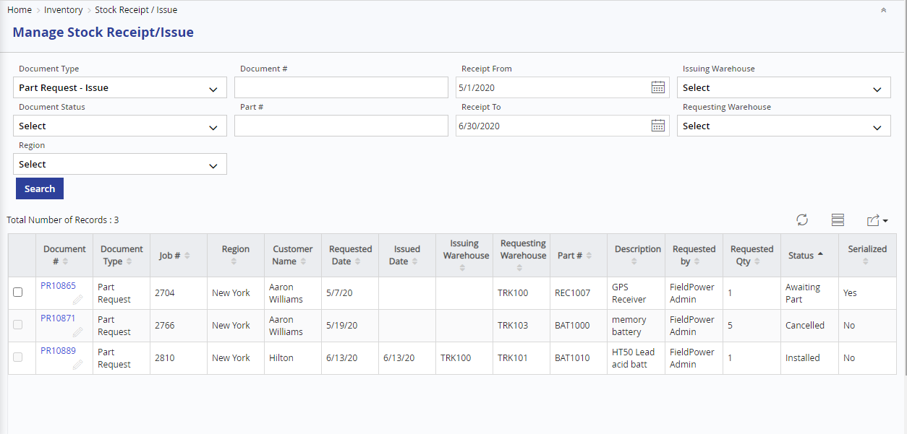

#### Warehouse Location and Bin Management

The inventory management of FieldPower allows the store users to maintain & manage location and bin information in the system. Whenever a part is issued or received, the system will ask for the location and bin from which it is being issued or received. All the inventory reports can have details of location and bin level inventory information.

#### Stock Request

Stock Request screen is used for requesting Spare Parts from another warehouse, based on a part request. The request will be listed in Receipt / Issue Screen, of the requested warehouse. Once the requested warehouse issues the stock, the stock request will be listed in the requestor stock receipt / issue screen, from where the stock can be received and added to the warehouse stock.

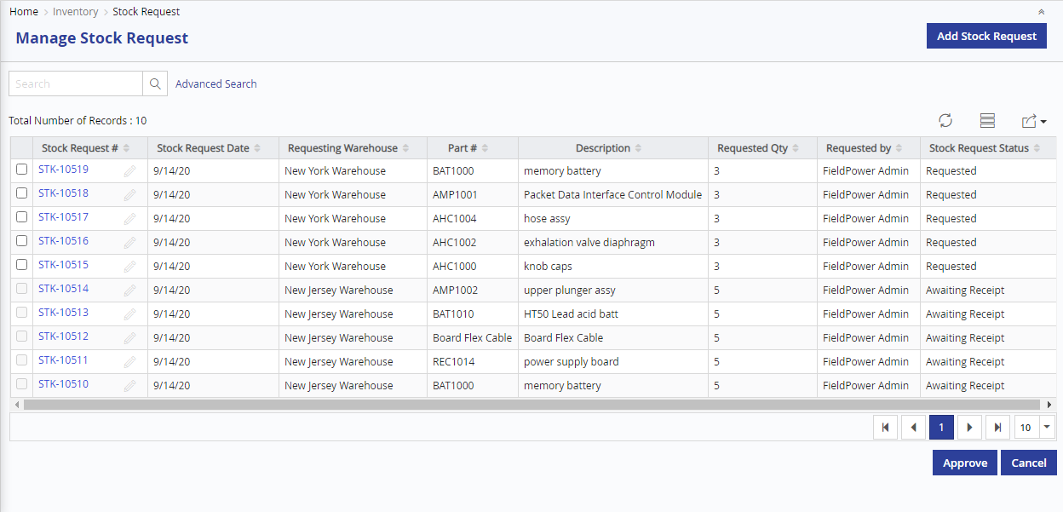

#### Stock Transfer

Stock Transfer screen is used to request transfer of the spare parts from one warehouse to another warehouse, without a part request.

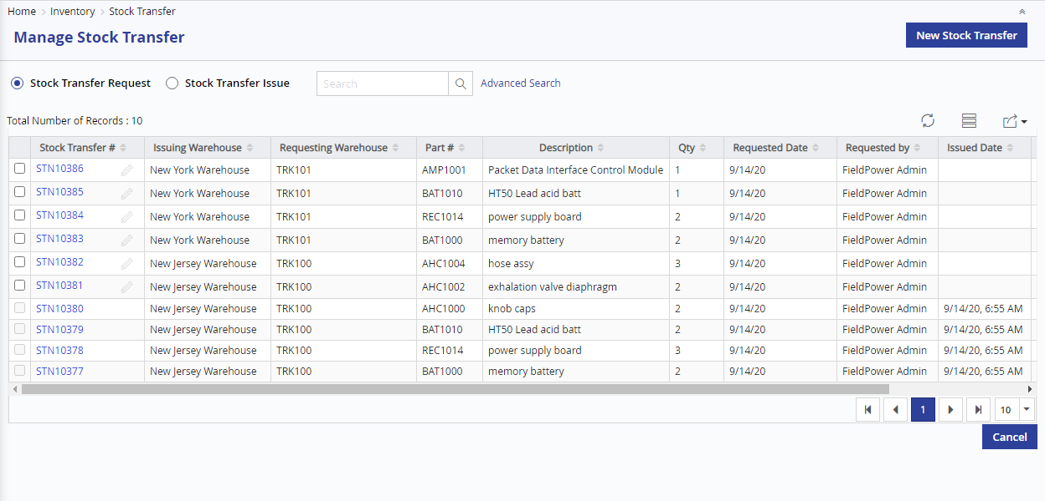

### Mobile Application

Mobile FieldPower is designed to allow Technicians to access the application by iPhone, Android or Windows and all the latest smart phones. The conveniently small hardware form factor makes it easy for technicians to receive the work order assignments, map and track routes by GPS, receive SMS & emails, and talk on the same device. Virtually, all communications and instructions fit easily in their pocket on one single device.

The Mobile App comprises of the following features: -

* Instant dispatch of service call information to mobile devices
* Real-time status feedback from field to central dispatch and customer service
* Automatic connecting and reconnecting as users move in and out of cell coverage areas, with storage of work data on mobile device
* Time tracking and field service mobility reporting
* Location and Navigation
* SLA and alerts
* Platform Independent and OS Agnostic
* Supports in Apple, Android, Windows mobile, and IPAD

#### Mobile Architecture

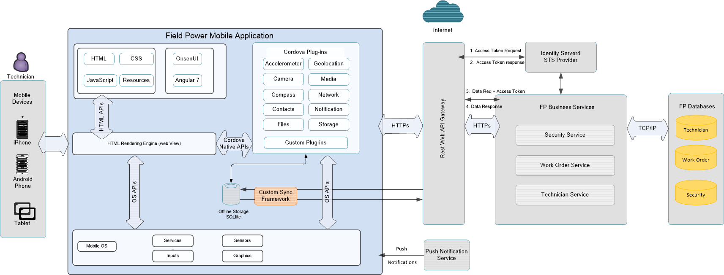

The hybrid development combines the best of both the native and HTML5 worlds. We define hybrid as a web app, primarily built using HTML5 and JavaScript that is then wrapped inside a thin native container that provides access to native platform features.

* A Hybrid App is a native app with embedded HTML
* All Business portions of the App are written in web technologies like HTML5, CSS3 and AngularJS.
* Single code base for multiple platforms
* It has almost all the features of Native App including App store presence, etc.

Apache Cordova is an open-source mobile development framework. It allows you to use standard web technologies such as HTML5, CSS3, and JavaScript for cross-platform development, avoiding each mobile platform native development language. Applications execute within wrappers targeted to each platform, and rely on standard-compliant API bindings to access each device's sensors, data, and network status."

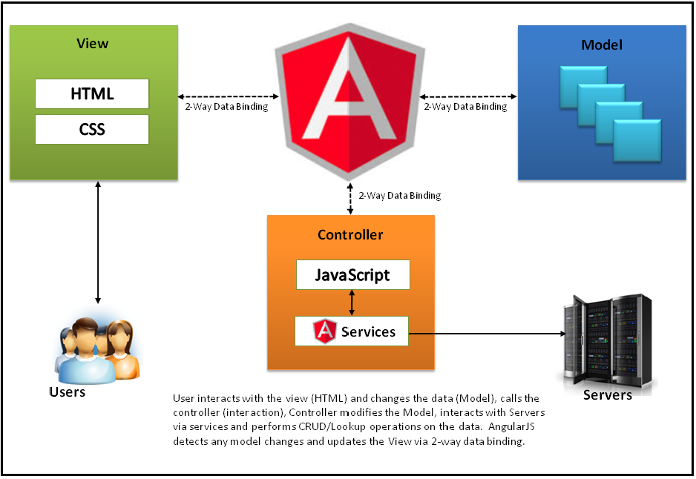

* User Interacts with the view (HTML) and changes the data (Model)
* Calls the Controller (interaction)
* Controller modifies the Model, interacts with Servers via Services and performs CRUD operations on the data.
* Detects any Model changes and update the view via 2-way binding

One application can be downloaded in all types of devices, smart phones and tablets as shown below.

#### Technician Job Calendar

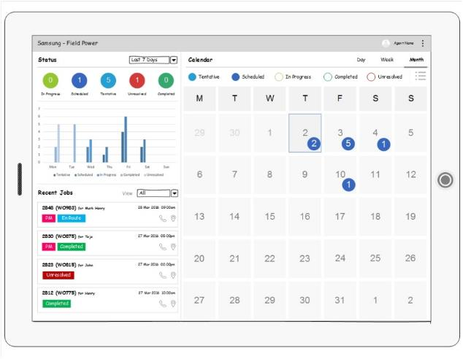

#### User Authentication

Specific privileges will be granted to mobile users through user management in web application to access Mobile app. The password management function will be enabled to authenticate the users. The admin can also make a user inactive and force him to be logged off the system. Encrypted password storage in mobile database is another noteworthy feature from a security perspective. User credentials Authenticated only at Login and rest of other service will be authenticated with Session ID. This session Id will be stored in DB and will be verified for every single request from the Mobile, for extra security session id and data are encrypted with AES 256 algorithm. The user will also have the provision to change his / her password from the mobile device itself.

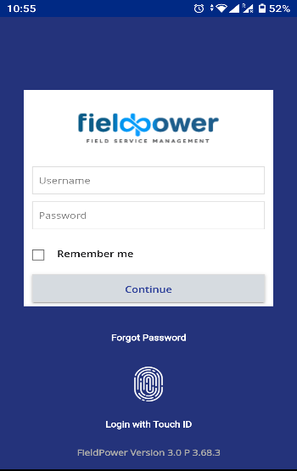

#### Synchronization

Encrypted Data is transferred over the network. The solution is fully integrated with an AES-256 algorithm for transfer to ensure that data transmitted cannot be subjected to alteration. Also, the compressed way of data storage helps in minimal transmit time and rate of the required data. Whenever there is network connectivity, the system automatically sync the data, both ways, so that the data is up-to-date for all.

#### Offline mode

FieldPower mobile client’s works seamlessly in offline mode also. The data is stored locally in an encrypted format. This local data store is used when the mobile is out of coverage area. All the status updates and attachment updates can be done seamlessly in offline mode also. The client syncs automatically with the server, when the mobile comes in to coverage area. The sync can be both automatic and manual also.

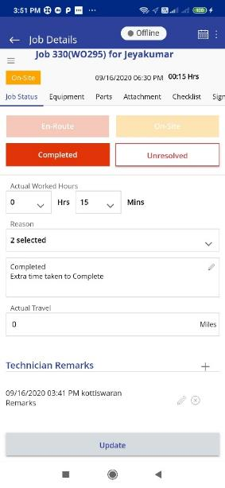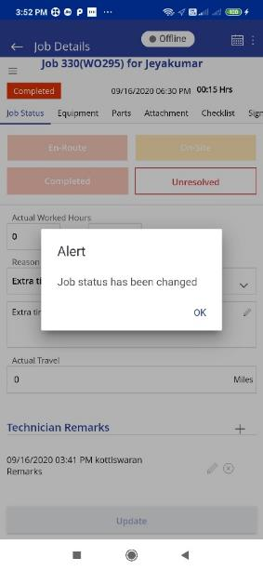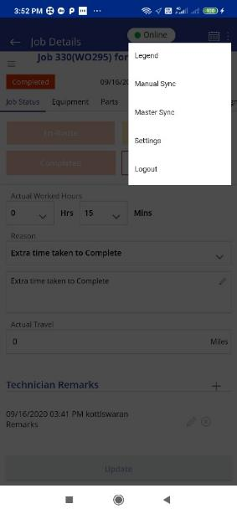

#### User Check In – Check Out

FieldPower mobile App allows the Field Technician to check-in and check-out from his device. Application will not allow him to update the jobs without Checking-In to the system. Also both the Check-in and Check-out time will be captured by the system to make sure he was online during working hours. These details can be used for calculating timesheets and other analytical reports of the technicians.

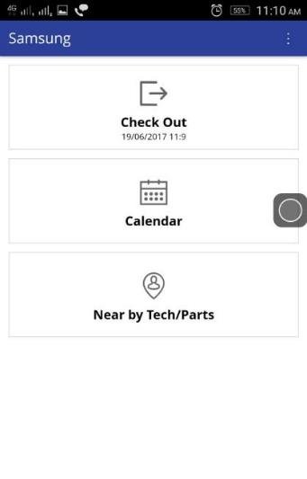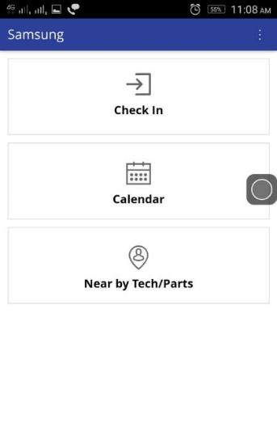

#### Calendar View

After the successful login, the mobile app displays the calendar screen listing all the jobs assigned to him. The calendar screen will show the job with current status, customer name and the estimated time for completing the same.

Technician can traverse to the next and previous days from this calendar screen. The technician can also view the calendar in day view, week view or the month view.

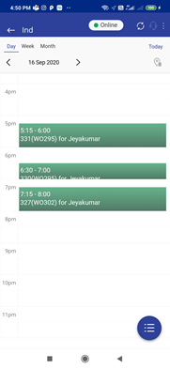 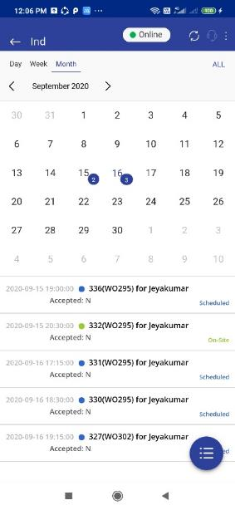

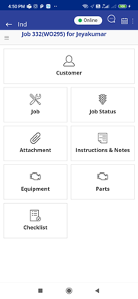 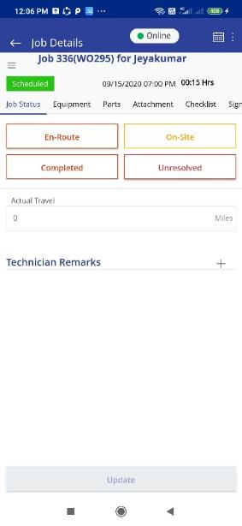

#### Driving Direction

Mobile FieldPower application will have integrated maps, using which, it will guide technician to reach customer location by showing, Turn by Turn notifications. The driving directions can be viewed from calendar view or from the job details page.

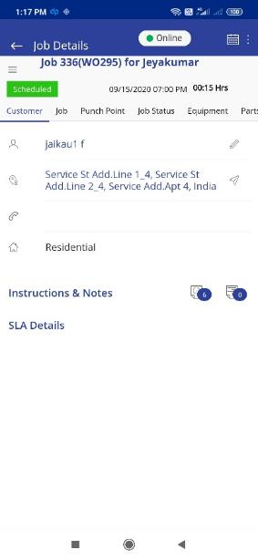 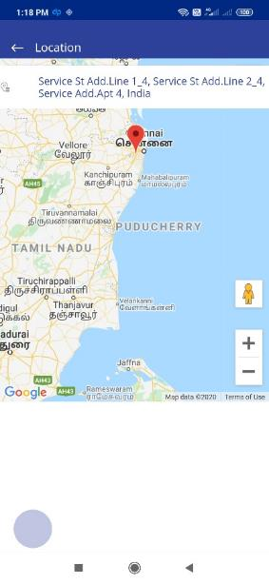 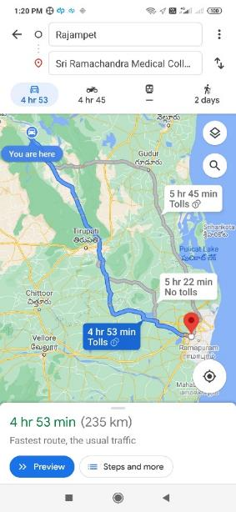 Customer Address Location Driving Direction

#### Status Update

Using the FieldPower mobile application, technician can update the job status from the field. The technicians can check and reject / unresolved or update status as En route or complete a job from the mobile application. In case of rejection or unresolved, the technician need to provide reason for the same. Technicians can also provide remarks, in case the Technician needs to bring any information to Dispatcher’s notice like estimated time to complete the task, any deviations etc., From this screen, technician can easily traverse to other screens like Job Summary, Job Notes etc. Field Technician can also take photo and upload the same to the job. When complete the job technician can adjust actual worked hours.

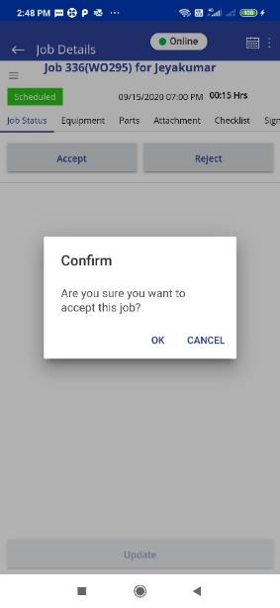

*Job Status Update screen*

#### Electronic Signature

FieldPower Mobile App has the feature to get digital signature from the customer. With this, the technician can opt for the customer signature with current and time. The signature is converted into base 64 string and encrypted and send to the server. The same signature can be viewed by dispatchers or administration for verification purposes.

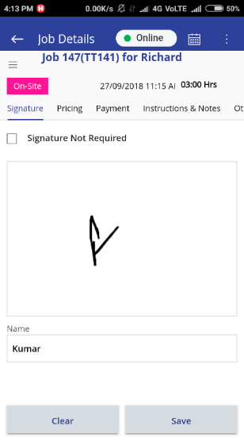 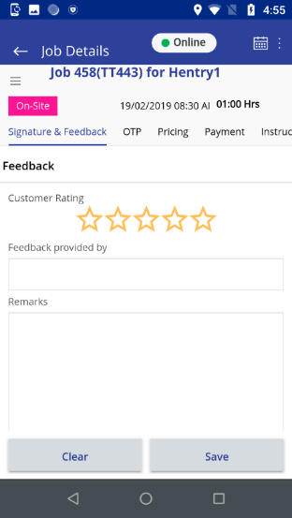

#### Customer Info Update

Customer information like contacts can be updated in the mobile app and will be stored locally and also synchronized with the web application

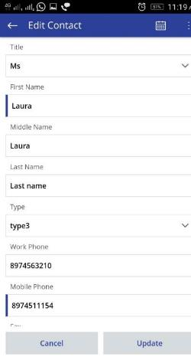

#### File Attachment

The application supports file attachment feature to add supporting documents for the job. All the attachments that have been uploaded by the administrator or the dispatcher will be viewable by the technician in this screen. These can be manuals or some reference materials, which can be useful for the Field Technician to complete the job. Field Technician can also take a photo, using the mobile device and attach the same against the Task. The same can be viewed by the Dispatcher / Supervisor

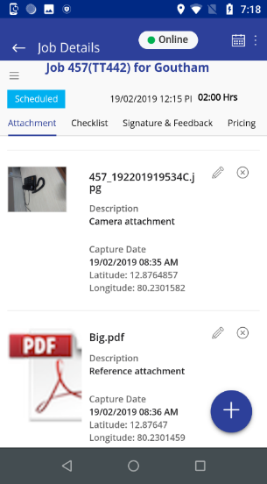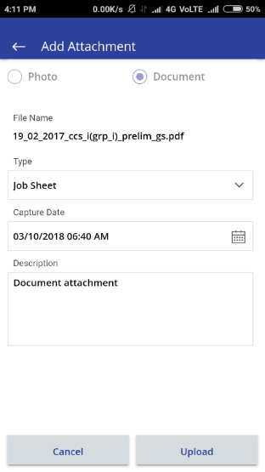

Image Annotation

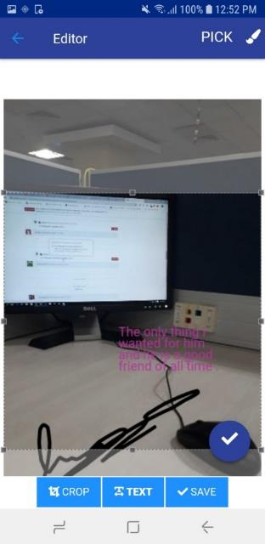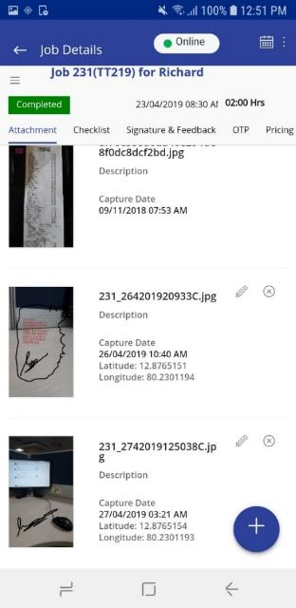

#### Part request

Technician can have the option to make spare part request from his mobile device itself.

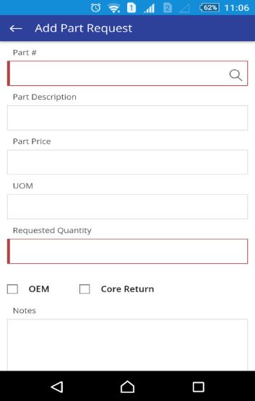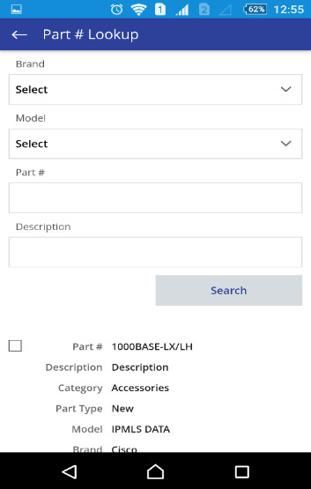

#### Work order History

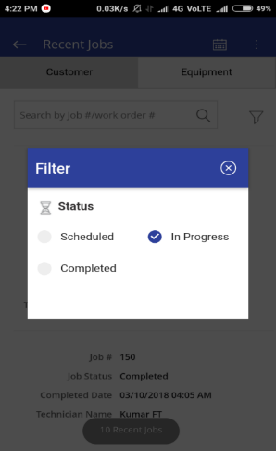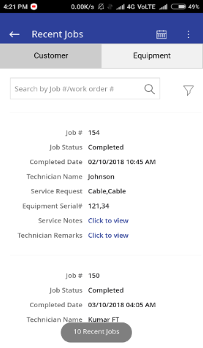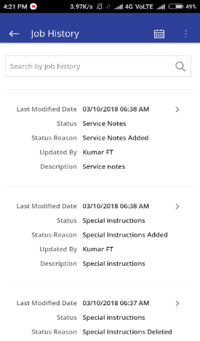Using this below “History” screen, field technician can view all the previous Work Orders executed for the customer and Equipment details. Field technician can go further and view the previous Work Order details also to get addition Nationwides on the current issue.

#### Dynamic Forms

Dynamic Forms are like dynamic forms, which can be added to any job. The administrator can create different checklists in the administration section and can attach one or more against each job. The the value of the checklists, can be configured to be one of the following by the administrator:

* Dropdown list with specified values
* Checkbox or tickbox
* Numeric textbox
* Character textbox

The Administrator can also specify if the checklist item is mandatory or not.

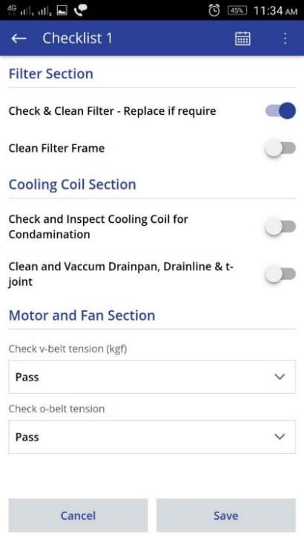

#### Nearby Technicians - Parts

If the Technician needs some spare parts or needs some helping hands, he can use this option to find out who the Technicians near to him are and who all are having the required Spare Part in their Vehicle. The contact details of the technician will also be listed along with the distance. The technician can then contact them and coordinate accordingly.

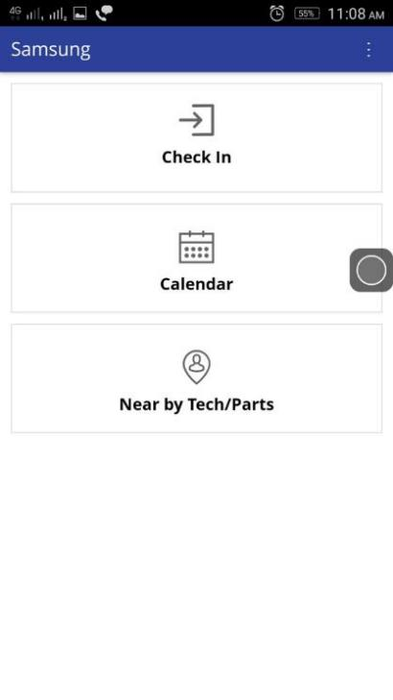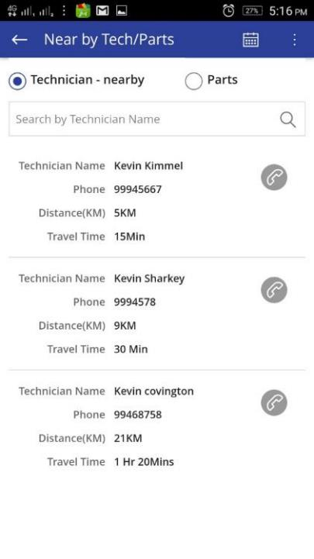

*Nearby Tech/Part*

#### Payment Details in Mobile Application

FieldPower mobile application has ability to collect payments from the customer for the current job or any additional job done by him / her. This feature can also be integrated with payment gateway for credit card payments.

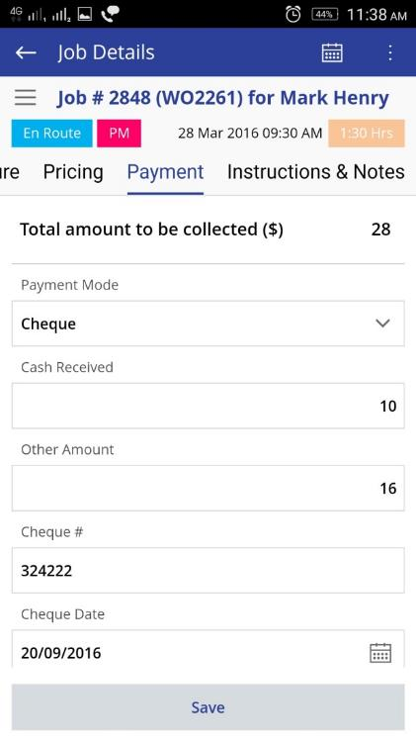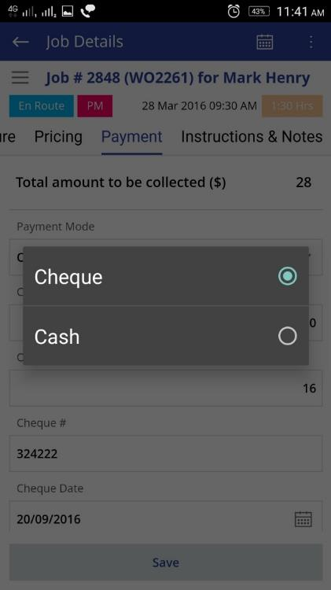

#### Resolution Code

Whenever the technician completes the job, he / she has to select appropriate resolution code before completing. This will be helpful for the dispatcher / administrator for doing root cause analysis in future cases.

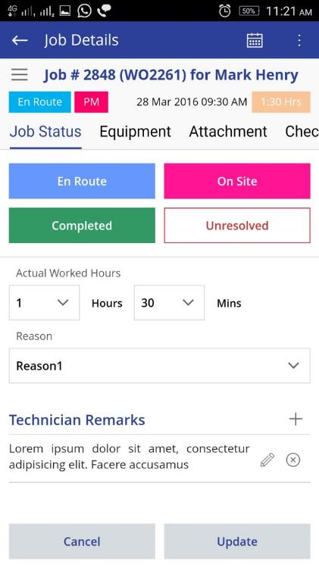

#### Equipment Details

FieldPower Mobile application has a provision for Technician to select specific customer’s equipment and view it’s details like history of service done on the equipment. The screen also allows the technician to update some specific information regarding the equipment like add-on parts, their serial numbers etc.,

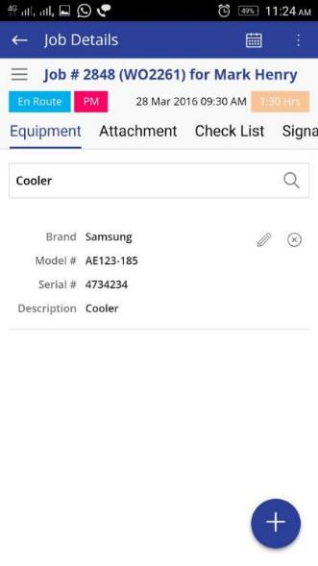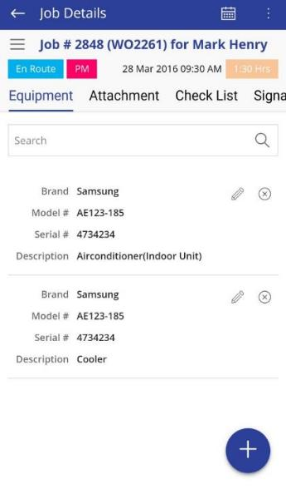

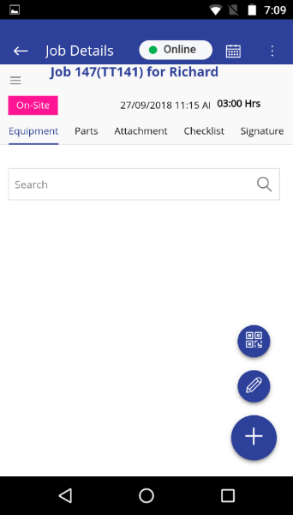 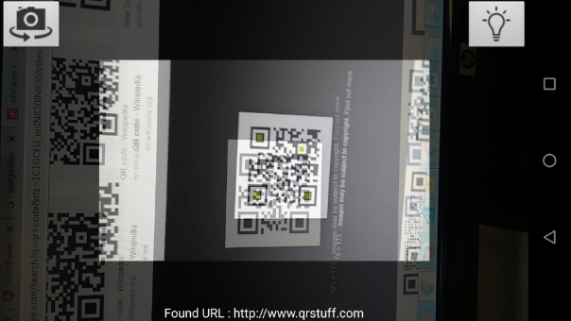 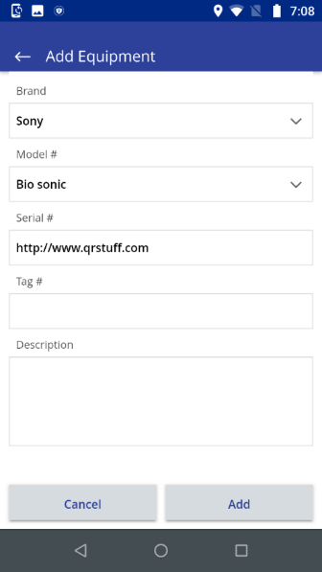

Adding Equipment using Scanning QR / Bar code.

#### Push Notification

FieldPower Mobile application will receive Push notification alert when a job is scheduled to technician.

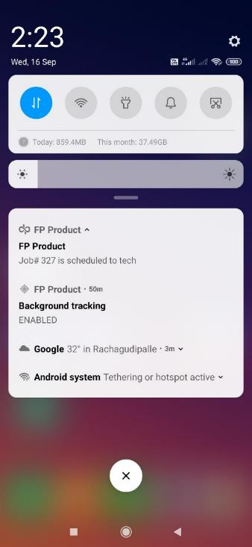

#### Geo Fencing

In Field Power Mobile application, there are two features Geolocation and Geo-Fencing.

Mobile application provide geolocation to web application based on setting in web application. Based on geo location

- Geo fencing setting - Application would validate with assigned location based on given geo radius when update the status of a job.

- Technician, job / technician can be tracked in real time.

- Geo location would be captured at the time of photo capturing / attachment.

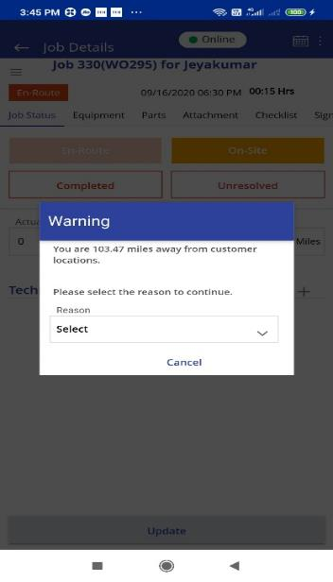 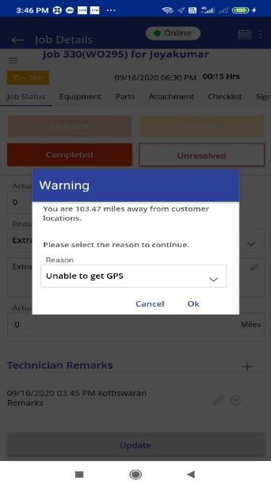

Geo fecncing alert while Onsite the Job Geo Fencing alert while completing the Job

#### Interface with web application

All Data and status update would be synced with FP web application and vice versa.

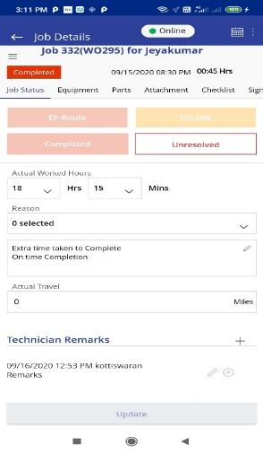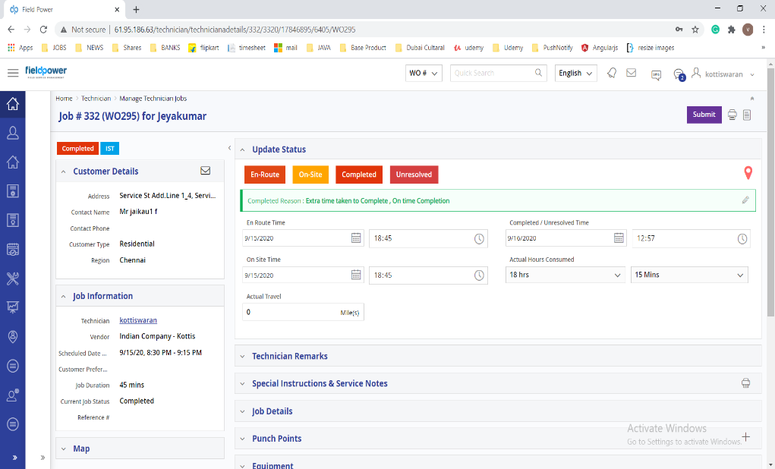

#### Mobile Chat

Field Power mobile application has chat feature and integrated with chat server and Web application. Technician can chat with admin user and fellow technician.

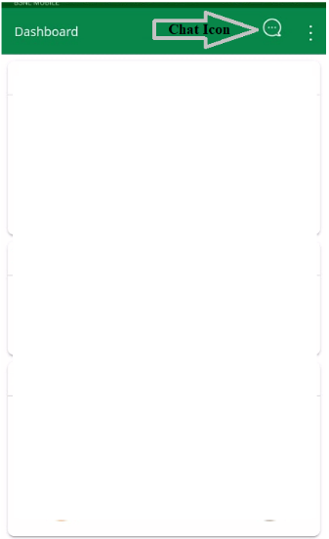 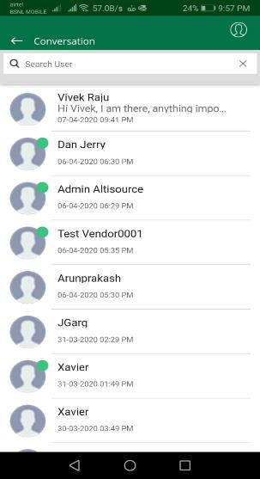

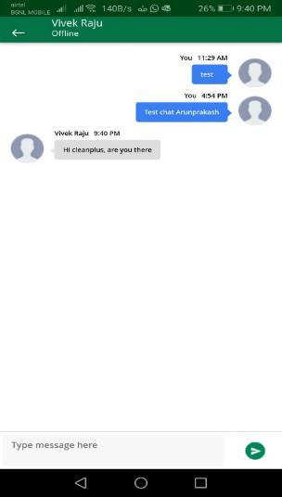 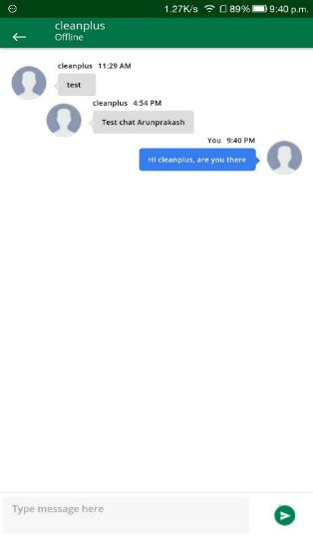

#### Punch Point

Technician can create the same job from feature named “Punch Point” and can do self –schedule based on availability.

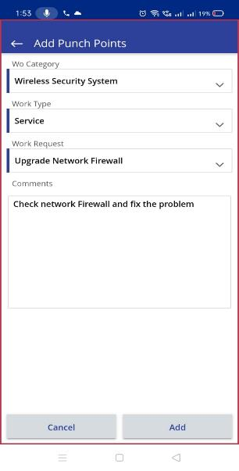 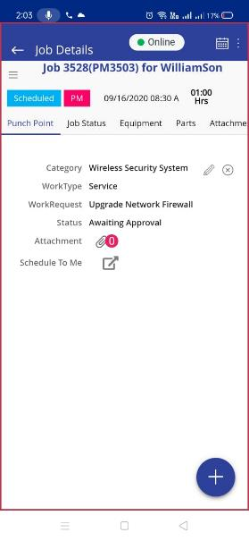 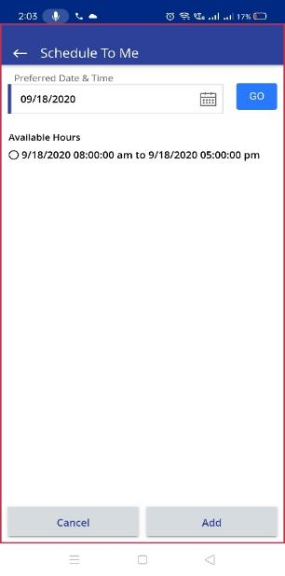

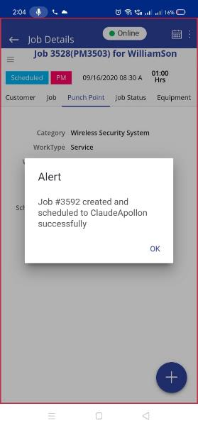

#### Sharing appointment

Technician can share appointment details with fellow techs or third party contacts based via email or SMS text or other media.

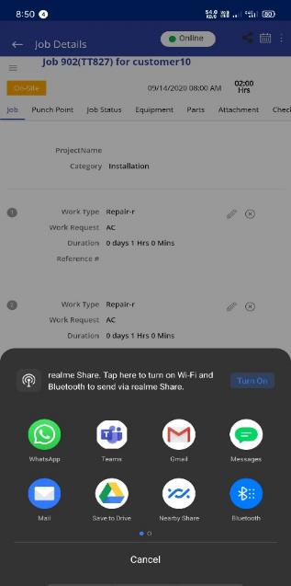 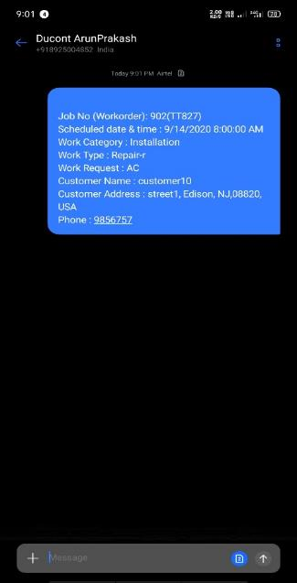 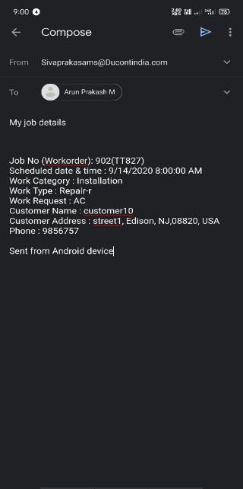

SMS Email

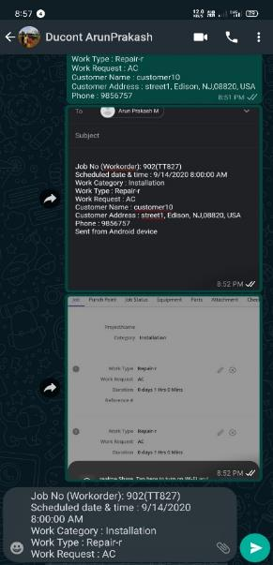 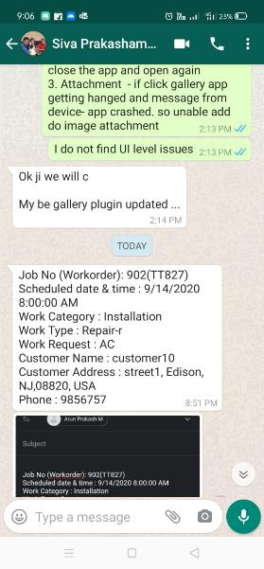

Whatsup message

### Customer Portal

Field Power has a dedicated Customer Portal, where an active customer can login and view all the Work Orders / TTs associated to them. Customer can create multiple Work Orders by using Customer Portal when any corrective Maintenance is needed.

The Customer Portal will be personalized to include the proper brand, logo and colors to the required specifications for the FieldPower client organization. Additional customization can be provided based on a defined SOW for the requested changes and modifications.

* Ability to view total count for each job status related to the logged-in customer
* Ability to view the list of recent Work Orders / TTs specific to the logged-in customer
* Quick Search at the top enables the user to search his/her Work Order based on WO#
* Ability to create New Work Orders
  + Ability to add multiple Jobs to a Work Orders
  + Ability to select 3 sets of Preferred Date and Time Slot
  + Ability to add the existing Equipment’s to a Job
  + Summarizes the Customer Information, Job Information and Equipment Information
  + Click Confirm to generate the Work Order
  + A unique Work Order # will be created after confirmation
* Customer can track the current status of the Work Order / TT
* Dashboard showing summary of Multiple Statuses like Open, Awaiting Schedule, Scheduled, In-Progress, Approval Pending and Closed
* Ability to view the equipment’s which are already existing with the Customer
* Ability to view the list of Contracts and the list of Equipment’s associated with the contract

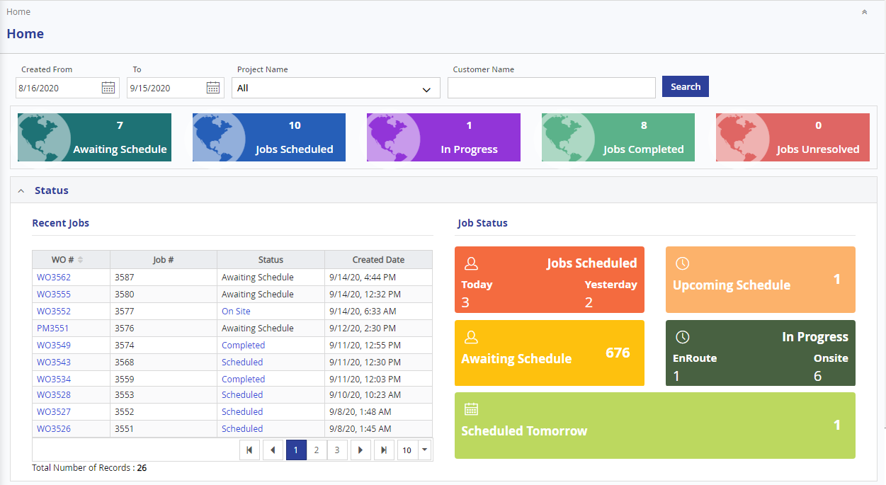

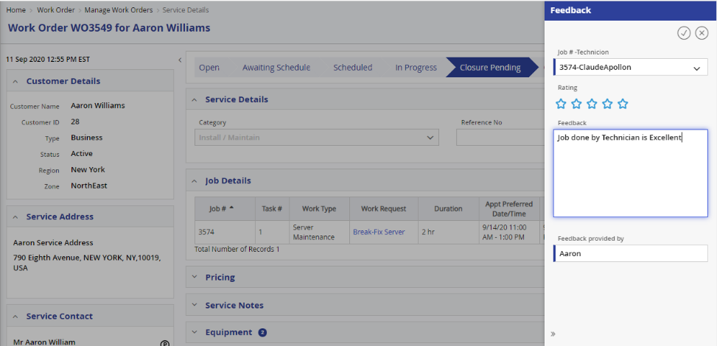

*Customer Feedback*

### User Preference

#### Personalized Theme

User can choose a theme for his own in User Management Screen.

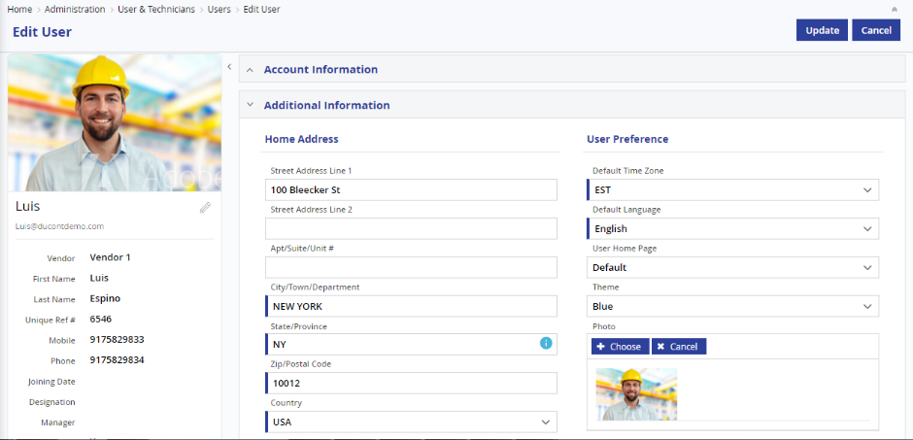

#### Language Preference

FieldPower System currently supports Multilanguage capabilities and the software is deployed in many continents, North America, (English/French), Europe, Asia Pacific & Middle East (Arabic). Our solution potentially handles all targeted linguistic and cultural variations (such as text orientation, date/time format, currency, accented and double-byte characters, sorting, etc.) within a single code base.

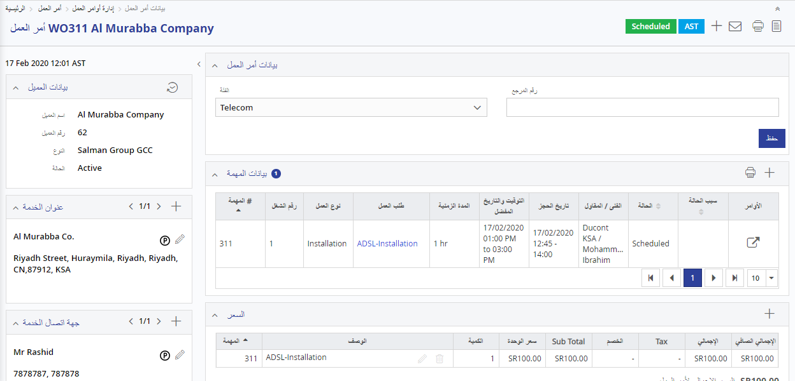**Arabic Support**

**French Language**

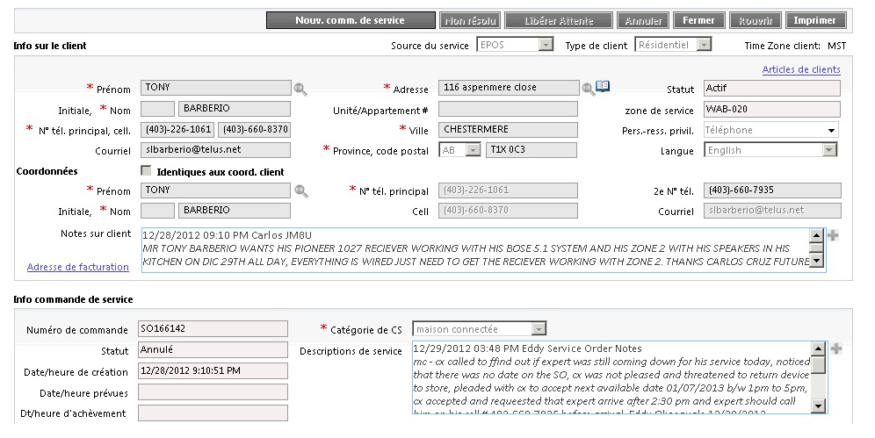

#### In-built Chats

FieldPower System currently has in-built chats, which enables the technicians and the supervisors / managers to engage themselves in a Whatsapp like chat. This chat is also pushed to the technician’s mobile FieldPower app, enabling the field personnel to be connected with their colleagues and managers seamlessly.

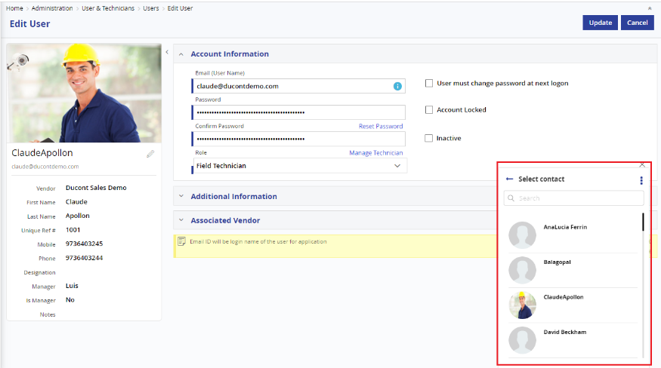

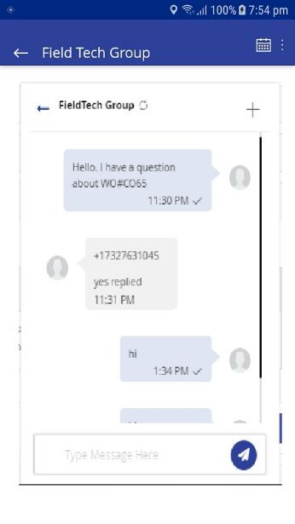

### Administration

#### User Management

The user management system is utilized to create, view, update and delete the users of different roles for the system. The following features are available as a part of the user management system.

* Users can be classified as Administrator, Dispatcher, Technician Manager, Technician and other users.
* Technician can be assigned as preferred technicians for specific Customers.
* Multiple skills and competency levels can be assigned to a Technician.
* Multiple Certifications can be assigned to a Technician.
* Multiple Job Types can be assigned to a Technician.
* Roles can be assigned for each user.
* Multiple Region and warehouse can be assigned to a Technician.
* Profile photo can be uploaded against each user.

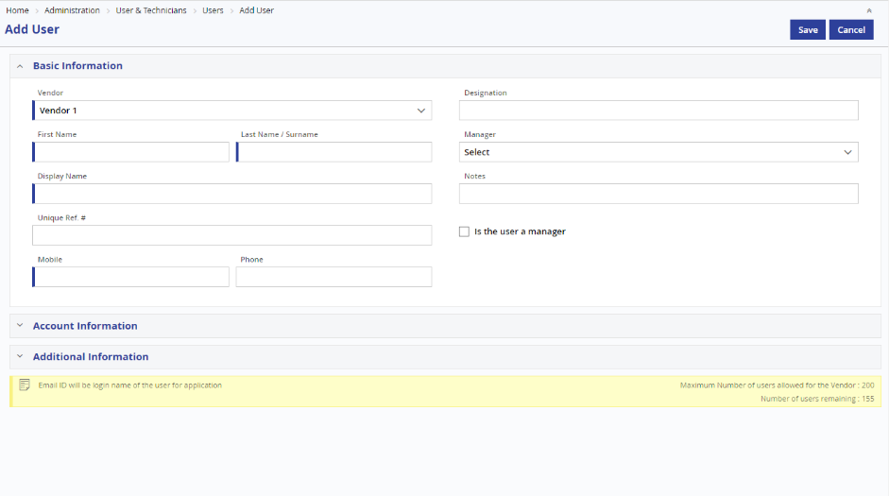

*Add User Master*

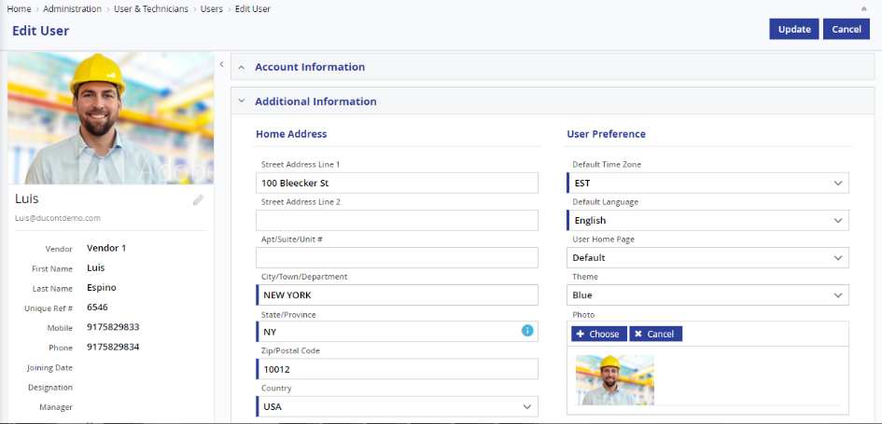

*Edit User*

**User Master – Skill & Skill Level Competency**

In Field Power, skill and competency (certification) levels are mapped with technician and jobs. Field Power allows mapping a technician with multiple skill / competency levels. It allows the end user to schedule the technician with any job, requiring appropriate skill / competency level. It helps the dispatcher to schedule the right job to the right technician based on the skill needed for the job.

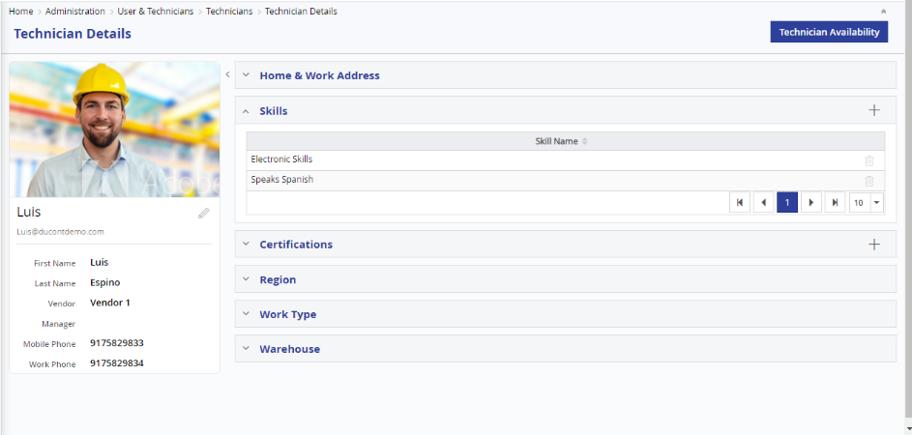

*User -Skill*

**User Master – Certification tab**

Using the Certification tab, an admin user can map one or more certification details to the technician. This can be used for scheduling the jobs which require specific certified people.

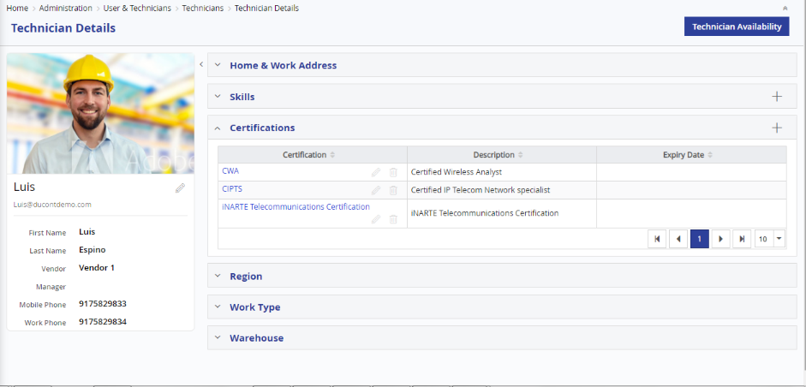

*User -Certification*

**User Master – Region tab**

Using the Region tab, an admin user can map the Regions where the technician will be working. These Regions will be considered by the system during scheduling, based on the scheduling preferences.

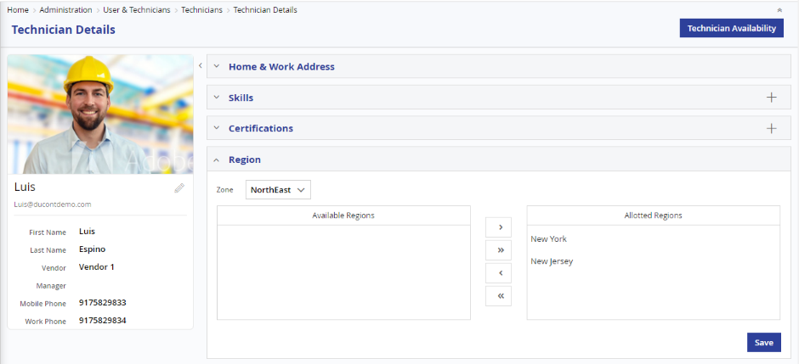

*User -Region*

**User Master – Work Type tab**

Using the Work type tab, an admin user can map one or more Work Types where the technician will be working.

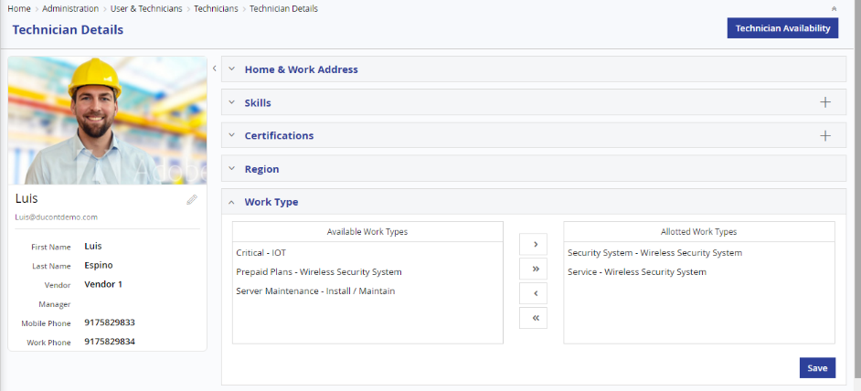

*User –Work Type*

**User Master – Role tab**

Using the Role tab, an admin user can map the role for the user.

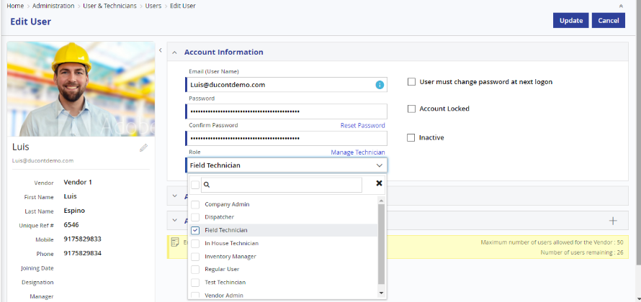

*User –Role*

#### Role Master

Roles can be created by administrators using the Role Master screen. Each User can be assigned with multiple Roles in the User Master. The rights and permissions of the users over the application are driven by his/her role and its corresponding permissions that are set.

There are 4 Role Groups, which are available in the Field Power system. User can create roles based on this role groups.

1. **Administrator**

Admin users act as administrators. Administrators typically have full permission in the application.

1. **Regular User**

Controllers, Call Centre Users, Store Users and other types of users will be considered as Regular users.

1. **Field Technician**

Technicians who complete the job by visiting the Customer’s location can be assigned with this role.

1. **In-house Technician**

Technicians who complete the job by solving customer’s problem through remote can be assigned with this role.

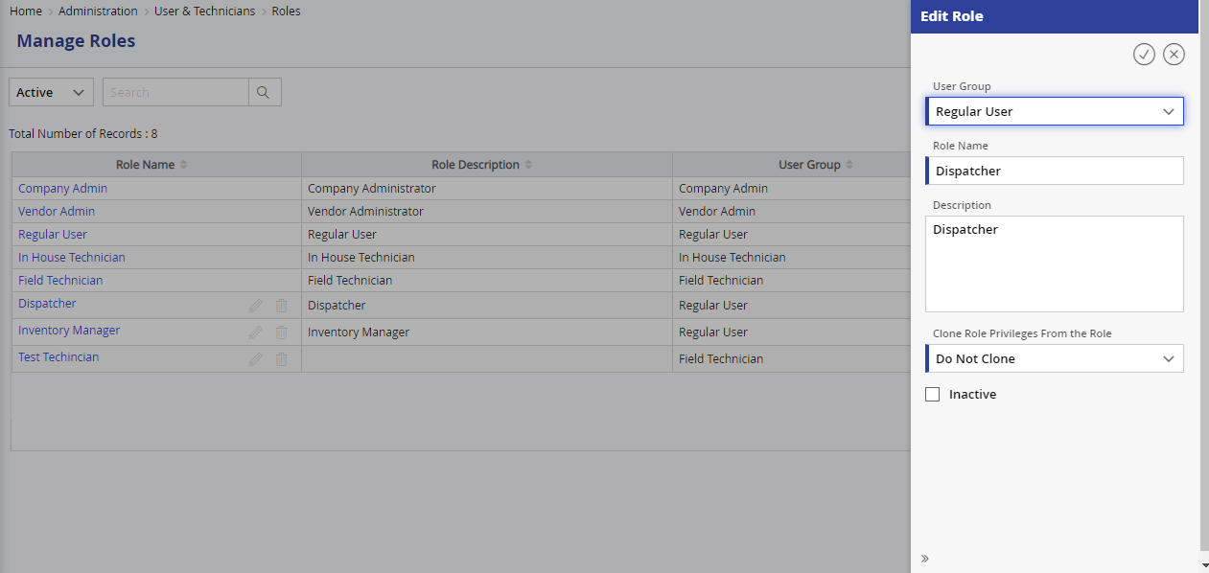

*Role Master*

#### Role Privileges

This admin screen is used to define the access privileges or permissions for the created roles with the application screens (user managed access control). The access can be given both to the screen controls and some functionalities also. When the users / technicians are mapped with these roles, the menu itself will expand and contract based on the allotted roles.

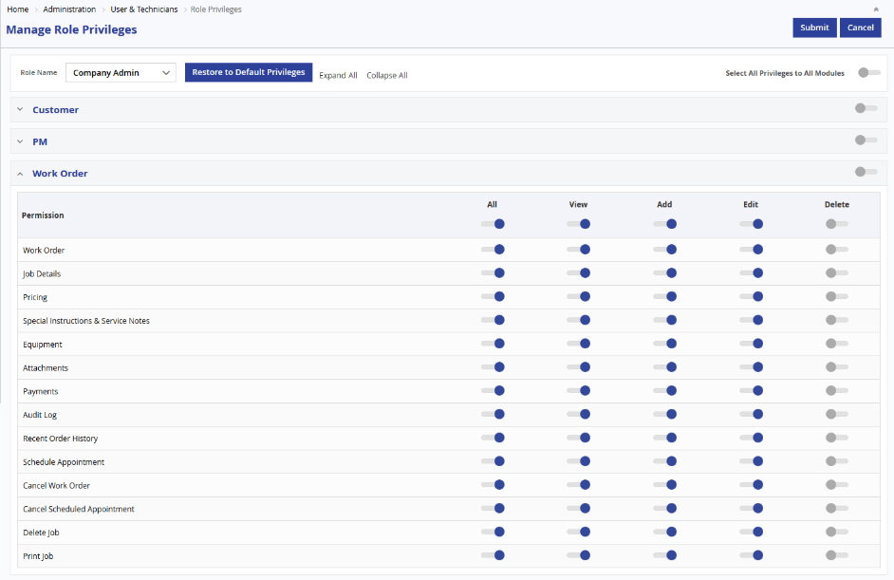

#### Checklist Master / Dynamic Forms

Dynamic checklists are like dynamic forms, which can be added to any Type. The administrator can create multiple checklists against each Type. The value of the checklist can be configured to be one of the following by the administrator:

* Dropdown list with specified values
* Checkbox or tickbox
* Numeric textbox
* Character textbox

The Administrator can also specify if the checklist item is mandatory or not.

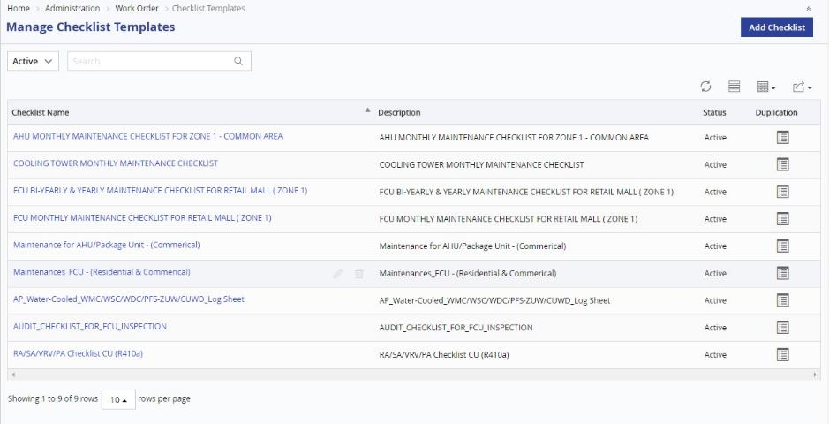

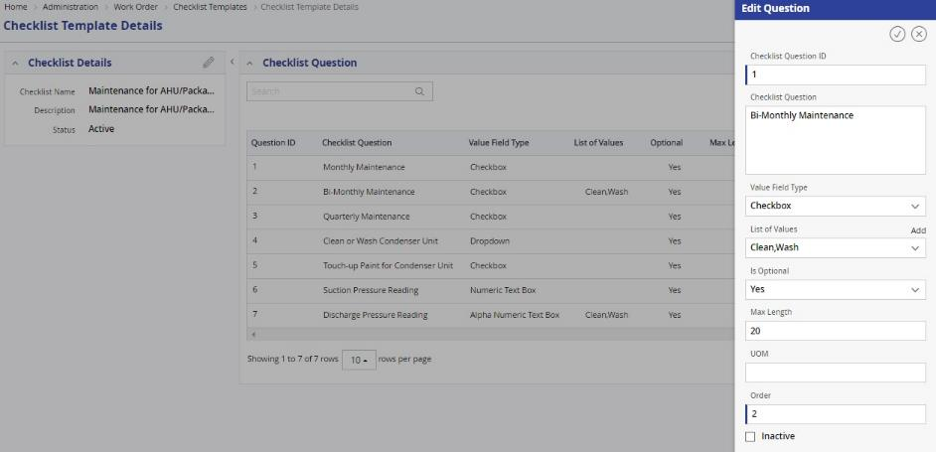

*Checklist Details*

#### Work Order Master

Work Order Master enables the User to classify or categorize the service Requests or jobs performed in the application. The hierarchy is displayed as tree structure in the Work Order master screen. All terminology, validation, workflows, scheduling etc. are configured in this Work Order Master screen, which is mostly accessible by administrators or as per the access privileges set in the Role Privilege for the user.

Using this screen, the Service Request types can be set as Field or Remote / In-house service, which decides on the flow of the tickets. The dispatcher can also configure the planned duration in terms of minutes, hours, days (e.g. 15 minutes, 2 hrs, 4 hrs, 2 days etc.).

Field Power has the option to define the fixed price for the customer, Technicians that can be configured for each service request. This price will be used for calculation of cost and for invoice.

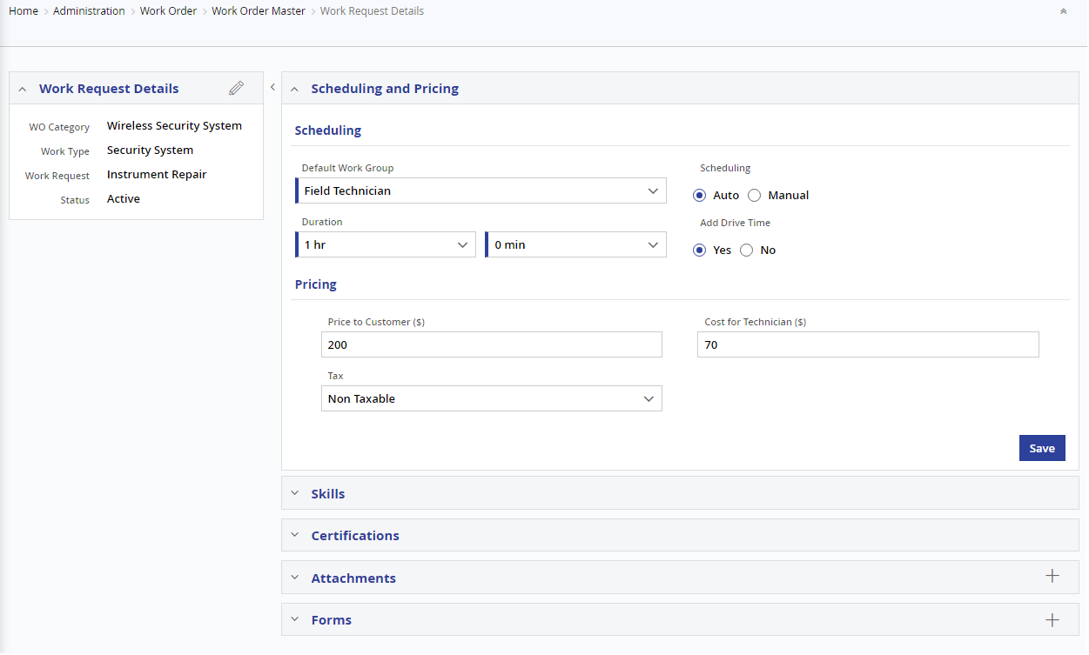

*Work Order Master*

**Work Order Master – Certification Tab**

In this certification section, of the Work Order master the admin user can define any special certification(s) required by the Field Technician for completing the particular job. FieldPower will check mandatorily the technicians having the matching certification(s), based on the setting in the scheduling preferences.

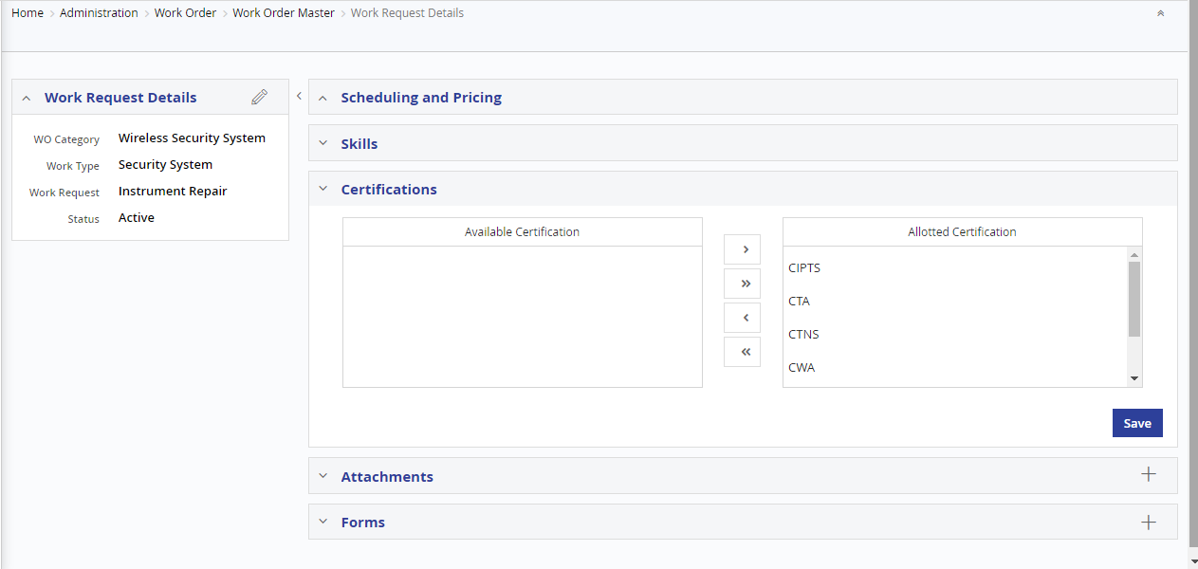

*Certification tab*

**Work Order Master – Skills Tab**

In this Skills section, of the Work Order master the admin user can define any specific skill(s) required by the Field Technician for completing the particular job. FieldPower will check mandatorily the technicians having the matching skill(s), based on the setting in the scheduling preferences.

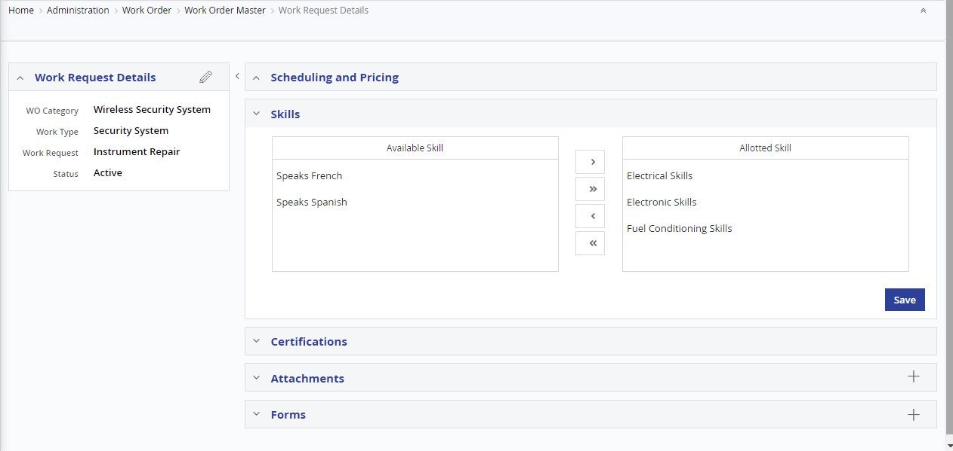

**Work Order Master – Checklist Tab**

The Checklist tab in the Work Order master enables the admin user to define Checklist for each job. These checklists will be cross accessible by the Field Technician when completing the job. Based on the inputs to the checklist fields, the administrator or dispatcher can verify the quality of the completion.

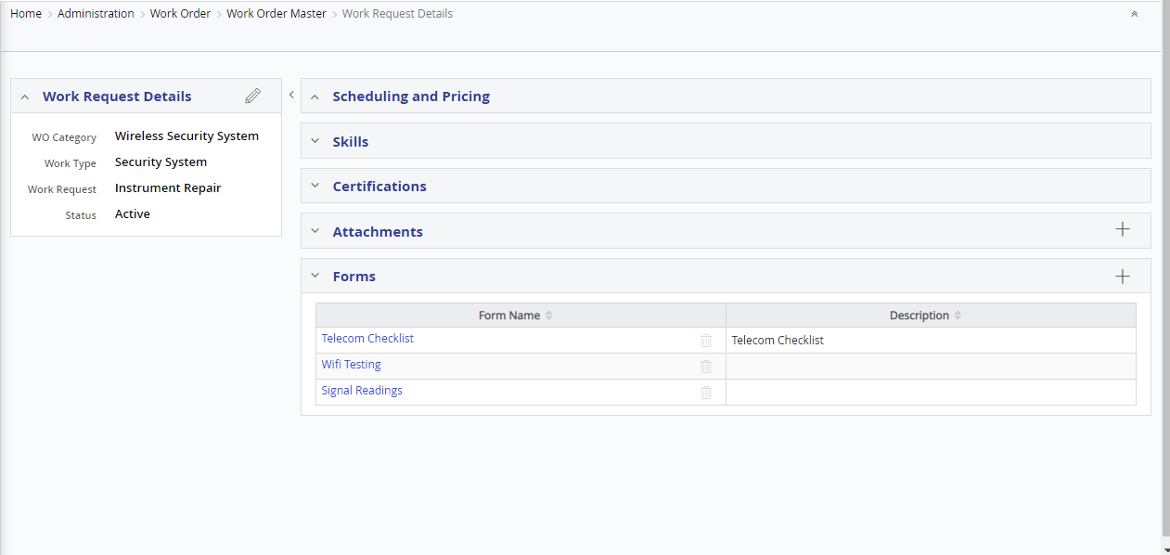

**Work Order Master – Attachment Tab**

The attachment section in the Work Order master enables the admin user to attach user manuals / SOPs for each Work Order type. These will be automatically get attached to the job created against the Work Order Type and will be accessible by the Technician and will assist them in completion of the job.

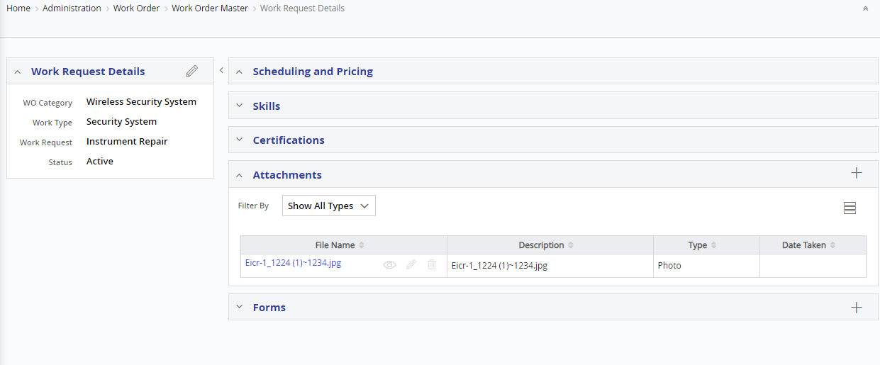

#### Region Master

Regions are geographical boundaries that can be set for customers and technician. These can be used for geo-fencing wherein a set of technicians can work for specific set of customers only.

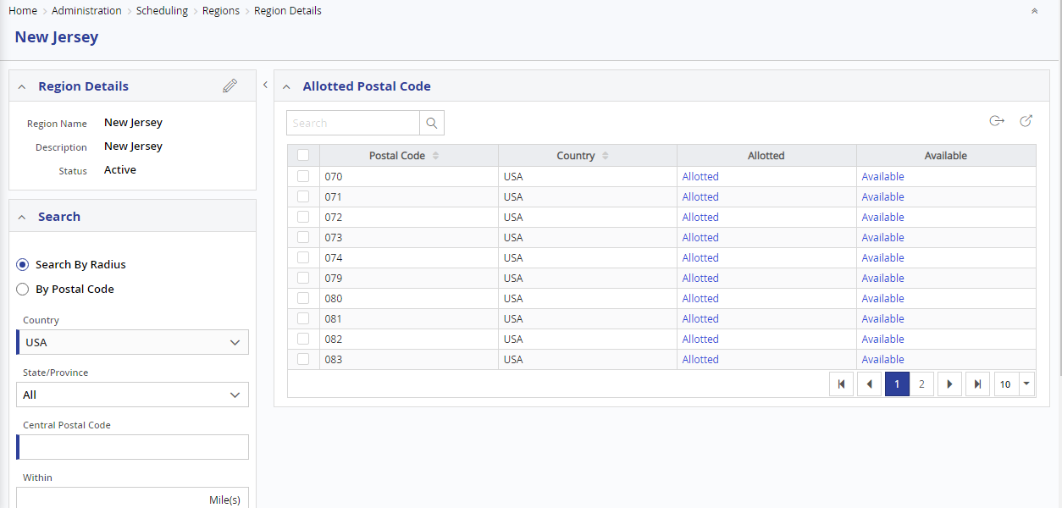

#### Holiday Master

Holiday Master allows the administrator to configure the details about the Public Holidays in the system. The system will not schedule jobs to technicians on public holidays, unless the setting is turned off in the scheduling preferences.

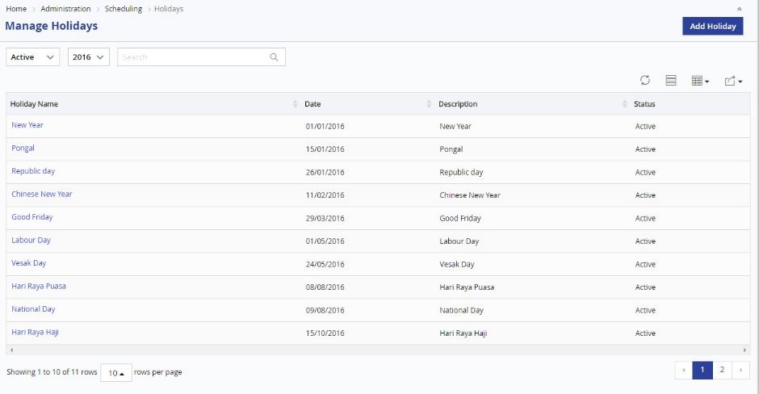

#### Status Reason Master

Status Reasons can also be referred as resolution code and can be created by administrators using the Status Reason Screen. In addition, the User can configure Status Reasons for the job statuses Unresolved (Rejected), Cancel and Completed. The values defined in this master will be available for selection when a job/work order is cancelled or a job is unresolved or completed by a technician.

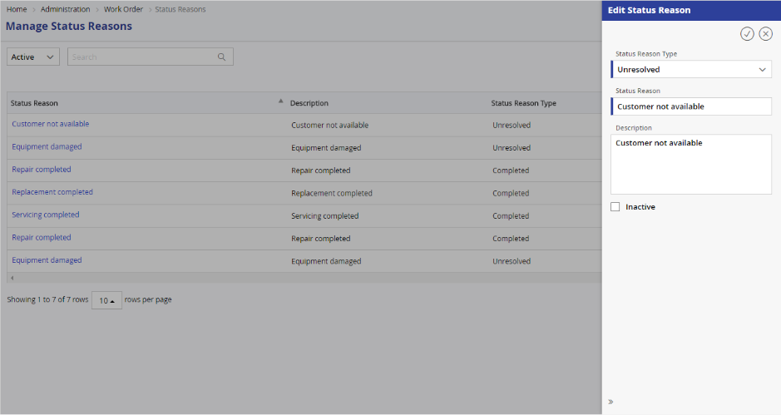

#### Configure Statuses

Work order Status, Job Status and Customer Status can be renamed according to the company in the Master entities tab of the company master settings screen. System will allow the user to rename each status. System will display the renamed work order status, Job status and customer status in all applicable screens across the application.

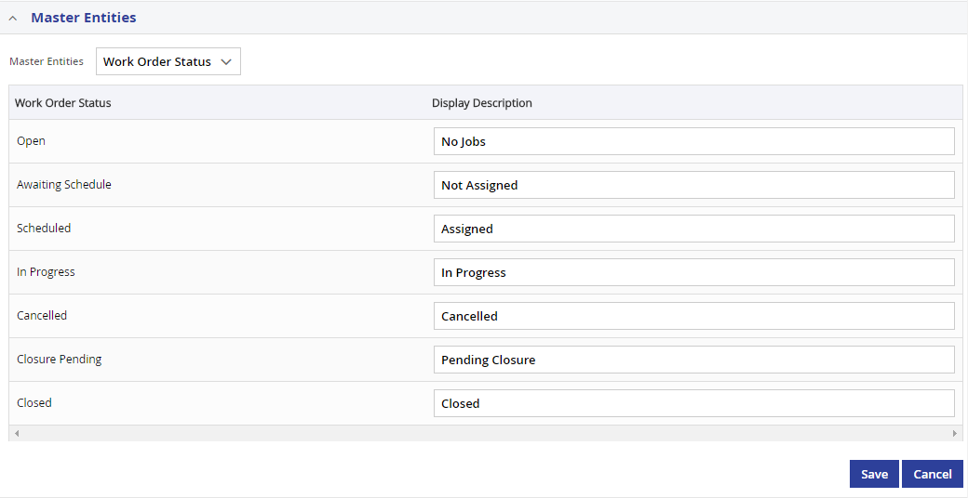

#### System Settings

The admin user can change configuration settings, which help him to control, most of the functionalities of the application, in this screen. The functions that are covered in this screen are,

* User Account Settings – defines the general user settings like password length, strength, expiry etc.,
* Attention required settings – defines when attention required notification should be shown.
* Email & SMS Settings – defines the CC list for mails and turning on and off the Email and SMS.
* Work Order Settings – defines the prefix for the Work Order numbers and PM Order auto-generation date.
* Approval Settings – defines the auto-approval of Work Orders
* Mobile Settings – defines the GPS tracking option and the photo resolution for Technicians

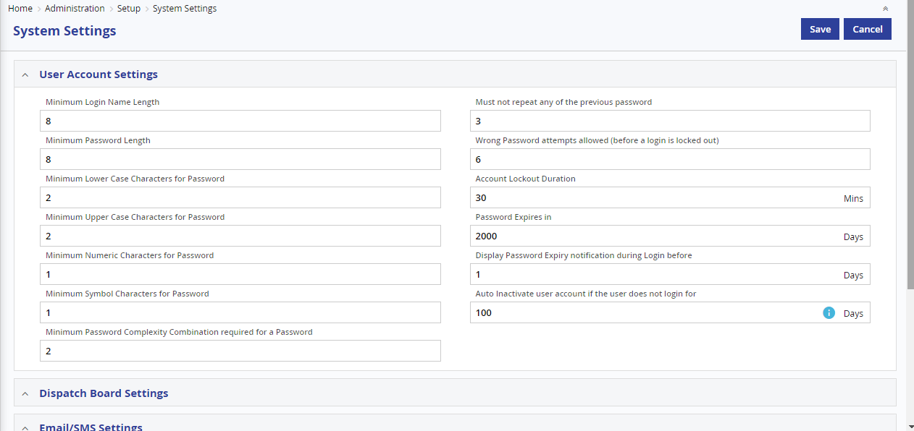

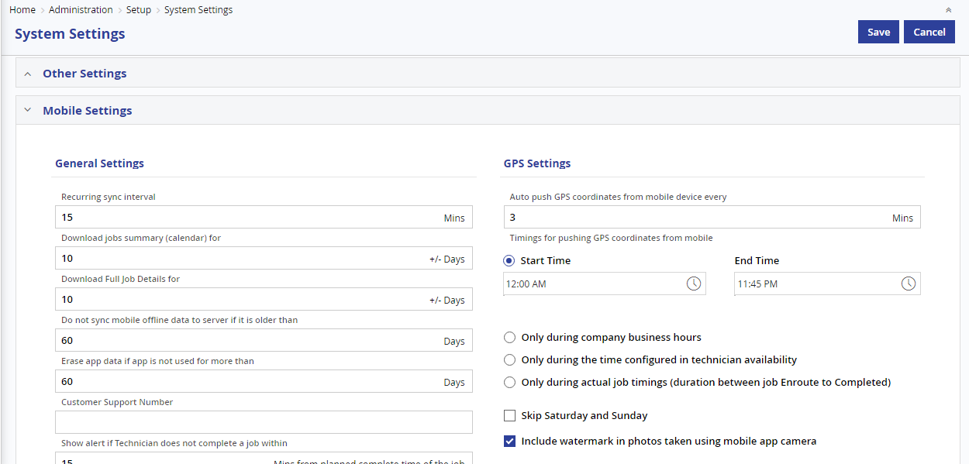

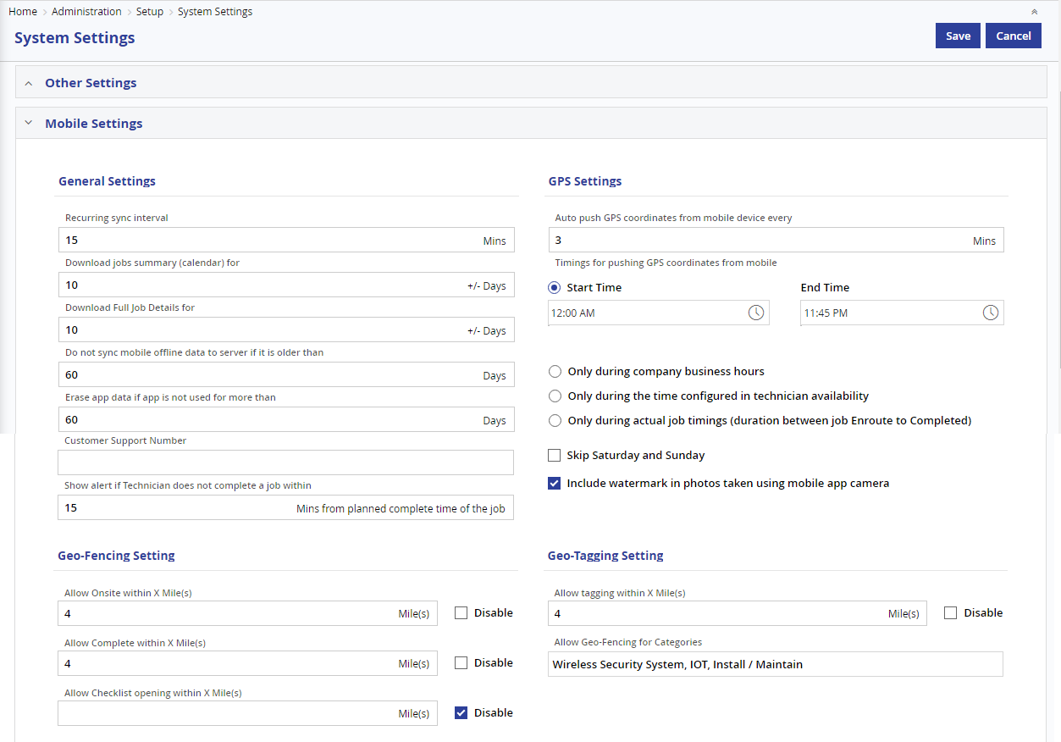

#### Custom Fields

There are cases wherein a screen might need some additional fields to capture some additional information. To enable this, FieldPower has the unique capability of configuring and adding custom fields. The custom fields can be created using the custom field master in the administration section. The field can be of one of the following type:

* + Text Field
  + Number Field
  + Date Field
  + Label
  + Dropdown
  + Check Box
  + Bar Code / QR Code Field

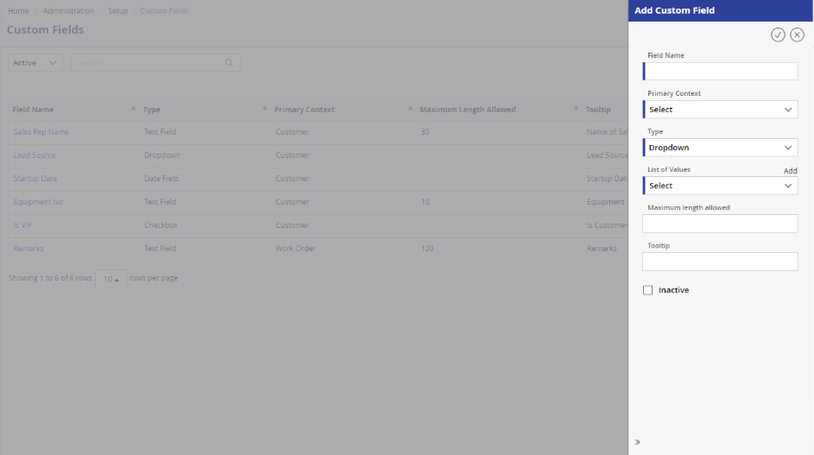

Once created, the field can be attached to any of the existing screens as below:

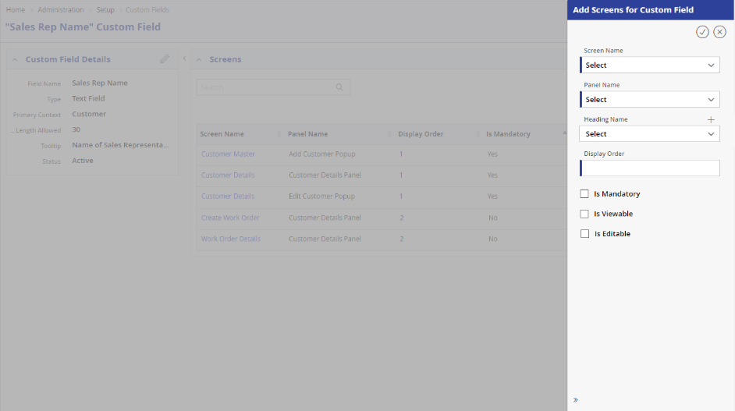

#### Custom View

There are two levels of custom view. Using the first option, the administrator has the complete control of what are the columns that need to be seen in the list views of the screens. The administrator can control the filters, columns, export options that need to be visible in a particular list view. They can choose from the available fields and add or remove the fields from the screen accordingly. This also includes display / hiding of the custom fields defined.

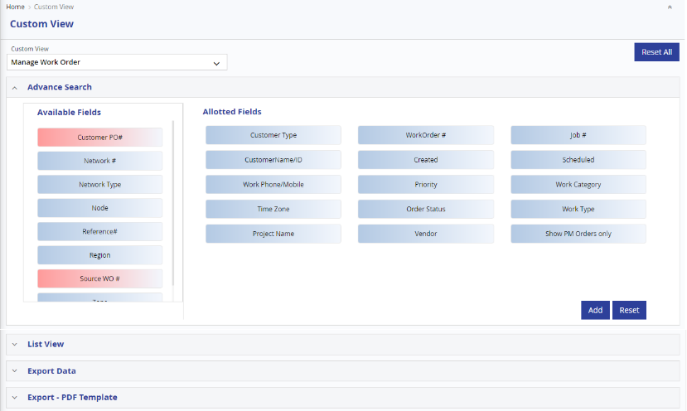

The second one is user specific settings. Most of the listviews have configuration, where user can configure the columns they want in the order they want. This gives some personalized view of the lists.

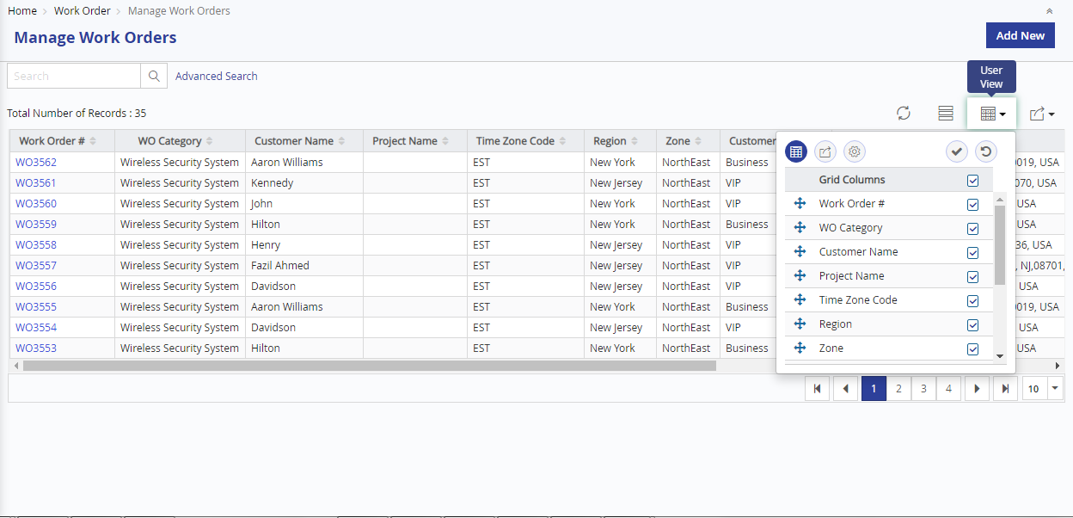

### Reports & Dashboards

FieldPower has variety of interactive graphical Reports & Dashboards which used to measure quantity, quality, and performance of the field service work, and should be used to compare SLAs, determine where improvements are needed, and to meet audit requirements. All reports can be exported to Word/PDF/Excel files.

Based on the user’s access rights, the users can view the reports according to the hierarchical access level. Technicians will be able to view their own job details, Managers will be only able to view their Technician’s job details and the Administrator will be able to view all information including dashboards. Also, the data is hidden across different vendors also, so that one vendor’s information is protected from other.

#### Online Reports

Following are some of the default reports available in FieldPower.

1. Work Order Summary Report
2. SLA Report - Customer
3. SLA Report - Technician
4. Field Status Report
5. Unresolved Summary Report
6. Tech Utilization Report
7. Technician GPS Status Report
8. Technician Conveyance Report
9. Resolution Code / Status Reason Report
10. Stock Adjustment Report
11. Stock Status Report
12. Van Inventory Report

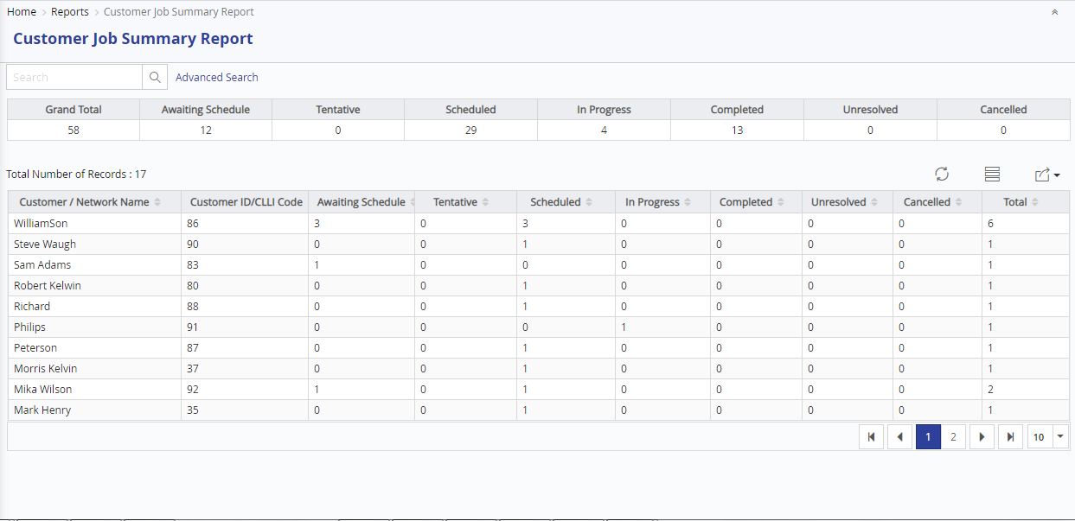

*Work Order Summary Report*

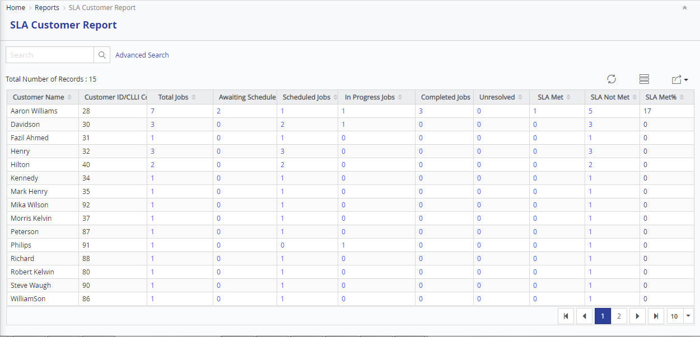

*SLA Customer Report*

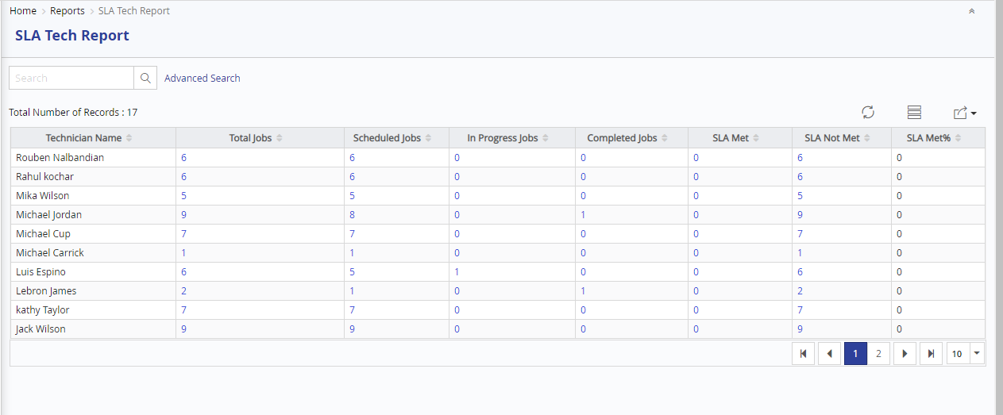

*SLA Technician Report*

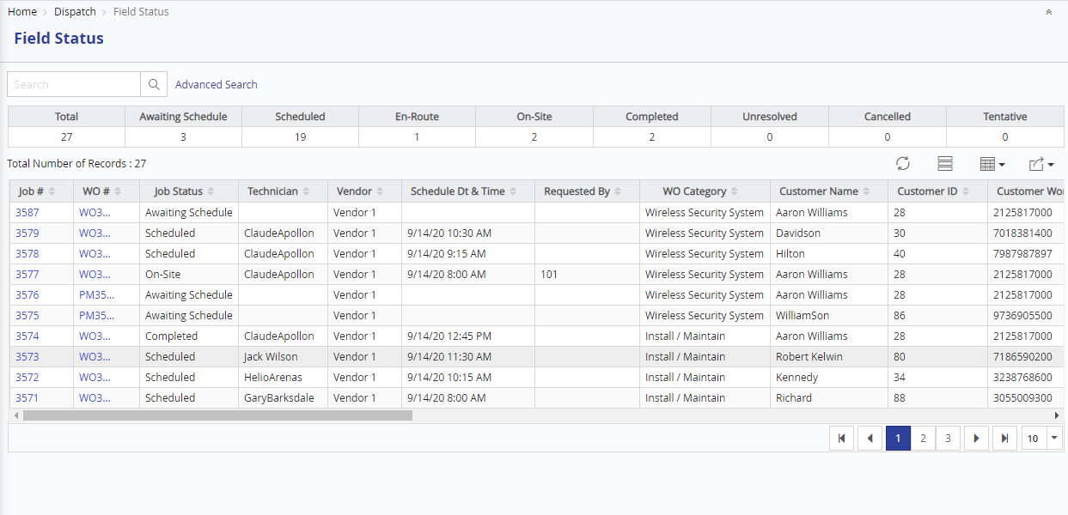

*Field Status Report*

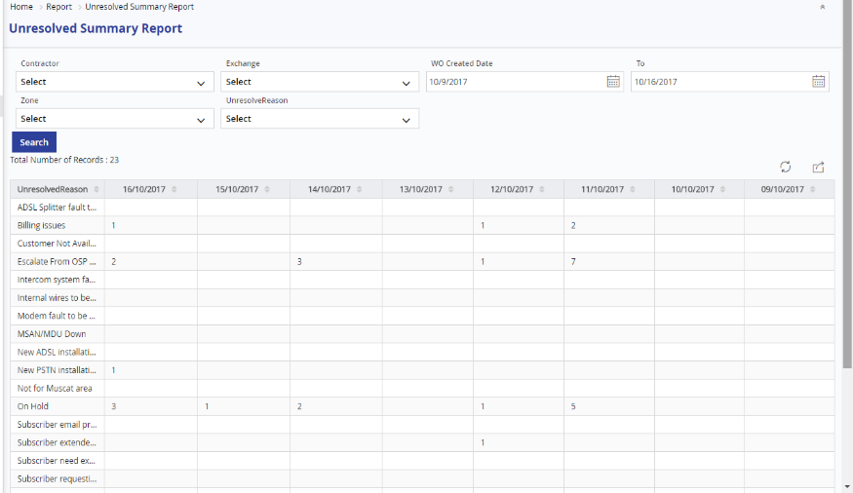

*Unresolved Summary Report*

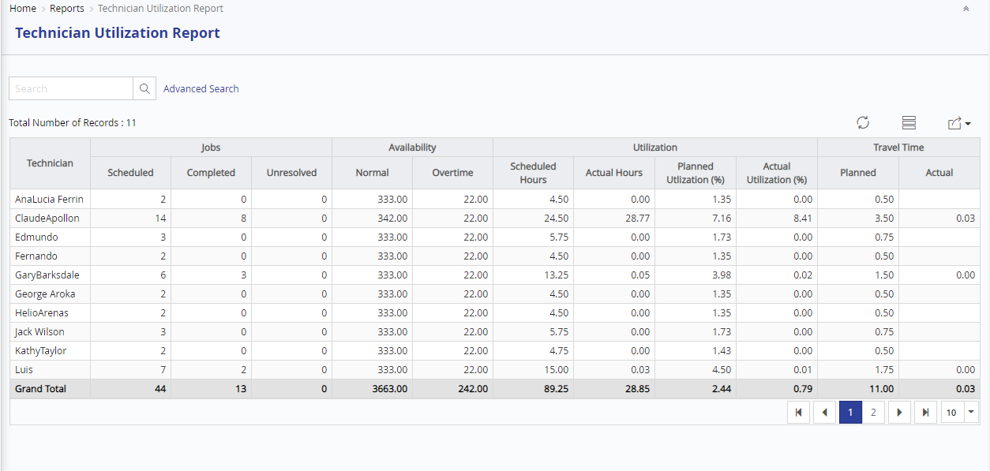

*Tech Utilization Report*

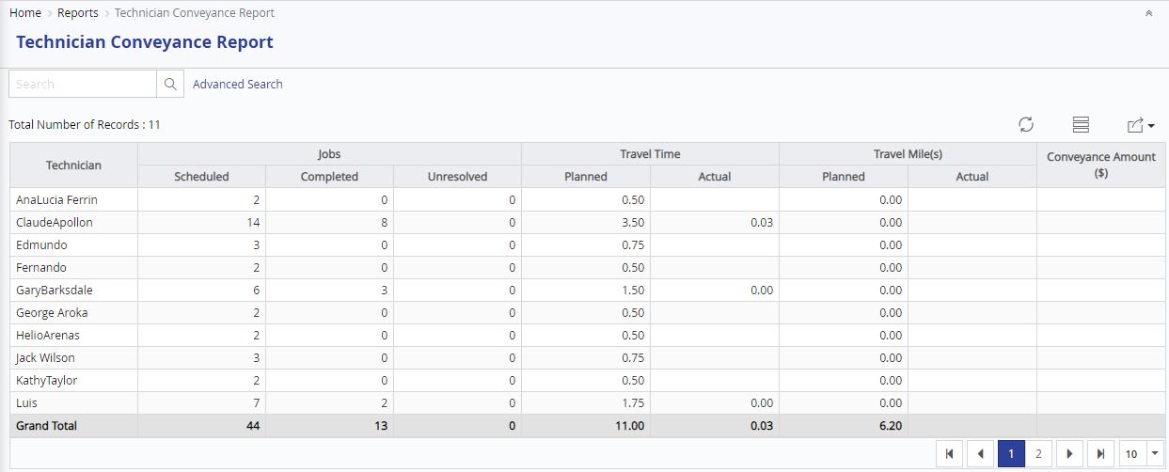

*Technician Conveyance Report*

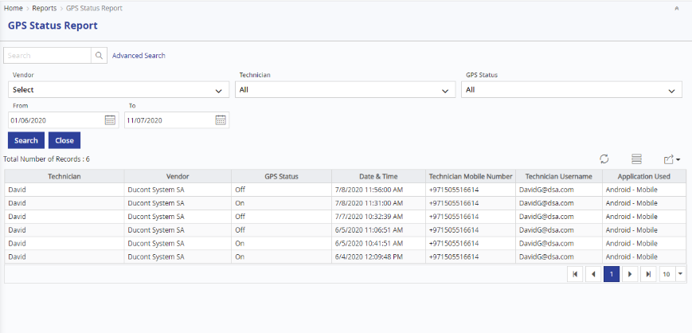

*Technician GPS Status Report*

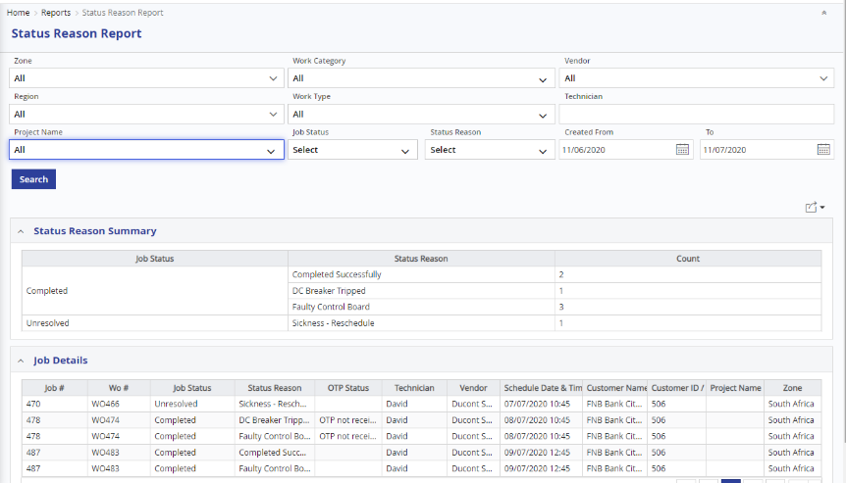

*Resolution Code / Status Reason Report*

#### Dashboards

FieldPower has varied dashboards, which give different perspectives to the data.

Management View

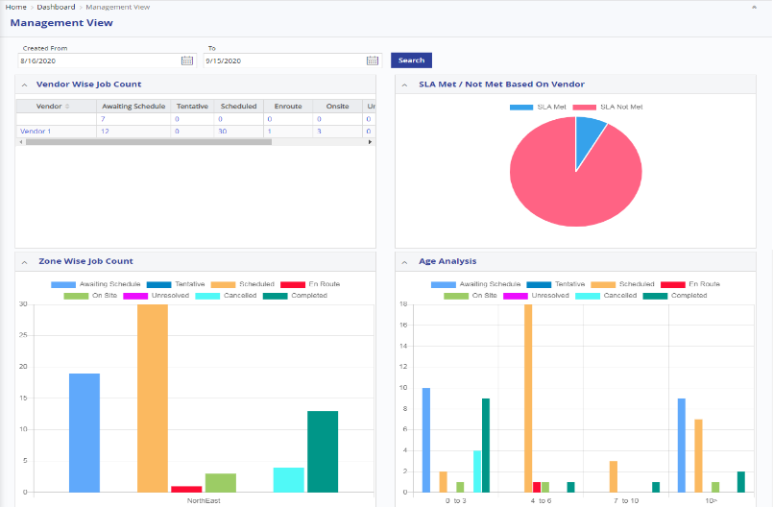

*Management view Dashboard*

Dispatcher View

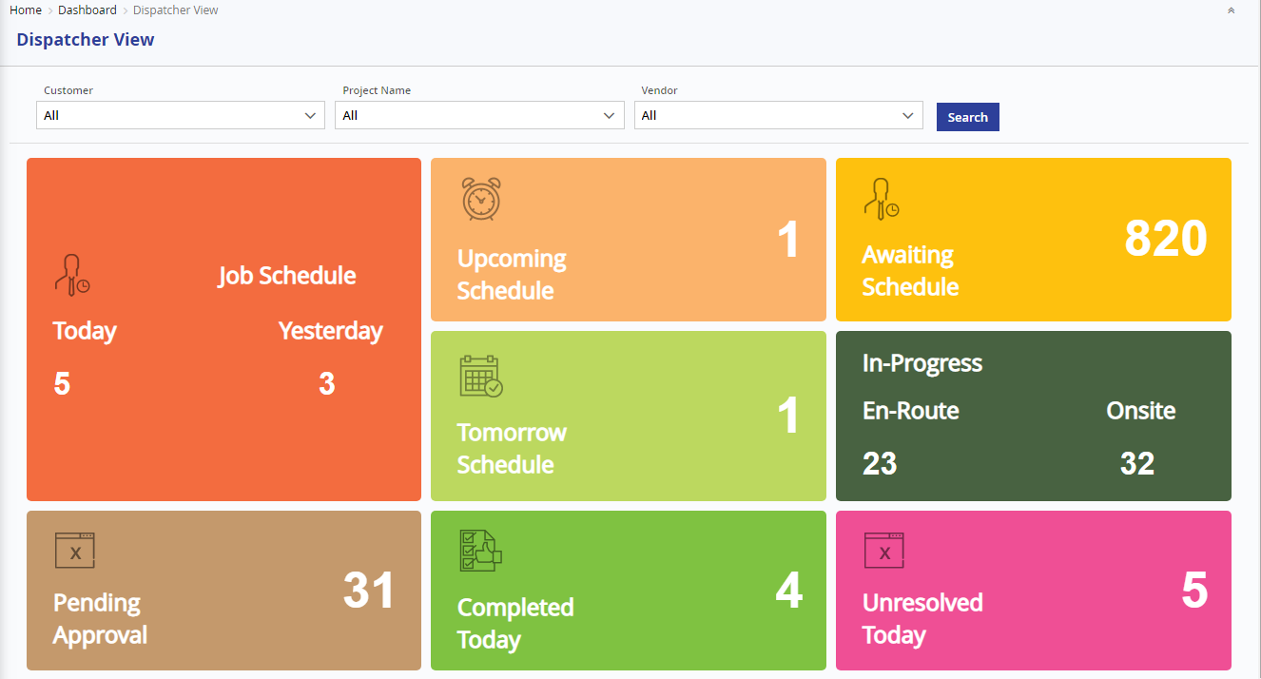

*Dispatcher view Dashboard*

Operational View

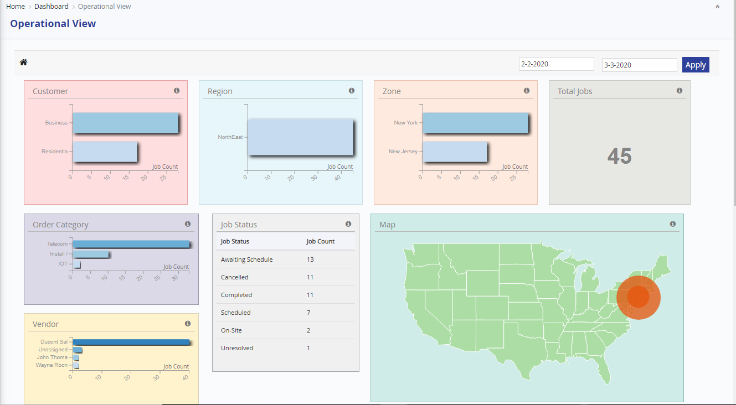

Descriptive Dashboard

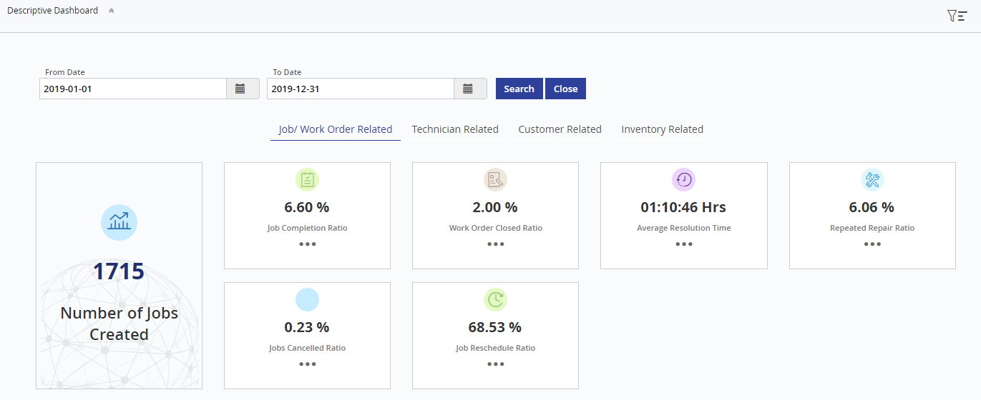

**Job Completion Analytical Dashboard**

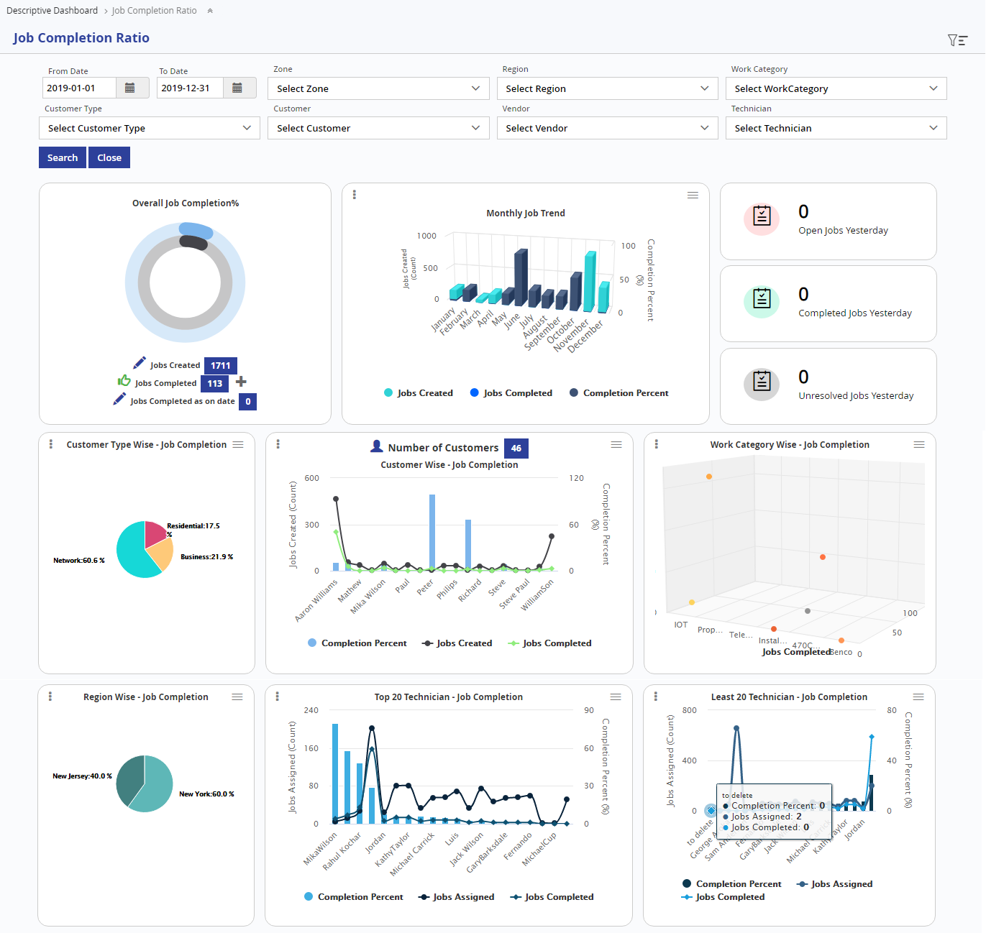

**SLA Analytical Dashboard**

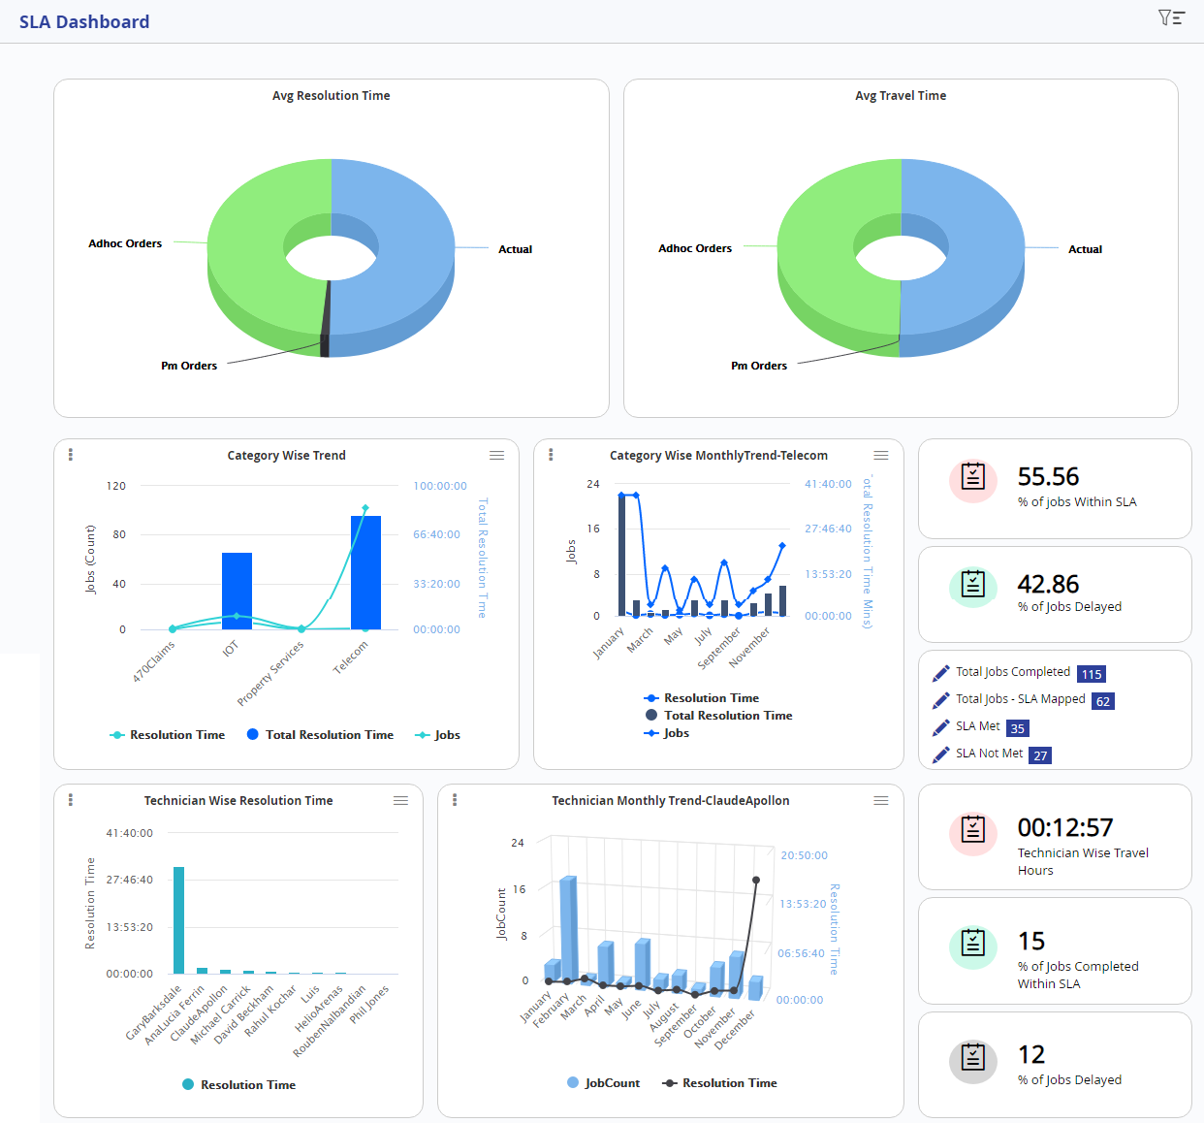

#### Ad-hoc Reports

This option gives users to create their own reports. These reports can either be List Reports and Summary Reports. The users can also build graphical reports with Bar/Pie/Line Chart. The user can also choose Data for report and rename columns and choose Report filters. They are also able to setup Formula for calculated felds, and include subtotals. All these reports can be exported to pdf or excel formats.

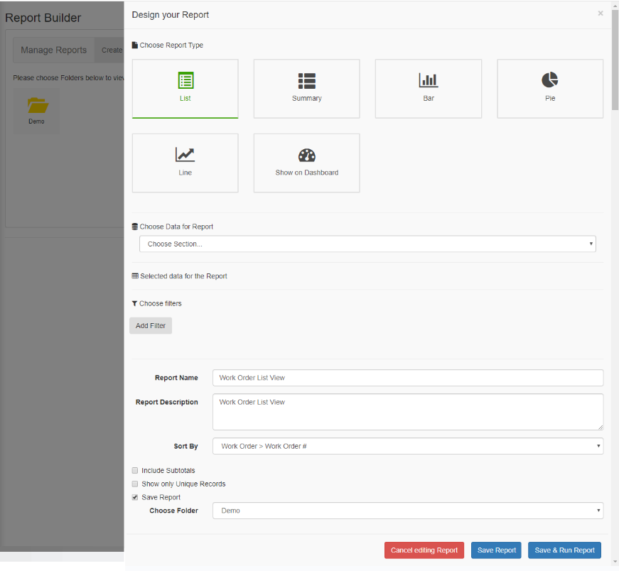

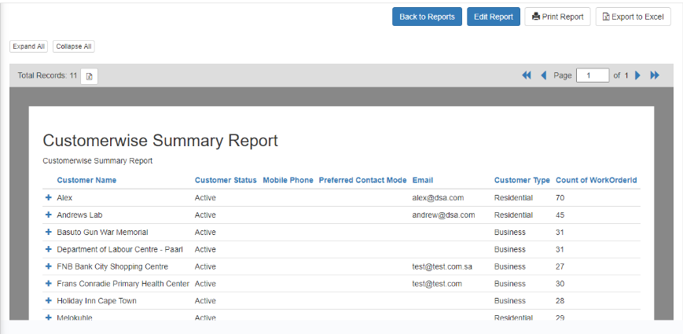

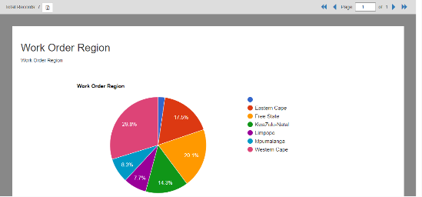

### Integration

Being a System Integrator, ZSL has more than decade experience in customizing and integrating external systems, to our Clients’ needs. Our application integration services help companies gain greater business agility using the applications they have today. With access to a real-time flow of information, people are able to make better business decisions more effectively.

#### Integration Options

* XML / Web Services
* Batch feed
* Flat files
* SQL to SQL application integration and so on

#### Real Time Integration Approach

The field Power system is being widely used with legacy / prominent enterprise systems. ZSL has dedicated teams working on enterprise solutions like ERP, Remedy and customized .Net applications. In the process we have developed connectors for integration with major Enterprise solutions. Prior to implementing the Integrations, the following steps would be performed as part of the Analysis and Interface Design Phases:

* The Interface/Integration requirements would be arrived at by ZSL team working with other application owners to identify the needs, constraints etc. Since our team has performed such integrations, we will bring a wealth of experience, suggestions and best practices to the table, shortening the cycle
* Multiple ZSL teams will be engaged depending on the needs of other ERPs, to execute this step in parallel
* The Interfaces/Integrations will be prioritized based on various considerations such as logical order in which Field Power will have to integrate (e.g. Single Sign on may usually be the first candidate)

#### Integration Expertise

Some of our Integration experiences are

**ERP Systems**

* SAP
* Oracle
* Microsoft GP
* Microsoft Axapta
* Mainframe Billing System
* Microsoft Navision

**CRM**

* Microsoft CRM
* Siebel CRM

**Ticketing System**

* Remedy
* Net cool

**Others**

* QuickBooks
* 3rd party Systems such as inventory, Billing, Payroll
* VRU System (Voice Response Unit) – 3rd Party Call Centre System
* Home grown Systems (Ticketing Systems)

#### Swagger

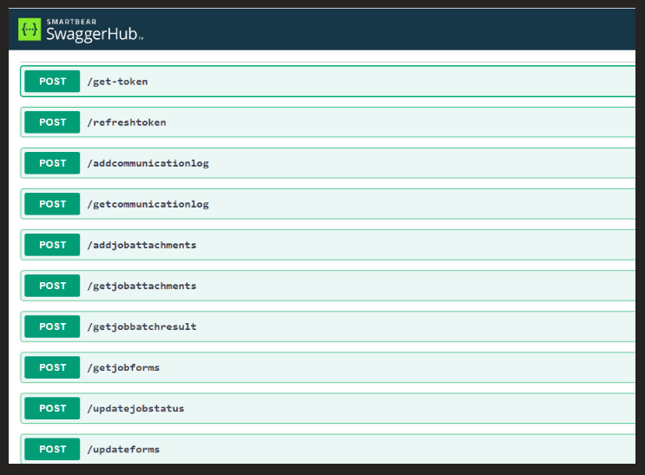

# Project Management

## Project Strategy

ZSL follows a project management approach based on industry best practices. Key elements of our approach are:

* A robust project management methodology
* A project organization with clearly defined roles and responsibilities
* A detailed project plan with clearly defined tasks, subtasks, milestones, and delivery dates
* Formal project risk management methodology and practices
* A structured change management system
* Clear, open and continuous communication with clients and the project team
* An industry standard quality assurance program covering all project phases

Given the scope of the Project – implementing a comprehensive Field Service Automation solution and integrating the application with various CLIENT applications, a strategy that enables us to execute the project in chunks, gaining quick wins and making necessary course corrections is suggested. This provides the opportunities for rollout of functionality in small increments (if necessary), instead of implementing all the functionality as a monolith.

Agile methodology will be used to execute the project and develop the functionality incrementally. We recommend the Agile model since Agile methods attempt to minimize risk by developing software in short “time boxes”, called iterations, which typically last one to four weeks, each iteration is like a miniature software project of its own and includes all of the tasks necessary to release the mini-increment of new functionality: planning, requirements analysis, design, coding, testing and documentation. Agile methods emphasize working software as the primary measure of progress.

We carefully considered the following points/benefits to propose agile methodology:

* Being a new engagement, Customer satisfaction is critical, and it can be ensured using the agile approach of rapid, continuous delivery of useful software. Besides there would also be emphasis on close, daily, cooperation between business people and developers
* Working software which is the principal measure of progress could be delivered frequently (few weeks) in order to solicit feedback and use the feedback to mitigate risks earlier
* Provide flexibility in case requirements need to be changed
* Review the rate of progress and quality early
* Conduct regular reviews with the business
* Evolve the solution based on experience and feedback
* Reduce the amount of change at the end of the project
* Review and improve the project process
* Frequently practice the deployment prior to delivery

## Project Governance

Having implemented FieldPower and integrated with ERP applications, ZSL understands the magnitude of such an engagement and the business impact it can have on our Clients like CLIENT. A well-qualified and experienced ZSL team will be constituted to work with CLIENT hand in glove for rolling out the Work Force Management Solution. An indicative team structure (Project Organization Chart) is shown below:

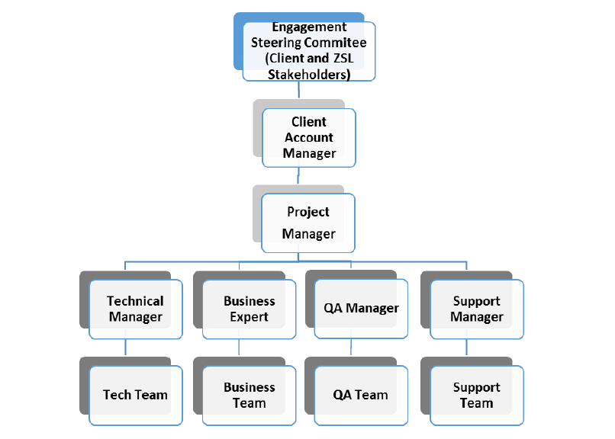

The project organization chart shows only key stake holders and this team will be supported by project leaders, business leaders, module leaders, developers, QA personnel, documentation experts, system administrators etc.,

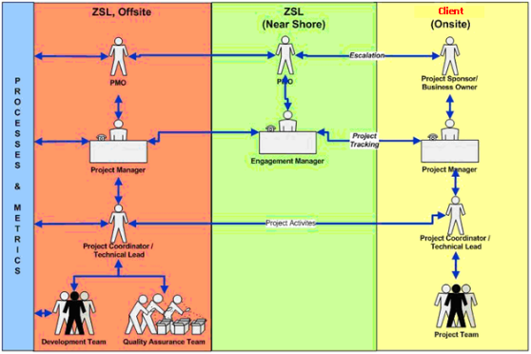

**ZSL Team Structure**

ZSL provides a dedicated team for the CLIENT for the full duration of the Implementation consists of:

* Project Manager
* Project Lead
* Implementation Engineers
* QA Team
* Business Analyst/Documentation specialist
* Training coordinators

**CLIENT Team Structure**

In order to ensure project success and ensure that all the items on the project plan are delivered as per schedule, CLIENT is expected to provide the following resources as a best case scenario.

* Project Sponsor
* Project Manager
* Subject Matter Expert
* Technical Resources
* UAT Testers

**Steering Committee**

ZSL setup a Steering committee comprising of nominated senior members of the CLIENT management team and a nominated representative from ZSL. The committee will be fully apprised of project status on an on-going manner and the steering committee shall convene at CLIENT site once a month, to address any issues and remove any obstacles, so as to keep the project on track. Emergency sessions of the committee can be convened on a needed basis, which can be conducted remotely using audio/video conferencing.

This group would meet to review the project progress, external dependencies and make necessary course corrections as applicable (frequency to be decided mutually).

## Implementation Approach

The overall implementation plans, comprising of difference phases as shown below:

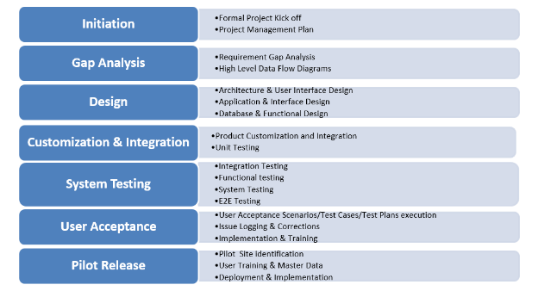

## Quality Assurance Review

ZSL’s quality assurance program begins with adherence by our project teams to our expansive project management methodology, as well as adherence to the diverse components of our methods and processes. ZSL is committed to delivering quality at all stages of CLIENT relationships, but nowhere is this more pronounced than in the area of quality assurance. While other companies treat the term as synonymous with quality control, for ZSL it means far more. From the dedication of ZSL’s staff in helping clients meet business goals, to the state-of-the-art tools and technology that back ZSL’s solutions, the company sees quality assurance as a standard that must be upheld at all times, even extending to the company’s approach to details such as online documentation of reports, proposals and design layouts. Once hand-off is complete, furthermore, ZSL reaffirms this commitment with rigorous quality assurance mechanisms that apply to all customer support procedures.

Additionally, ZSL ensures quality and currency in our project delivery practices through an internal process improvement program for our own methodologies.

Our internal Project Review process is applied to all active projects. The Project Review is a formal and independent evaluation of the methods and techniques used to deliver a project and of the deliverables that are produced as a result.

The Project Review is intended to measure the project’s probability of success based on adherence to “best practices” and ZSL’s established methodologies.

The objectives of the Project Review are to:

* Ensure a mitigated risk managed process
* Identify project strengths, risks, and opportunities
* Recommend changes and develop action plans to improve project conduct and operations
* Improve the quality of projects by measuring adherence to ZSL Inc’s methods and processes
* Gather “lessons learned” to improve the quality of our delivery process
* Identify “best practices” for process improvement.

## Project Execution Timeline (Typical Project Plan)

The overall project execution timeline is provided as a Gantt chart below. We are able to propose the iterative delivery plan, given that there is a good map between our off the shelf offering and CLIENT requirements. Since we have integrated FieldPower with Remedy, Access Care, GP, SAP, CRM, any ERP and internal third Party applications for other Clients, the Design and Development can be done rapidly.

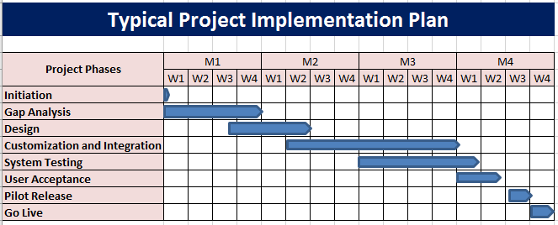

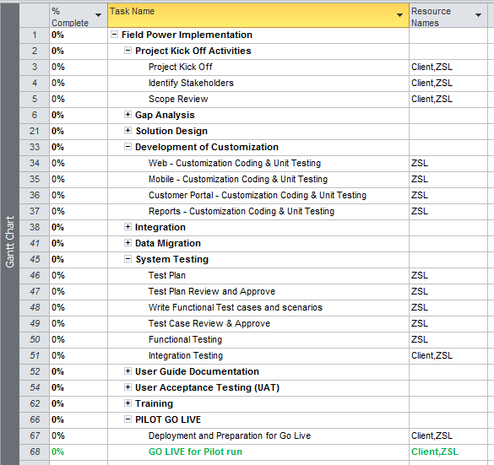

A detailed project plan will be submitted after the contract is awarded & will get updated as the project progresses. Regular Progress & Status reports would be provided to Customer on mutually accepted timelines.

Note that the above schedule is indicative and this will be updated accordingly, based on requirement study and mutually agreed upon on start date both by ZSL and CLIENT.

## 

# Training

FieldPower will develop training content based on completed and approved testing scripts provided by Client. Following completion of testing, no changes may be made to the environment in which training will be delivered. Training may commence five (5) business days following the final training sign off, completed UAT, provided the following dependent tasks and activities are successfully completed and approved:

* Final sign-off of UAT
* Stabilized training environment (no changes or work can be done in training environment prior to completion of training)
* Walkthrough of change log and training environment to establish deltas for training content

FieldPower will deliver training on the FieldPower functionality and will include “Train the Trainer” sessions up to five (5) business days following the completion and sign off all testing activities. “Train the Trainer” is a program designed to prepare trainers and super users to deliver FieldPower training to their respective end-users. An approach of a “Train the Trainer” strategy will be implemented so that specific key personnel will be trained to be the internal ‘go to’ staff for any and all first line issues and questions.  They would in turn provide user training for new personnel as well as periodic refresher help to internal users across the organization. The Super Administrator would be the main point of contact for Client with Fieldpower going forward. Hence we recommend assigning experienced personnel.

Training will include business flow orientation with an end-to-end system introduction as well as hands-on experience with the various modules and capabilities of the system needed for day-to-day operation based on the different user groups such as - Administrators, Supervisors, and Technicians. Processes on systems other than FieldPower are out of scope.

Fieldpower will develop end-user “Train the Trainer” classes for the following three (3) unique user profiles:

* Admin Users
* Back Office / Dispatcher
* Field Technician

Deliverables

All content for “Train the Trainer” will be created by Fieldpower and delivered to Client via onsite instructor-led sessions. Training materials provided will cover key topics each profile will perform in the application in order to drive measurable, attainable, repeatable results. Training materials are designed to be utilized for training end users in an 8-hour hands-on training session or a 4-hour web-based training session for each user profile. Training materials will be delivered electronically in PowerPoint for the respective role-based training.

# Support & Maintenance

## Commitment to Our Clients

FIELDPOWER is committed to delivering high-quality products and support to our clients and partners. In the event that you need to escalate a case, senior technical staff is ready and available to help you quickly bring your issue to closure.

## Support & Maintenance

FIELDPOWER will provide Phone, Email and IM (Instant Message) support from our Technical Support in the normal working hours 8.00 AM to 5.00 PM or 24/7 based on the Silver or Gold Service Level.

All defects and issues logged by the client with FIELDPOWER during the warranty/Terms phase will be assigned a priority/defect level which indicates its relative importance.

**The defined priorities/defect levels are listed below:**

|  |  |  |
| --- | --- | --- |
| **S/N of Defect Level** | **Defect Level** | **Impact** |
| 1 | Critical **\*** | Blocks further progress in the application. The user cannot proceed with the required process. The application may or may not crash. Severe issue that prevents the user from accessing the desired functionality. A lengthy workaround is available but is not commercially viable.  For Example : Application is not responding, User are not able to login, Page can't be displayed , No Operation |
| 2 | Major **\*** | Caused a major loss of functionality but the user can proceed with lengthy workaround that is a viable in a business environment.  For Example : Unable to Create/Update the record, Data Issues |
| 3 | Minor * | Causes a minor loss of functionality or a cosmetic problem where easy workaround is viable in a business environment.  For Example : Alignments, Incorrect Validations |

* FIELDPOWER support team will try with best effort to resolve the issues or providing work around within limited resolution time, but If it is required any development work such as patch work or fix, then the below activities will be performed in business hours before applying the fix/patch in production.

* Functional or Development Lead will identify and create an impact document and will send to Client Team.
* FIELDPOWER development team will be working on the patch or fix.
* Patch/fix will be tested by Quality/Testing Team.
* Patch/fix will be deployed in Pre Production server first and tested by User to get the confirmation to roll out in production.
* Patch will be rolled out in production server during the scheduled roll out time.

The defined defect levels and the timescales resolution are given below.

**Business Hours (8.00 AM to 5.00 PM)**

|  |  |  |
| --- | --- | --- |
| **Defect Level** | **Maximum Response Time** | **Maximum Resolution Time** |
| Critical | 2 hours  (Acknowledging the Problem) | 4-6 hours  (FIELDPOWER to work with in business hours and non-business hours until problem identified) |
| Major | 6 hours  (Acknowledging the Problem) | 48 hours  (FIELDPOWER to work in business hours until problem identified) |
| Minor | 8 hours  (Acknowledging the Problem) | 5 Business Days  (FIELDPOWER to work in business hours until problem identified) |

**Non Business Hours, Weekends & Public Holidays**

|  |  |  |
| --- | --- | --- |
| **Defect Level** | **Maximum Response Time** | **Maximum Resolution Time** |
| Critical | 8 hour  (Acknowledging the Problem) | 24 hours  (FIELDPOWER to work with in business hours until problem identified) |
| Major | 16 hours  (Acknowledging the Problem) | 2 business Days  (FIELDPOWER to work in business hours until problem identified) |
| Minor | 24 hours  (Acknowledging the Problem) | 5 business Days  (FIELDPOWER to work in business hours until problem identified) |

**Available Services:**

1. **Gold :** 24 hours per day, 7 Days per week
2. **Silver :** 08:00 AM to 05:00 PM, Monday to Friday and Excluding Public Holidays

Both the services will be offered based on the above mentioned defect levels and timescales. The maximum resolution time is measured from the elapsed time from the time that the defect is logged in the FIELDPOWER’s bug tracking system to the time that the fix is available to be tested by the Client. FIELDPOWER will ensure that the appropriate escalation process is in place to ensure that these timescales are achieved.

## Incident Response Management

Incident management process to be followed Client service desk and FIELDPOWER:



## Escalation Procedures

The following escalation process will be administered by the FIELDPOWER support team and in place from the agreed start date of the support contract.

**Support Issues**

|  |  |  |  |  |  |  |
| --- | --- | --- | --- | --- | --- | --- |
| **Escalation Level** | **Description** | **Client Contact** | **FIELDPOWER Contact** | **Escalation based on issue Priority*:** | | |
| **1** | **2** | **3** |
| 1 | Day-to-day issue resolution | Support Desk | Support Desk | ✓ | ✓ | ✓ |
| 2 | Routine escalation | Operation Manager | Support/Project Manager | ✓ | 🗶 | 🗶 |
| 3 | Critical escalation when issues may impact business performance | Operation Head | Delivery Head /Product Head | ✓ | 🗶 | 🗶 |

*Issue to be escalated to the individuals stated without delay via email and phone call, Name and contact numbers are provided after application go live.

### ****Release & Deployment Process****

#### Planned Releases

Planned Releases will be delivered based on the schedules, unless agreed otherwise by both parties, this will be formally reviewed after go live. The release will resolve all agreed open issues (as agreed in a release plan). All software upgrades will also be addressed in the planned releases.

#### Emergency Releases

Emergency Releases will be delivered on an as required basis. Delivery dates will be agreed by both parties and will be in accordance with the pre defined SLAs. Emergency Releases will resolve any defects classified as ‘Critical and will resolve selected ‘Major’ issues which are identified by the Client and FIELDPOWER.

## Support Ticketing System

FIELDPOWER uses JIRA as Support ticket system to track all the support tickets and respective SLA. JIRA simplifies every step of support tracking for everyone involved. Creating, triaging and resolving support tickets in a snap. And managing tickets along with all other development tasks in the single project keeps our support process on track.

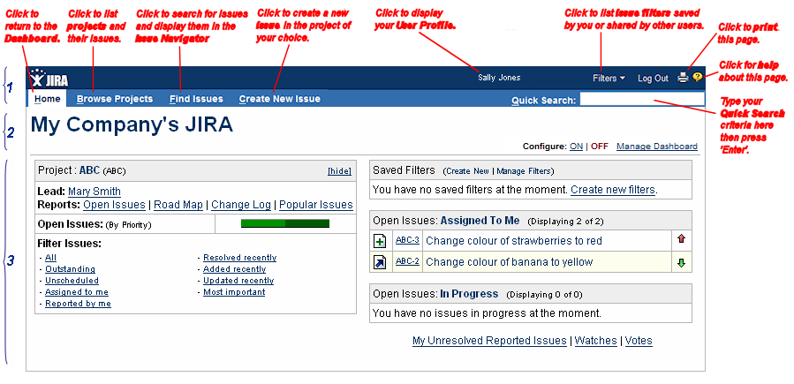

## Ticket Process Flow

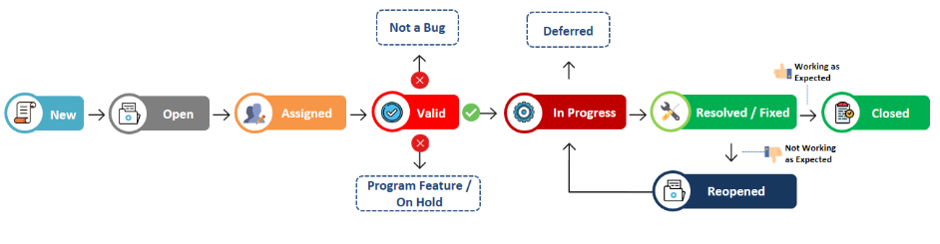

# Case Studies

|  |  |
| --- | --- |
| **Ladder Now – Roof Claims Industry** | |
| C:\Users\kamalakkannanns\Desktop\laddernow1004.png | Ladder Now is “the next generation of roof claim inspections”. Combining our history of top 5 carrier operations, architectural engineering, software development and nationally deployed cat inspection services guarantees that we are a ‘Reliable, Professional, Expert’ partner to the residential and commercial insurance carrier. |
| **BUSINESS CHALLENGE**   * Current system does not have provision for adjuster/customer to book appointment directly based on their preference. * The current system does not provide any intelligent scheduling and dynamic dispatch for control and management of the work process * Dispatcher manually monitors the job stages * The current system does not have integrated control of internal technicians * Technician come and receives the job details in office from the dispatcher on daily basis * Manual preparation of reports to measure the quality, quantity and cost effectiveness * Current System does not have dynamic price mapping based on services | **SOLUTION**   * Created a Flexible, Configurable and Comprehensive System to manage the work force effectively. * FP provides the Portal for Adjuster / Customer for booking the appointment based in their preference. * FP provides the intelligent scheduling and dynamic dispatching by the way of using Technician Region, Exchange, Skills and Certification. * FP provides an one integrated solution to manage all the field technicians e.g., Technician Availability. * FP provides ‘Technician alert system’ to alert the technician when the job has been scheduled by the dispatcher |
| **Business Benefits**   * One holistic solution to mange the end to end business process resulting in improved efficiencies * Eliminate all manual and duplicate entries * Complete visibility of data across the entire corporate environment based on Real time status updates * Elimination of second call backs due to misinformation or lack of field coordination and planning * Improved process efficiencies across the operation resulting in increased productivity and better response time using fewer resources resulting in significantly lower cost of service. | **Integrated Systems**   * Quick Book |

|  |  |
| --- | --- |
| **Altisource– Real Estate Owned** | |
|  | Altisource™ provides services to some of the most respected organizations in their industries, including one of the nation’s largest sub-prime servicers, government agencies and many lenders, servicers, investors, mortgage bankers, credit unions, financial services companies and hedge funds across the country. |
| **BUSINESS CHALLENGE**   * Integration with different type of home grown systems * Vendor Assignments and Reassignments * Vendor Score Card * Dynamic Forms – Preservation and Inspection fulfilment forms * Multi-Vendor Management | **SOLUTION**   * Integration with REAL Resolution system was achieved by using REST web service * Primary Vendor Automatic Assignments and Reassignments was done based on Bing Map and other assigning criteria * Calculation of Vendor Score Card based on Quality, Drive Time and Rejection Ratio * Creation of Dynamic Fulfilment Forms available for vendor fulfilment * Implementation of Multi-Vendor Management process with lead registration |
| **Business Benefits**   * Vendor’s performances were identified and ranked based on criteria * Primary Vendors get assigned automatically during Property Boarding * Automatic Vendor Reassignments on Vendor’s Prevent Use or In-active * Dynamic Fulfilment Forms * A new invited Vendor can register into the application on their own | **Integrated Systems**   * REALResolution * Other Accounting Software * Bing Maps |

|  |  |
| --- | --- |
| **Insight– Technology solutions** | |
|  | Insight is a leader in providing smart, cutting-edge technology solutions for global organizations of all sizes. From developing unique strategies to delivering the products, services and expertise. |
| **BUSINESS CHALLENGE**   * Managing and tracking multiple projects happening across the world * Managing multiple vendors and their technicians, need to pay them based on the work done. * Screening of technicians for their availability and concurrence | **SOLUTION**   * Project Management and Governance module. Ability to assign and track work orders to projects and obtain reports * Full-fledged vendor management including region and scope of work definition. Ability to track the vendor technicians with their availability, work done etc., * Command center will have the ability to screen the vendor technician for their availability and concurrence for jobs. They also can check the customer availability for the schedule. |
| **Business Benefits**   * The level of automation of the existing manual process enables in better utilization of time and resources leading to improved better efficiency. * Saving on distance travelled, allowance claimed, increased working hours and finally considerable fuel savings * Improved overall service quality and customer satisfaction, who can have better service of their facilities and assets. | **Integrated Systems**   * Excel Uploads |

|  |  |
| --- | --- |
| **Benco Dental – Equipment Sales & Service** | |
|  | Benco Dental is the largest privately owned, full-service dental distributor in the United States. Benco Dental provides equipment service and repair service for Dental clinic equipment. |
| **BUSINESS CHALLENGE**   * Wanted a Comprehensive System to manage the Work force effectively combined with Truck Inventory & GPS Tracking * Needs Intelligent scheduling and dynamic dispatching using GPS * Dispatcher manually monitors the SLA and the job stages * In Current system, any user can change the job priority & lot of Paper trails * Manual tracking of customer equipment service history * No Live Map tracking of technicians while he is in field service * Manual preparation of reports to measure the quality, quantity and cost effectiveness | **SOLUTION**   * Created a Flexible, Configurable and Comprehensive System to manage the work force effectively. * Automation for effective and efficient decision-making using scheduling variable when technician is allocated for Job * GPS based intelligent scheduling and dynamic dispatching based on the Tech Current location and the Customer location. * Continuous and Dynamic optimization of scheduling resources * Meet critical SLA levels, reduce return visits and communicate critical information in real time * Integrated with Prelude ERP system to synchronize the customer account information, Part profiles, Inventory count. * Track the time and materials used and sent them to Prelude ERP for Billing * Integrated with CRM to update all the customer service activities |
| **Business Benefits**   * Improved process efficiency with reduced number of follow ups with customers and field engineers. * Improved workforce utilization, reducing travel time, controlling workforce costs, reducing overhead and assuring optimal availability of resources * Quickly track the nearest technician with the right skills and inventory resources to attend customer calls. * Easy access to customer service history of their equipment’s * Automatic creation and scheduling of preventive maintenance service calls * Visibility of customer activities in the CRM for Sales people. | **Integrated Systems**   * UPS * Geo Tab * MS CRM * Prelude |

|  |  |
| --- | --- |
| **Motorola – Telecommunications equipment provider** | |
| mot-sol-h-s.gif | Motorola is a A global data communications and telecommunications equipment provider |
| **BUSINESS CHALLENGE**   * Limitations with their existing FSM solution, forcing the customer to look for a feature rich FSM solution to create and manage incidents and change requests remotely via tablets and smartphones * Dispatchers, technicians and vendors were unable to collaborate, create, update and track dispatched and completed work orders using a single system * More dependency on central dispatchers as there were no system in place for simplified dispatching & routing process * Lack of integration with existing systems and high support and maintenance costs * Existing system was not allowing users to self-assign jobs on emergency situations and while on the move | **SOLUTION**   * Implemented FieldPower Solution to perform the entire global operations * End to end integration with BMC remedy and the Client corporate OKTA enabled provision for external users to login with their registered email ID. Integrated NOC FEDREROS Alarm system to alert technicians on jobs. * User management module with role based access for delivering faster resolution and to improve productivity. Configured Technician Feedback Eco System to improve the App and web experience. * Feature to allow multiple change approval process for change management * Integrated alerts and notifications with customized sounds to differentiate vendor groups and technicians. SLA alerts to notify and warn technicians before 45 minutes of the agreed time to complete the job * Multi-language Support (Canadian French, Portuguese and Spanish) |
| **Business Benefits**   * Saved 35% of the annual costs spent on CLICK and REMEDY licences * Eliminated SLA violations by X% improved overall service quality and customer satisfaction * Automation enabled better utilization of time and resources leading to improved efficiency * Mobile apps enabled collaboration among back office, field staffs and partners and helped to manage Jobs anywhere, anytime | **Integrated Systems**   * Remedy * SAP |

|  |  |
| --- | --- |
| **Nokia – Tele Communications** | |
| logo | Nokia Corporation, stylized as NOKIA, is a Finnish multinational communications and information technology company and it is a global leader in creating the technologies at the heart of our connected world. |
| **BUSINESS CHALLENGE**   * Encrypted authentication * Instant Job schedules in handheld devices * Status feedback from technicians to Dispatcher / Manager * Automatic connecting and reconnecting as users move in and out of cell coverage areas, with storage of work data on mobile device * Time tracking and Field measurement data for reporting * Job acceptance and rejections * Dynamic Checklist * Signature captures * Advance Photo checklist * Image Editing * File attachment * Audio recording * Integrated image control tool (Image Annotate, Write Text, Cropping) * Synching large of volume of data   + - More than 40 images syncing in multiple threads to lead to time consuming | **SOLUTION**   * **Mobile application (Cross-platform compatibility)** - Used by subcontractors on site to simplify the collection and storage of the data related to the microwave equipment deployment * **Back office server application** - Used by Alcatel Lucent employees * Integrated with Home Grown systems with specific requirement based Web Services. * Integrated seamlessly with home grown systems SAP, CRM and Microsoft Outlook. |
| **Business Benefits**   * Better visibility and tracking on field jobs in Web and Mobile. * Improved Customer Service & Response Time with Fewer Resources at call centre as well as field operations * Dynamic Checklist functionality * Photo Application * Offline Support * File Upload |
| **Integrated Systems**   * SAP * CRM * Microsoft Outlook | |

|  |  |
| --- | --- |
| **OCS** | |
| https://media.licdn.com/mpr/mpr/shrink_200_200/AAEAAQAAAAAAAAJ5AAAAJGRhNWIzNWEyLTA2N2MtNDk1Ni05MWYxLTU0YWZjNjJlYmY5YQ.png | OCS, UK – Outsourced Client Solutions Group is an international business focused on delivering sustainable solutions to complex facilities management issues with over USD 4 billion in business revenue. Their largest Retail Division is engaged in providing dynamic solution to their Field Operatives, thru web and mobile application in scheduling and allocating jobs on the go. |
| **BUSINESS CHALLENGE**   * The Application to cater around 2500 Field Operatives and about 10,000 sites across Europe with their distance of travel, cost of travel and Cost to the Company. * They had multiple Divisions consists of Retail Stock Take, Retail Store Support, Pharmacy, Supply Chain and Vehicle Audit divisions | **SOLUTION**   * All their divisions are automated, and integrated with their existing SAP, SMS, START, Google Map solutions * The Application has been developed to avoid mileage pilferages, expenses over billing, cost escalation for jobs, Optimized way of scheduling and deployment * The Mobile version of the application is developed in IBM Mobile First platform with a hybrid development of IOS, Android & Windows versions * Optimizing the Mini Bus operation for its full capacity, to save on the running cost * Implementing Integrated Billing rules, Travel based Mileage Rules, and Salary based Wage rules |
| **Business Benefits**   * The level of automation of the existing manual process enables in better utilization of time and resources leading to improved better efficiency. * Saving on distance travelled, allowance claimed, increased working hours and finally considerable fuel savings * The application features are expected to bring in bountiful savings for the organization and it is already projected to save the company to the tune of GBP 4 million in the first year of its operation * Improved overall service quality and customer satisfaction | |

|  |  |
| --- | --- |
| **Best Buy – Consumer Electronics** | |
|  | Best Buy Co., Inc. is a multinational retailer of consumer electronics, computing and mobile phone products, entertainment products appliances and related services. Best Buy operates Geek Squad & Connect Pro support task force throughout the Canada across multiple time zones. |
| **BUSINESS CHALLENGE**   * Required a Flexible and Configurable System to provide a fully managed product for Work Force Management system and integrate with home grown systems * Multiple Brands, Multiple stores, Multiple product offerings following different work flow with multiple systems * Increase the number of calls handled per day * Reduce the call centre operation cost with reduced number of customer calls and time duration spent on each call * No real time visibility of different brand field operations to the management * Preparation of Reports is manual and takes time to consolidate | **SOLUTION**   * Implemented FieldPower solution system configured to manage the field workforce. * Integrated with Home Grown systems with specific requirement based Web Services. * Integrated Single Sign on within the internal network across all the brands. * Supports multiple brands, multiple branches. * Brand access is partitioned and isolated within them but for HQ users the data is seamless across brands. * Schedule and Route optimization based on shortest distance to handle more calls. * Integrated seamlessly with home grown POS system where customer can choose their service appointment time at the time of sale. * Integrated with CSPARC a home grown sales accounting system. * System Delivered and Fully Operational * Implemented to work across Multi time zone, Multi Lingual English & French * Implemented Blackberry & iPhone solution for the field engineers |
| **Business Benefits**   * Single Process flow across all the Brands. * Service Appointment window offered at the time of sale for customers reducing the number of follow-ups. * Better visibility and tracking on field job statuses. * Quicker MIS Reports production at brand level and consolidated level * Improved Customer Service & Response Time with Fewer Resources at call centre as well as field operations * Increased number of calls completed in First call. * Reduced overall travel time. * Resource utilization. | **Integrated Systems**   * ePOS * RATS * CSPARC * Inventory System * Transaction lookup. * Bing Maps * Blackberry BES |

|  |  |
| --- | --- |
| **EarthLink – Tele Communications** | |
| [Best ISP for dial up & broadband Internet - EarthLink](http://www.earthlink.net/) | EarthLink is an IT services, network and communications provider headquartered in Atlanta, Georgia and is the primary provider of residential and Business solutions in telecommunications |
| **BUSINESS CHALLENGE**   * BSS – Customer Operations * Installation Order Flow * Restoration Order Flow * OSS – Network Operations * Preventative Maintenance * Corrective Maintenance   Intelligent Scheduling  Mobility  Continuous Route Optimization  Vendor Management  Live Map – GPS Tracking  In-house Jobs / Techs | **SOLUTION**   * Implemented FieldPower solution system configured to manage the field workforce. * Integrated with Home Grown systems with specific requirement based Web Services. * Schedule and Route optimization based on shortest distance to handle more calls in Customer and Network Operations. * Integrated seamlessly with home grown systems METASOLV, REMEDY, E-Bus and WAVE |
| **Business Benefits**   * Better visibility and tracking on field job statuses. * Improved Customer Service & Network Service Response Time with Fewer Resources at call centre as well as field operations * Reduced overall travel time. * Efficient Resource utilization. * Schedule and Route optimization based on shortest distance to handle more calls in Customer and Network Operations | **Integrated Systems**   * METASOLV – For Provisioning Orders * REMEDY – For Fault Orders * Integration with e-Bus * WAVE – Trouble Ticketing System |

|  |  |
| --- | --- |
| **TSTT - Telecommunication Services** | |
| tstt3 | Telecommunications Services of Trinidad and Tobago Limited (TSTT), which is jointly owned by the Government of Trinidad and Tobago and Cable & Wireless |
| **BUSINESS CHALLENGE**   * Multiple systems to be used for each product lines * The current system does not provide any intelligent scheduling and dynamic dispatch for control and management of the work process * The current system does not have integrated control of internal resources, third party vendors, and sub-contractors * Dispatcher manually monitors the SLA and the job stages * Reduce the time spent on call with technicians | **SOLUTION**   * Implemented FieldPower systems integrated with internal systems to manage all the calls created from various systems * Implemented FieldPower solution to manage all the field technicians, contractors and the contractor technicians spread throughout the nation. * Implemented ‘Dispatcher alert system’ to ensure SLA of each jobs and receives alert when the technician not accept or reject the scheduled job * FSA provides ‘Technician alert system’ to alert the technician when the job has been scheduled by the dispatcher * Implemented solution in mobile devices to provide technical details and check list required to complete the job * Implemented 3 part closure approval process for completing the jobs to improve the quality of jobs completed |
| **Business Benefits**   * Elimination of second call backs due to misinformation or lack of field coordination and planning * Improved process efficiencies across the operation resulting in increased productivity and better response time using fewer resources resulting in significantly lower cost of service. * Visibility of contractor job status to Operations Management * Technician are equipped with all the information in their mobile devices that are required to complete the call | **Integrated Systems**   * Access Care * Concept Ware * SIS |

|  |  |
| --- | --- |
| **STC - Telecommunication Services** | |
| logo | Saudi Telecom Company (generally known as STC) is the leading national provider of telecommunication services in the Kingdom of Saudi Arabia providing the highest standard of services (Fixed Lines, mobile, Data, etc.) to their customers. |
| **BUSINESS CHALLENGE**   * STC Network Operations Department is responsible for management of their field service operations. It supports the entire service Process from creating the tickets for fixing and reporting on the problem at STC sites * Currently these operations are tracked manually using some preliminary in-house systems (PMR web and MAMAS) for preventive maintenance * Track and Monitor Managed Service Providers operations to make sure they meet the SLAs. * Track the technicians to make sure they perform the Preventive Maintenance Routines. | **SOLUTION**   * Create a Flexible, Configurable and Comprehensive System of Work Force Management System to manage the work force of STC and the MSPs effectively. WFMS generates PMR work orders based on the defined ETL and provides the intelligent scheduling and dynamic dispatching based on the Technician’s Skills and Technology. * Real time technician tracking using GPS. * Integration with RTTS to effectively schedule and handle Trouble Tickets (CMR) * View by statistics of relative quantity, performance, and profit / valuation |
| **Business Benefits**   * One holistic solution to manage the end to end business process resulting in improved productivity * Improved customer service and Improved manageability of network operations activity by STC and by all the MSPs * Improved process efficiency by continuous review of the existing process * Library of Industry expert’s dashboards based on data analysis and views based on accumulated knowledge * Ability to provide Ad Hoc / On-Demand reports from user defined criteria, export to Excel, Word, PDF, and Print * Improved manageability of network operations’ activities * Convenient Technician tracking using GPS. * ETL based PMR generation and automatic scheduling to technicians based on Skills and Technologies. | **Integrated Systems**   * NFTS * RTTS (Remedy) * MMS * SharePoint * GS Maps with Navteq Map |

|  |  |
| --- | --- |
| **Edotco** | |
|  | edotco is the first regional and integrated telecommunications infrastructure services company in Asia, providing end-to-end solutions in the tower services sector from tower leasing, co-locations, build-to-suit, energy, transmission and operations and maintenance (O&M). With a regional portfolio that includes over 26,000 towers across Malaysia, Sri Lanka, Bangladesh, Cambodia, Pakistan and Myanmar, Laos & Philippines. |
| **BUSINESS CHALLENGE**   * Required a Workforce Management System (WFM) solution with adequate performance to cater for all edotco’s operating countries * Each country or entity have their own configuration/setting * Integration with existing systems like WDS, ECHO, EASI, MRF, Rapid and Power BI * Trouble Ticket creation via multiple email formats * Bulk Import option for Trouble Ticket creation * Providing the option for the client to create Trouble Tickets in the system | **SOLUTION**   * Configured FieldPower for their major operations in Malaysia, Bangladesh, Pakistan and Myanmar * Introduced job creation with bulk upload * Most of the job creation is automated by integrating with their alarm and core systems * Multi Vendor Management * Spares Parts Module to handle their warehouse activities |
| **Business Benefits**   * FieldPower, which caters to multi-tenanted / multi-country operations helped them in having a single system with different interface for each country. * Improved customer service and Improved manageability of network operations activity by edotco * Site alarms sent by sensors are converted to Trouble Tickets and scheduled to suitable field technician * Edotco able to maintain multiple Vendors and monitor the performance of each vendors * GPS based intelligent scheduling and dynamic dispatching based on the Tech Current location and the Site location | |

|  |  |
| --- | --- |
| **Omantel – Tele Communications** | |
|  | Oman Telecommunications Company is the first telecommunications company in Oman and is the primary provider of internet services in the country. |
| **BUSINESS CHALLENGE**   * Installation * Restoration * Mobility * Preventative Maintenance * Corrective Maintenance * Spare Parts Management * Mobility * Vendor Management | **SOLUTION**   * Implemented FieldPower solution system configured to manage the field workforce. * Integrated with Home Grown systems with specific requirement based Web Services. * Schedule and Route optimization based on shortest distance to handle more calls. * Integrated seamlessly with home grown systems ORACLE Finance, NETCool, ERP Inventory, GCOMM, and OSS Fault Management. |
| **Business Benefits**   * Better visibility and tracking on field job statuses. * Improved Customer Service & Response Time with Fewer Resources at call centre as well as field operations * Reduced overall travel time. * Resource utilization. | **Integrated Systems**   * ORACLE Finance * NETCool * ERP Inventory System * GCOMM. * OSS Fault Management |

# Appendix

## FP –Architecture Diagrams

### ****AWS**** ****Cloud Architecture****

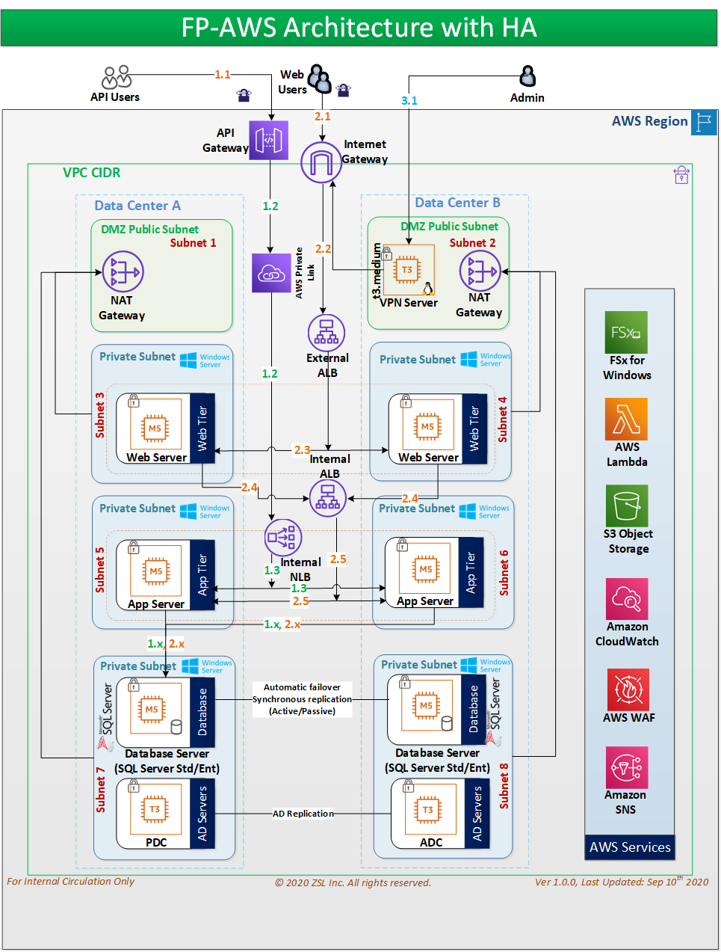

### ****[Technical Architecture](C:\\Users\\PAUL\\AppData\\Local\\Microsoft\\Windows\\INetCache\\Content.Outlook\\JGKNWNZP\\Technical architecture)****

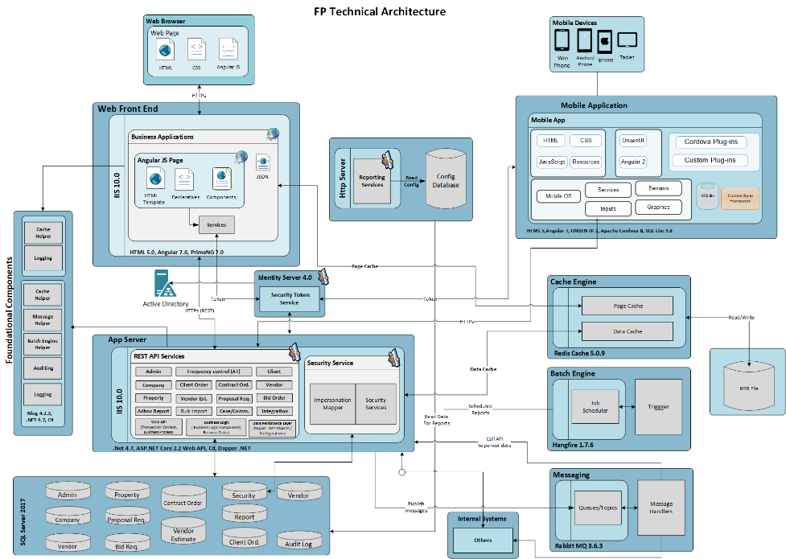

### ****[Security Architecture](C:\\Users\\PAUL\\AppData\\Local\\Microsoft\\Windows\\INetCache\\Content.Outlook\\JGKNWNZP\\Security architecture)****

